**JAVASCRIPT**

**SPECFLOW**

**E4eJavaScript**

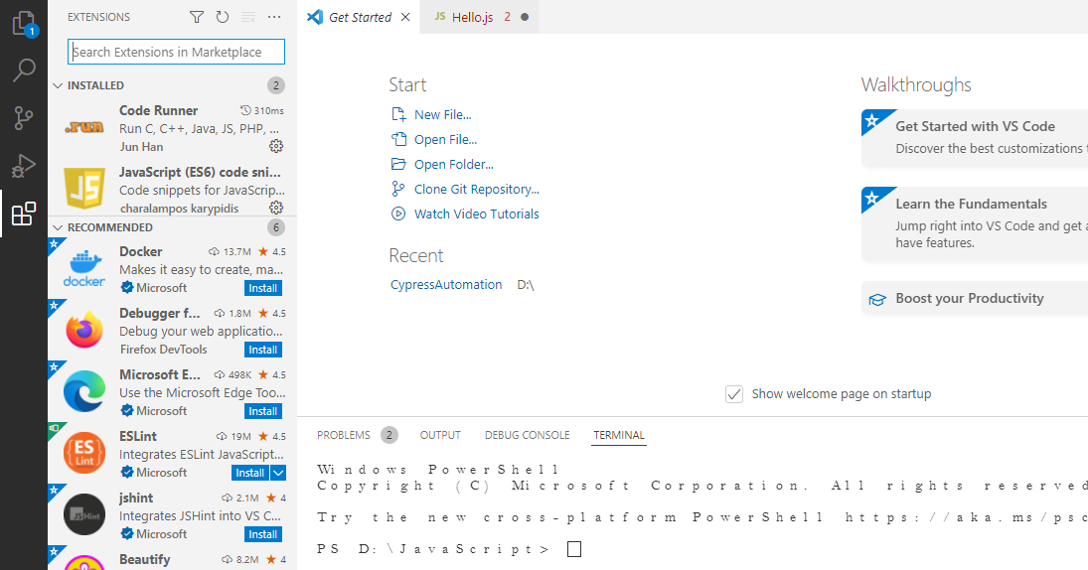

**Note : Code Runner and JavaScript code snippets.**

**Types of JavaScript Comments**

There are two types of comments in JavaScript.

1. Single-line Comment
2. Multi-line Comment

**<script>**

// It is single line comment

document.write("hello javascript");

**</script>**

## JavaScript Multi line Comment

It can be used to add single as well as multi line comments. So, it is more convenient.

It is represented by forward slash with asterisk then asterisk with forward slash. For example:

**<script>**

/* It is multi line comment.

It will not be displayed */

document.write("example of javascript multiline comment");

**</script>**

**JavaScript Variable**

A **JavaScript variable** is simply a name of storage location. There are two types of variables in JavaScript: local variable and global variable.

## JavaScript local variable

A JavaScript local variable is declared inside block or function. It is accessible within the function or block only. For example:

**<script>**

function abc(){

var x=10;//local variable

}

**</script>**

## JavaScript global variable

A **JavaScript global variable** is accessible from any function. A variable i.e. declared outside the function or declared with window object is known as global variable. For example:

**<script>**

var data=200; //gloabal variable

function a(){

document.writeln(data);

}

function b(){

document.writeln(data);

}

a();//calling JavaScript function

b();

**</script>**

A **JavaScript global variable** is declared outside the function or declared with window object. It can be accessed from any function.

**<script>**

var value=50;//global variable

function a(){

alert(value);

}

function b(){

alert(value);

}

**</script>**

#### **Declaring JavaScript global variable within function**

To declare JavaScript global variables inside function, you need to use **window object**. For example:

window.value=90;

Now it can be declared inside any function and can be accessed from any function. For example:

function m(){

window.value=100; //declaring global variable by window object

}

function n () {

alert(window.value); //accessing global variable from other function

}

## Internals of global variable in JavaScript

When you declare a variable outside the function**, it is added in the window object internally.** You can access it through window object also. For example:

var value=50;

function a(){

alert(window.value); //accessing global variable

}

**Note:** When a variable is declared in a function without using var keyword. Then that variable is a global variable and can be used anywhere.

Ex: Function global(){

oopsGlobal=5; // oopsGlobal is a global variable.

}

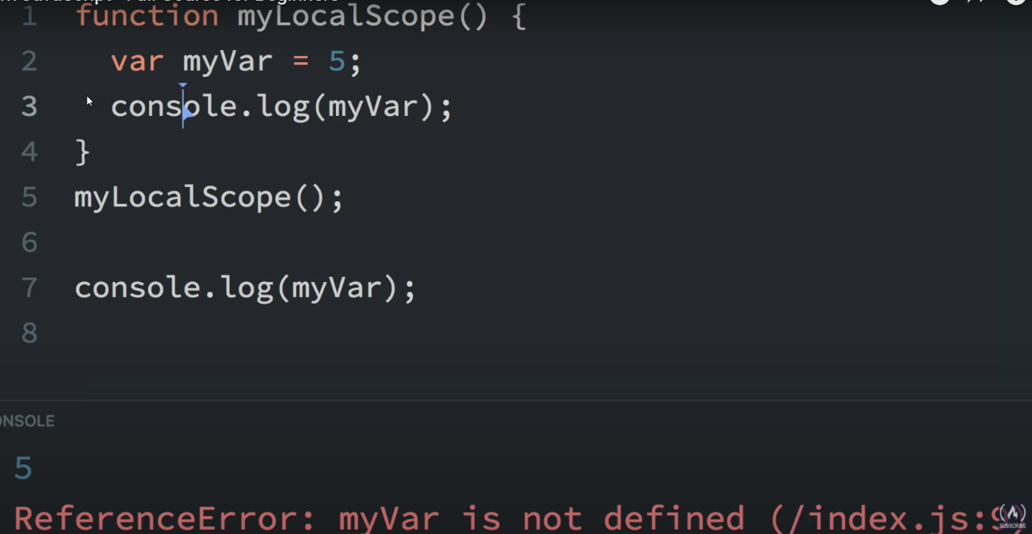

**Note**: When a variable is declared inside the function, It is not accessed outside the function.

**Global vs Local Scope**

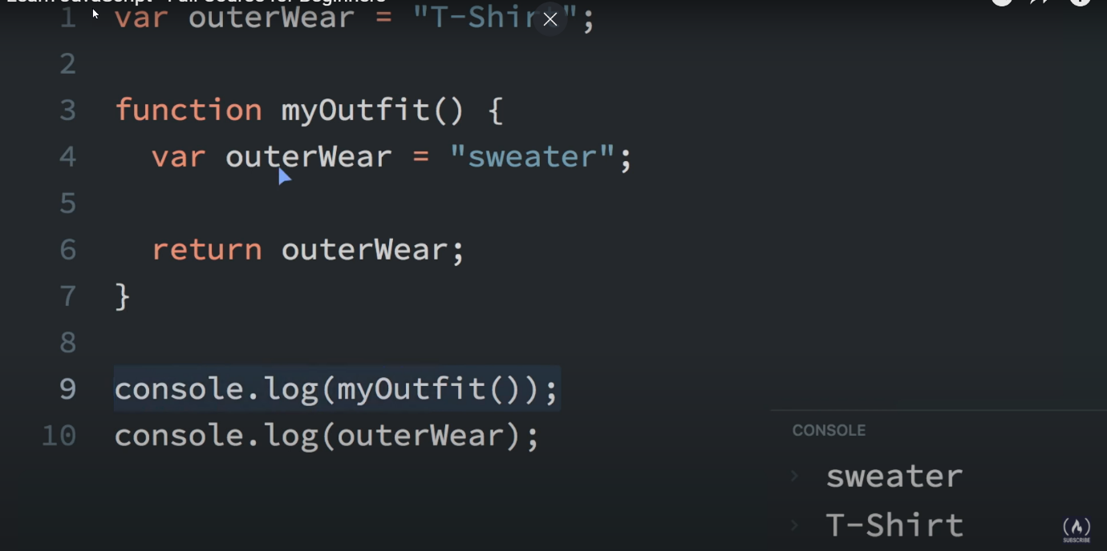

**Note:** Local variable has preference over global variable.

**Note: 3 == 3 Both are equal**

**3 == ’3’ Both are equal**

**Strict Equality operator ( === )** doesn’t convert into types.

3===3 -> true

3===’3’ -> false

**Function return Type**

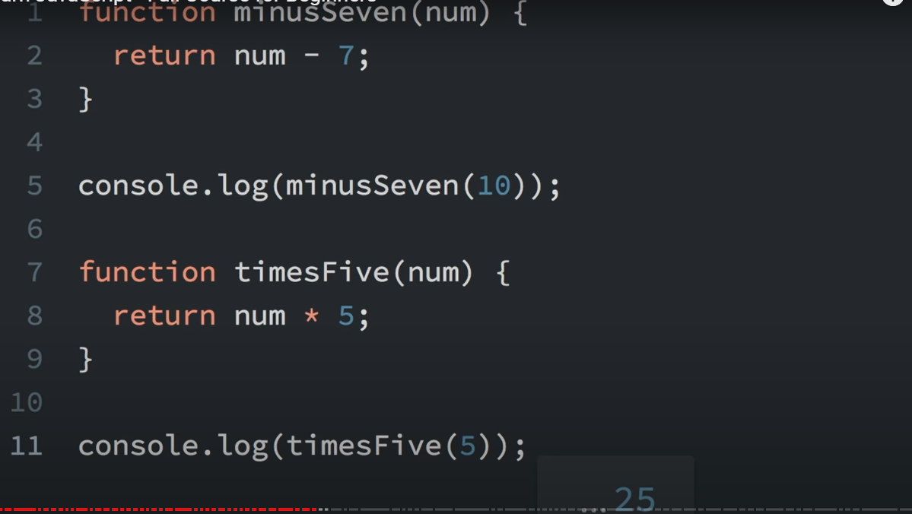



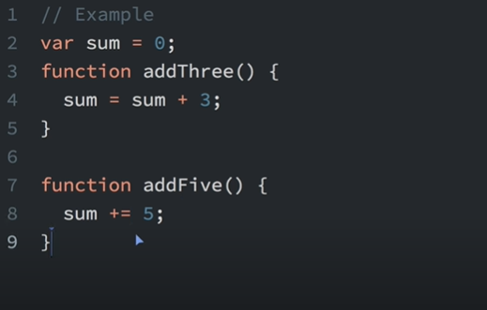

**Note:** When a function doesn’t have return value, Then the return value is undefined.

# **Javascript Data Types**

JavaScript provides different **data types** to hold different types of values. There are two types of data types in JavaScript.

1. Primitive data type
2. Non-primitive (reference) data type

JavaScript is a **dynamic type language**, means you don't need to specify type of the variable because it is dynamically used by JavaScript engine. You need to use **var** here to specify the data type. It can hold any type of values such as numbers, strings etc. For example:

1. var a=40;//holding number
2. var b="Rahul";//holding string

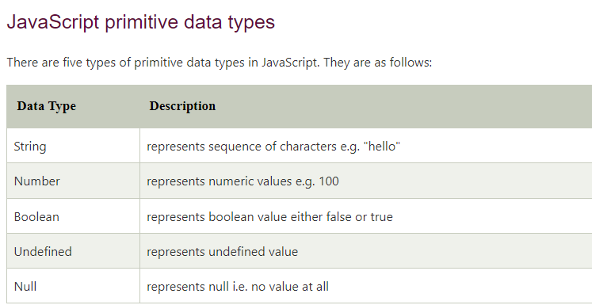

**Primitive values are immutable (they are hardcoded and cannot be changed**).

## JavaScript non-primitive data types

The non-primitive data types are as follows:

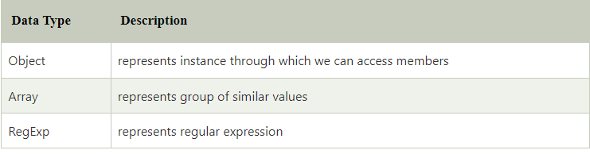

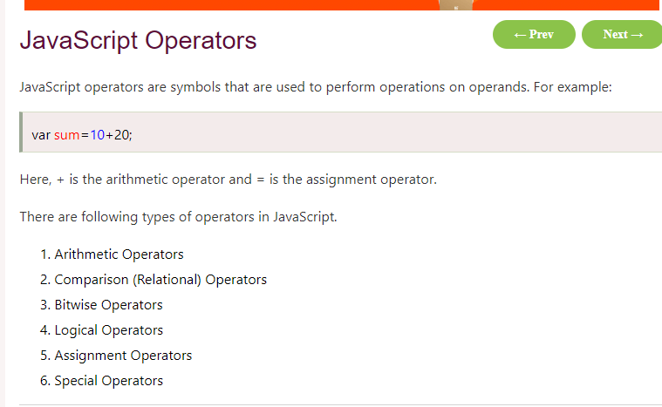

## JavaScript Arithmetic Operators

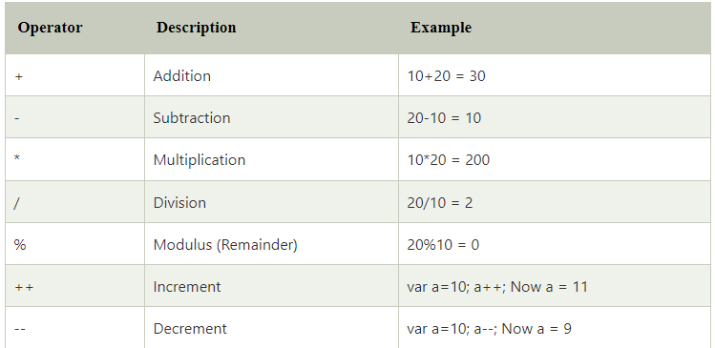

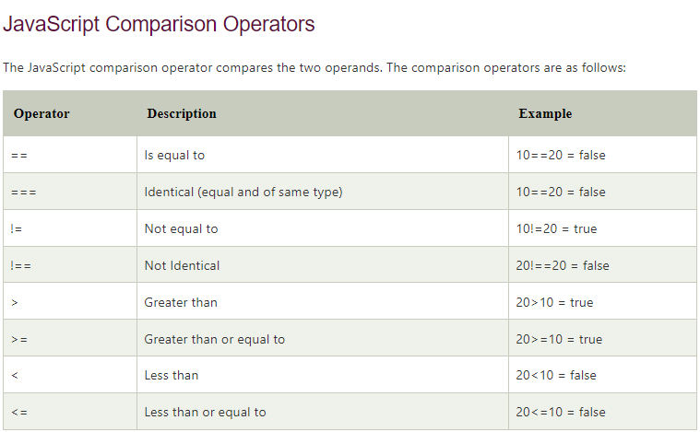

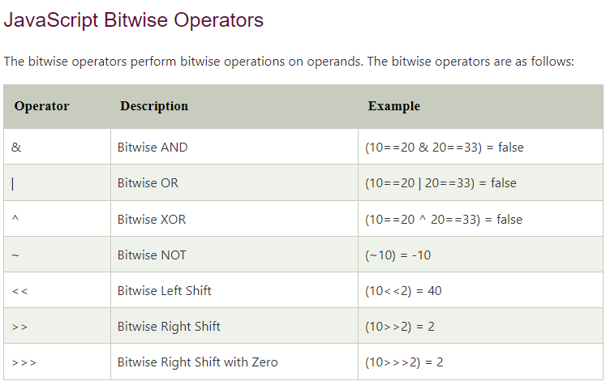

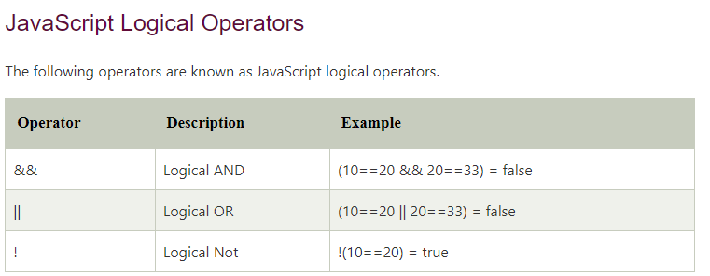

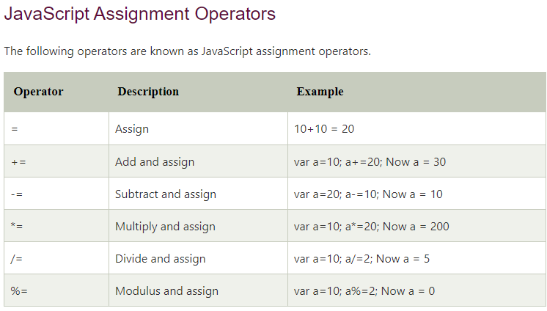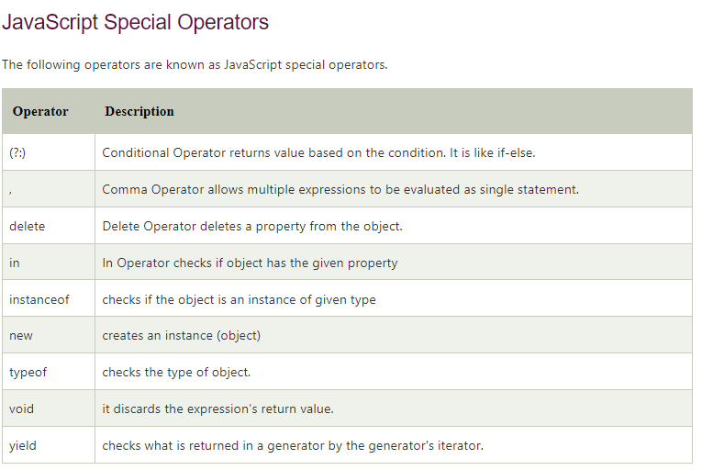

# **JavaScript If-else**

The **JavaScript if-else statement** is used to execute the code whether condition is true or false. There are three forms of if statement in JavaScript.

1. If Statement
2. If else statement
3. if else if statement

### **JavaScript If statement**

It evaluates the content only if expression is true. The signature of JavaScript if statement is given below.

if(expression){

//content to be evaluated

}

**<script>**

var a=20;

if(a**>**10)

{

document.Write("value of a is greater than 10");

}

**</script>**

**<script>**

var a=20;

if(a%2==0){

document.write("a is even number");

}

else {

document.write("a is odd number");

}

**</script>**

# **JavaScript Functions**

**JavaScript functions** are used to perform operations. We can call JavaScript function many times to reuse the code.

**Advantage of JavaScript function**

There are mainly two advantages of JavaScript functions.

**Code reusability**: We can call a function several times so it save coding.

**Less coding**: It makes our program compact. We don’t need to write many lines of code each time to perform a common task.

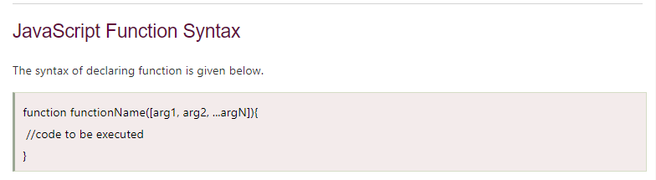

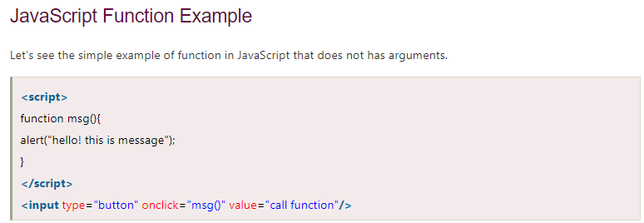

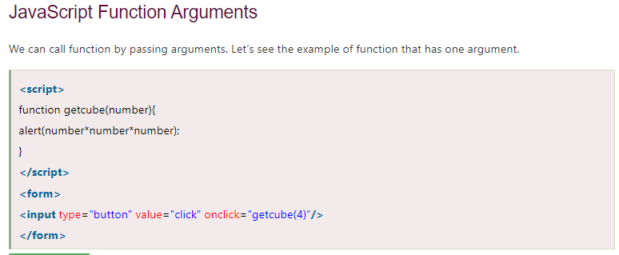

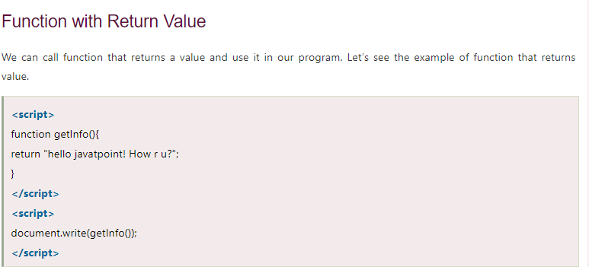

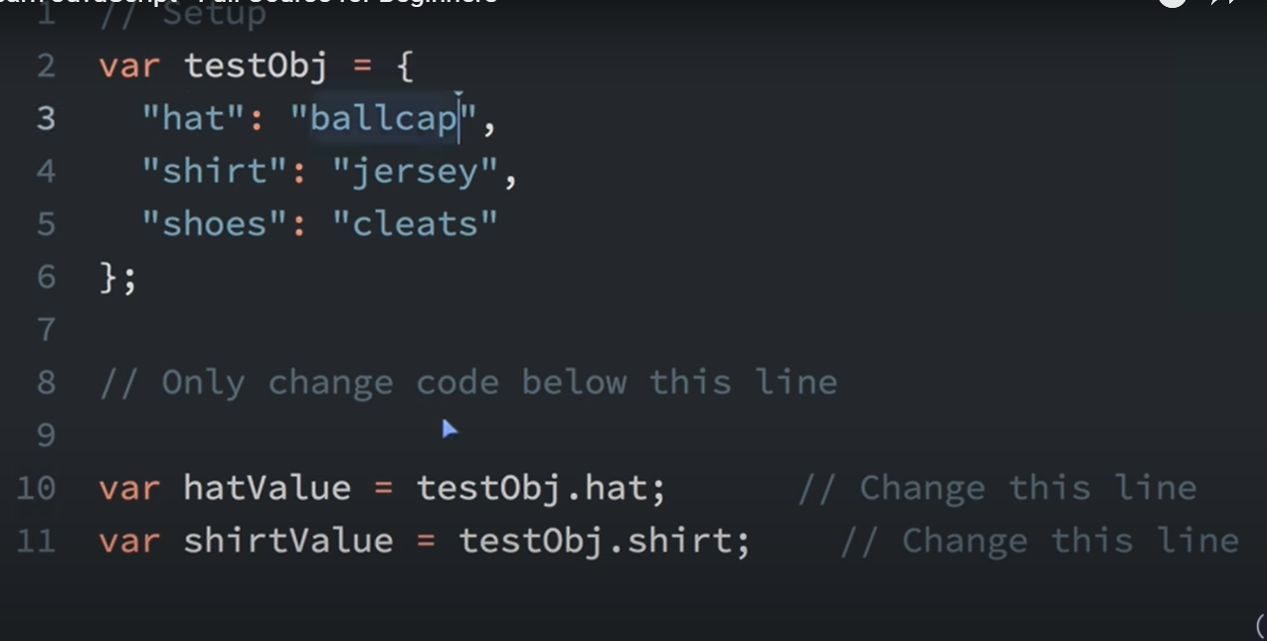



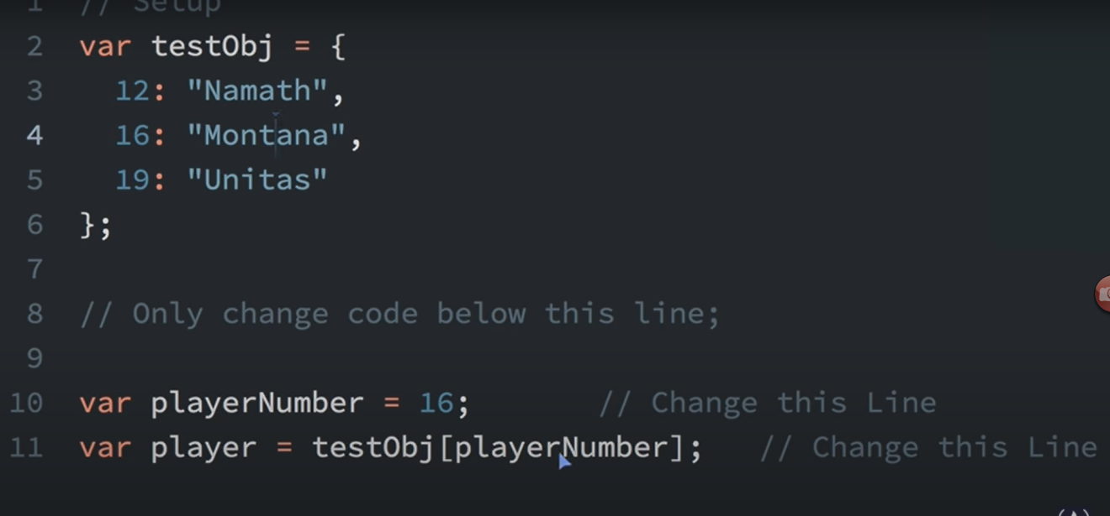



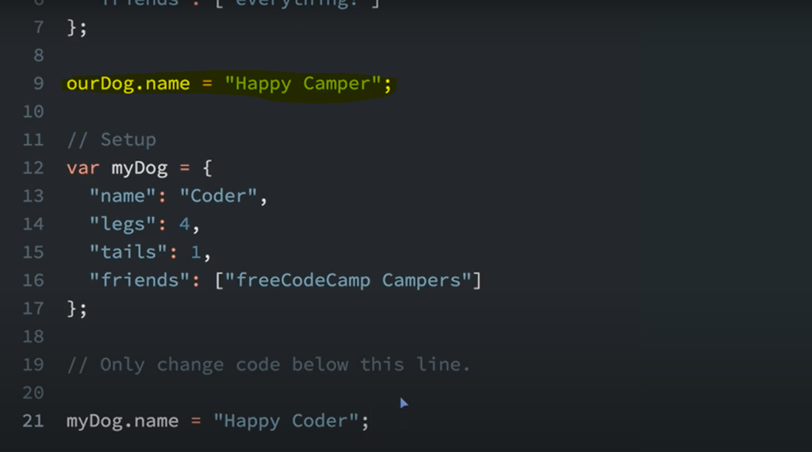



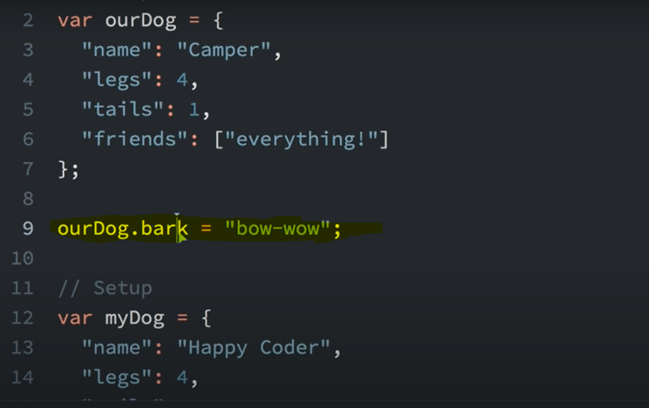

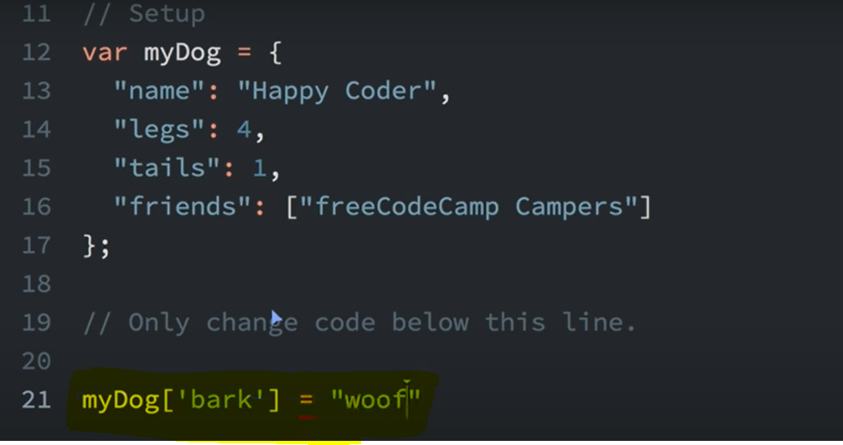



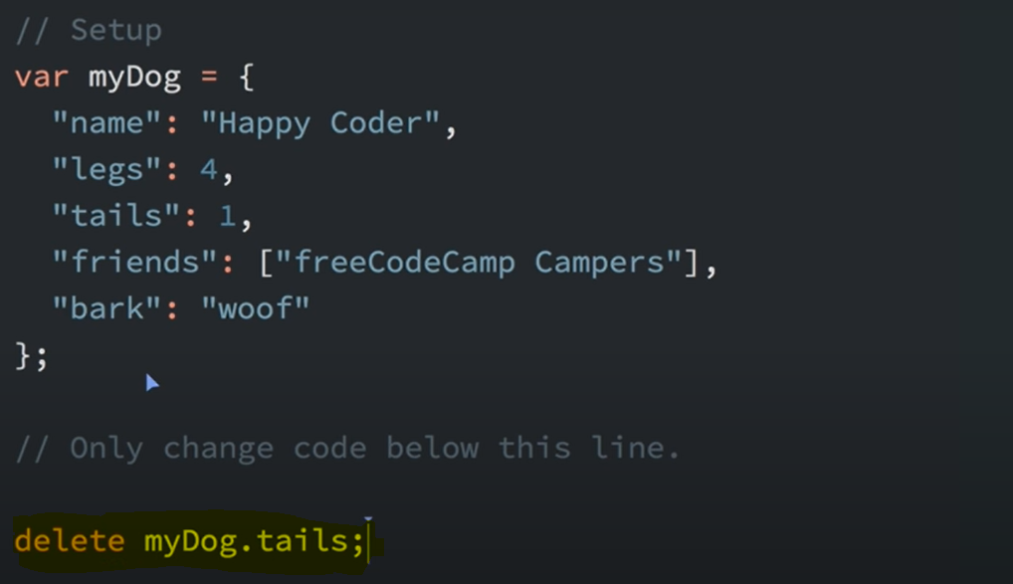



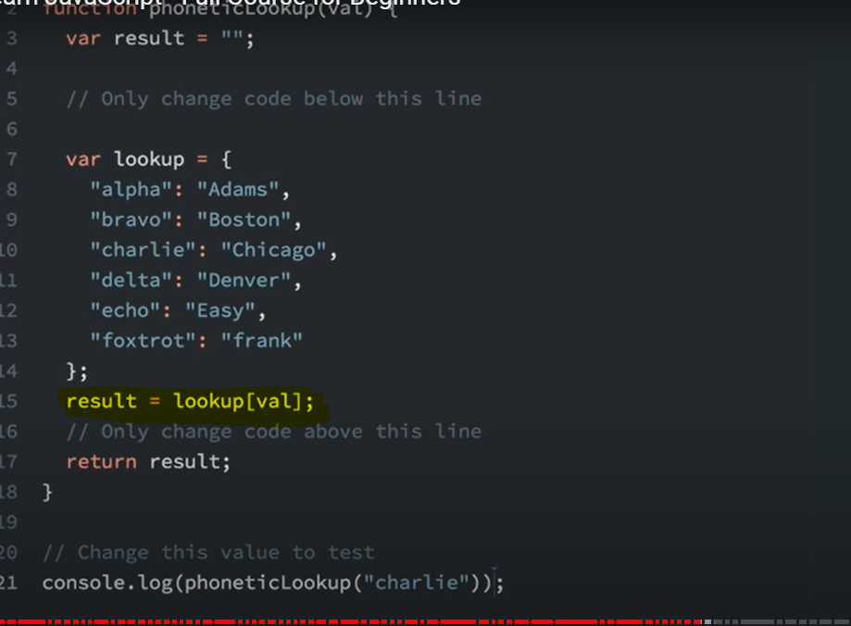



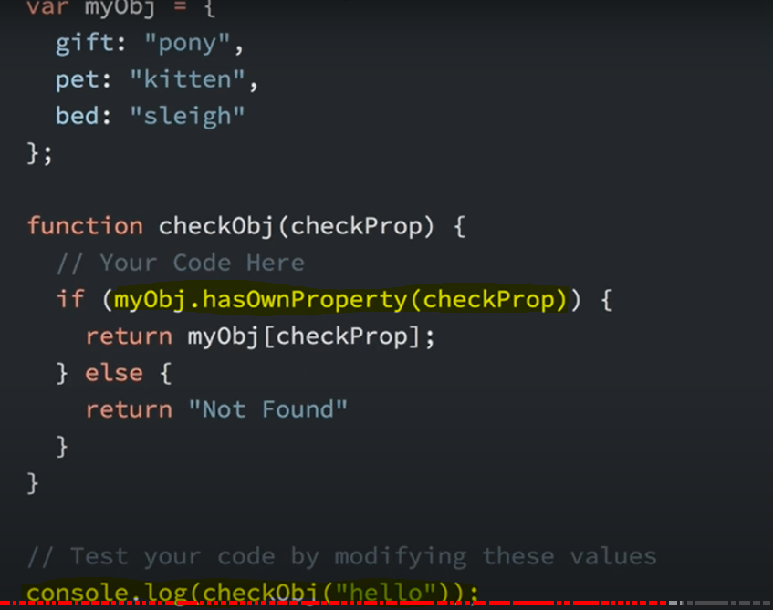



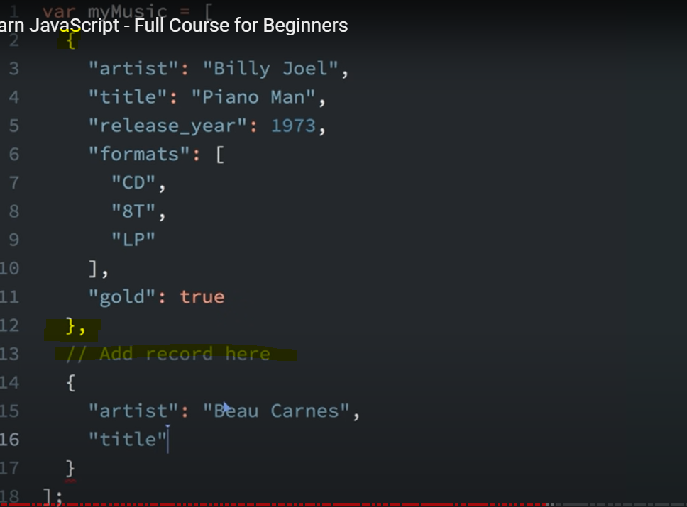



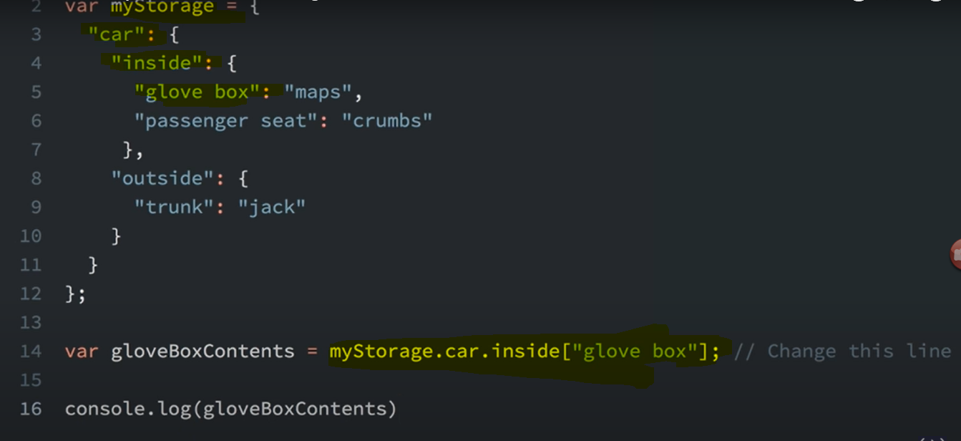

**Note : As there is space in “glove box”, we need to use square brackets. [“glove box”]**

**Accessing Nested Arrays**

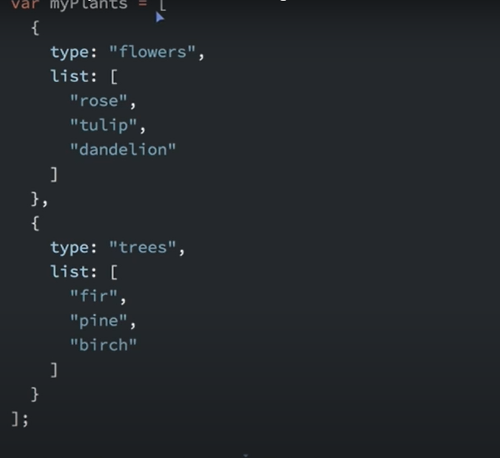

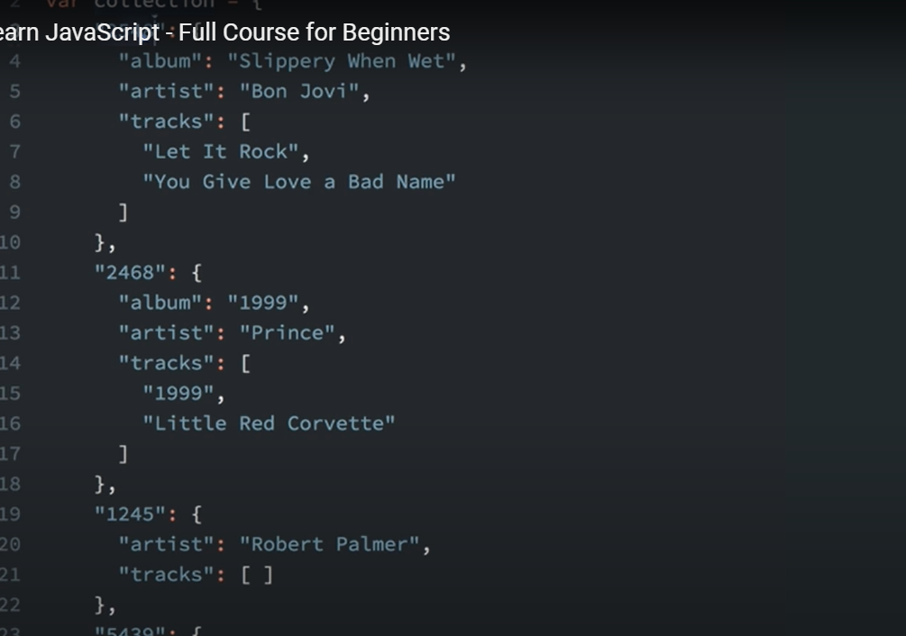

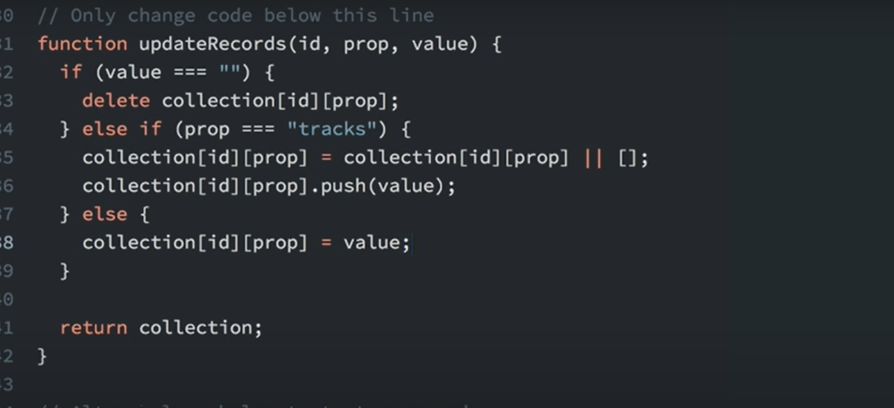

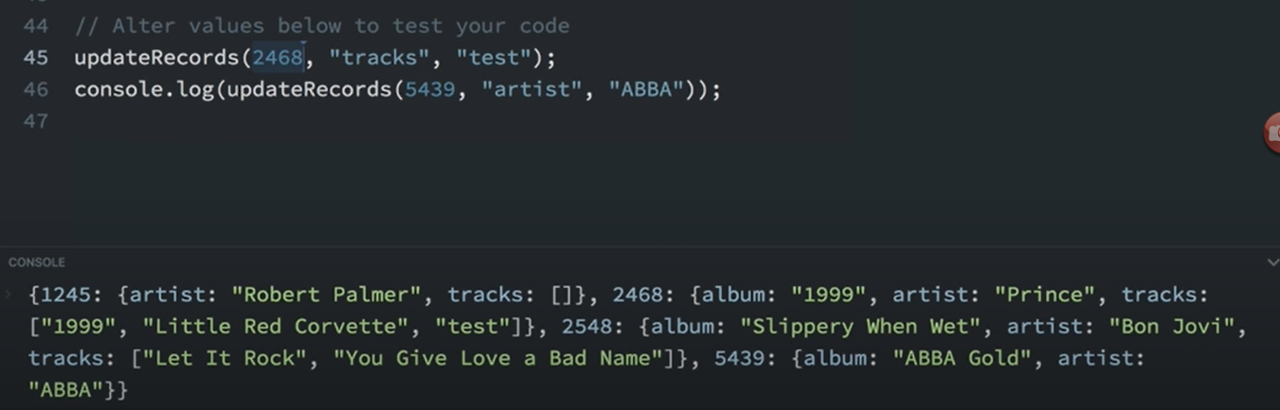

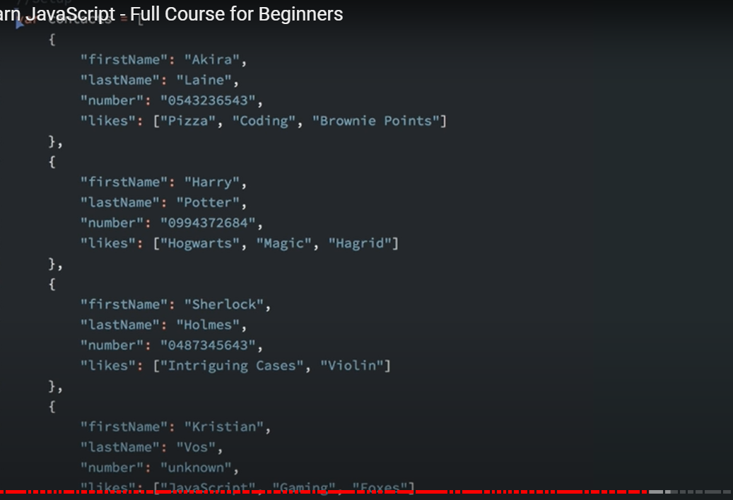

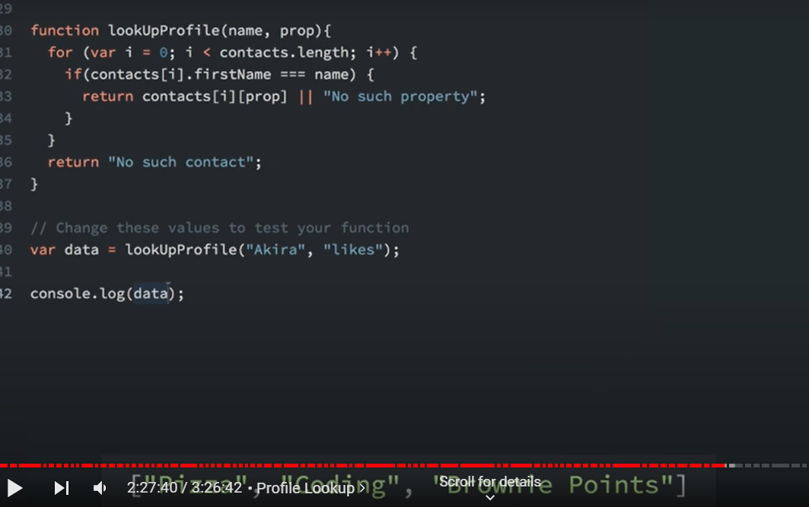

**Var vs Let vs Const**

Scope of Var is global.

Scope of Let is within the block or function.

Const value cannot be changed once assigned.

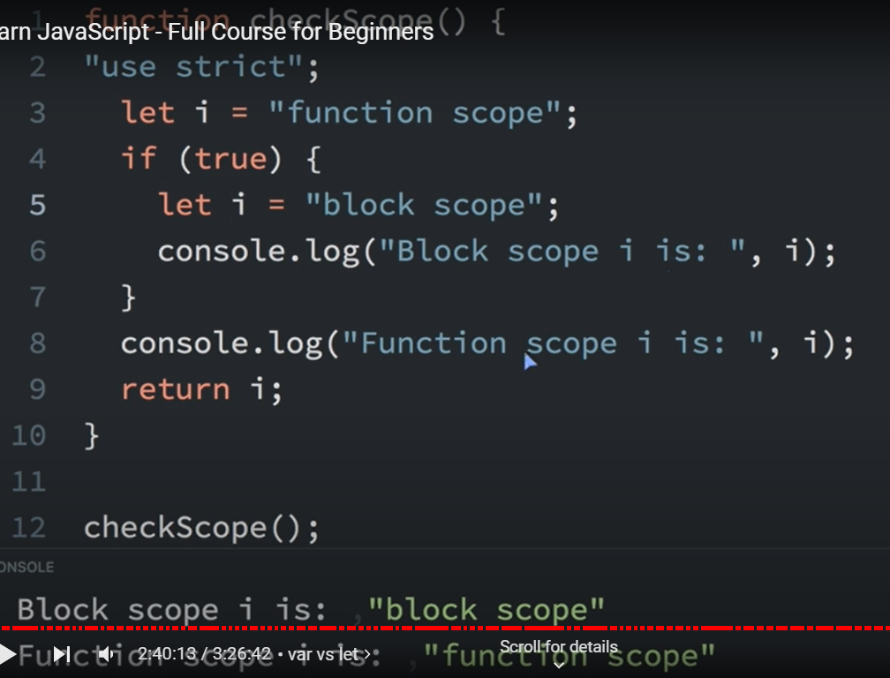

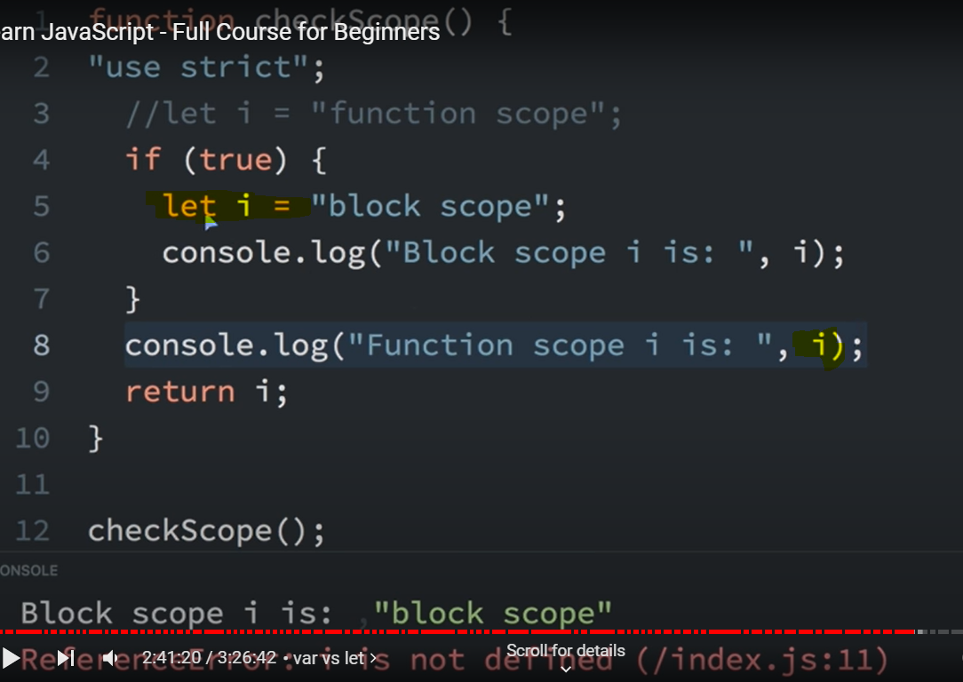

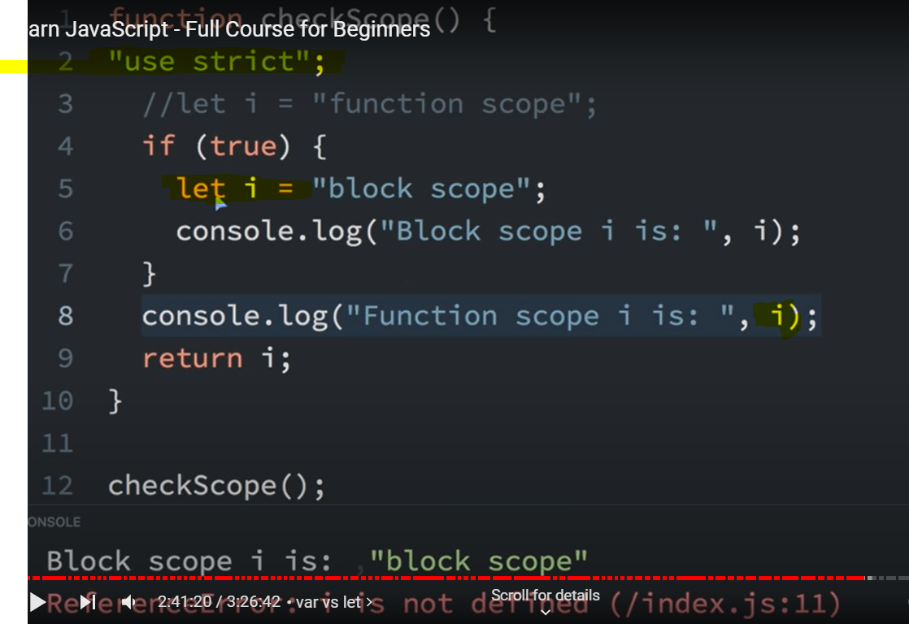

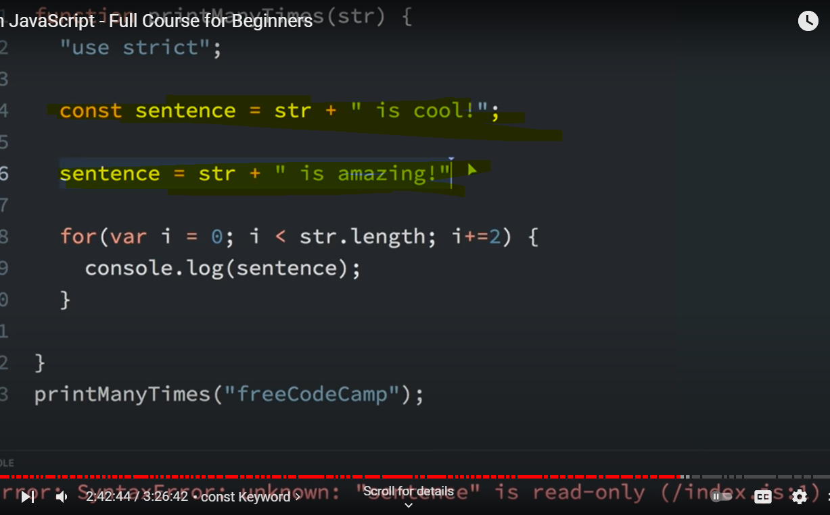

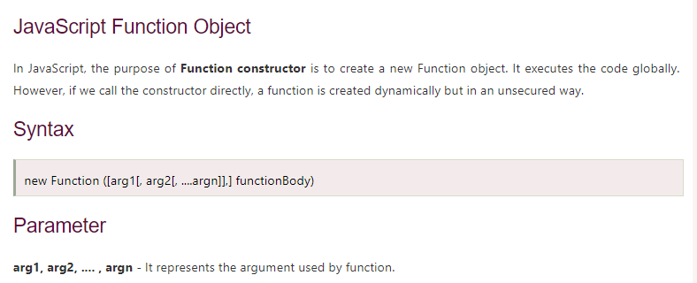

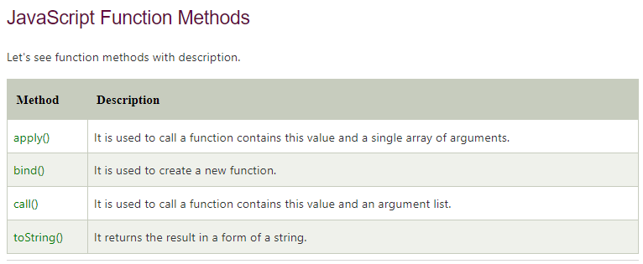

**<script>**

var add=new Function("num1","num2","return num1+num2");

document.writeln(add(2,5));

**</script>**

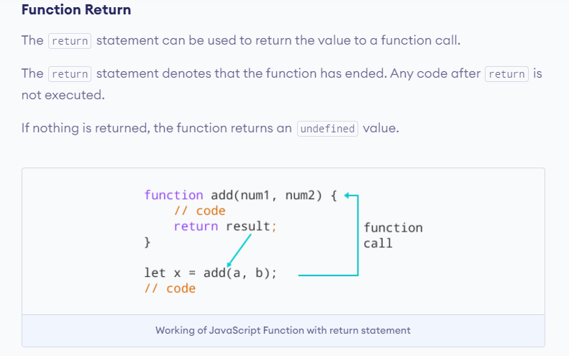

**Function Expressions**

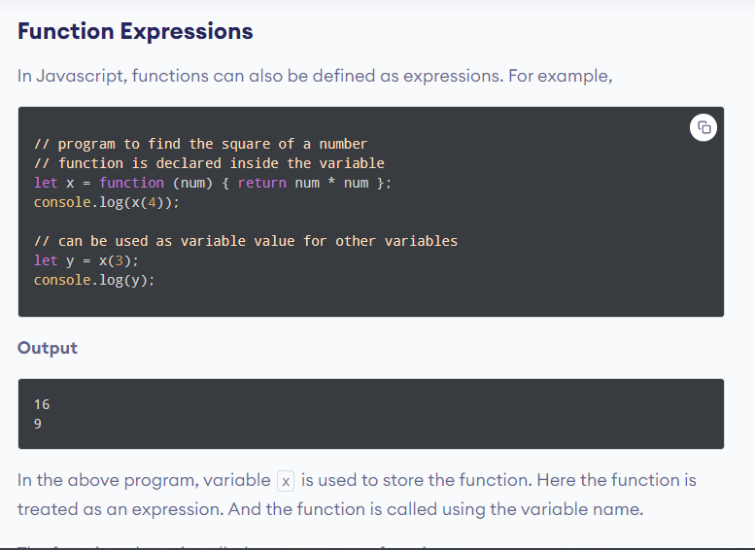

In the above program, variable x is used to store the function. Here the function is treated as an expression. And the function is called using the variable name.

The function above is called an anonymous function.

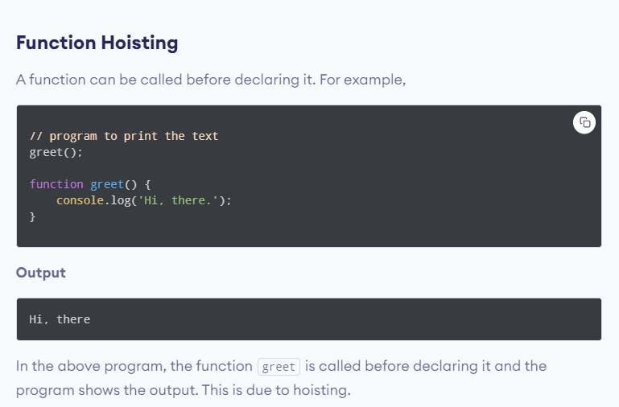

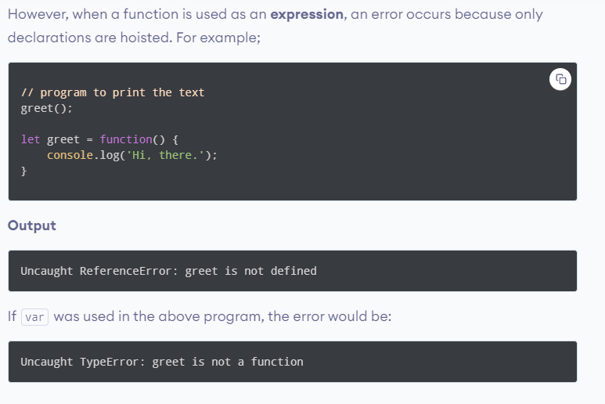

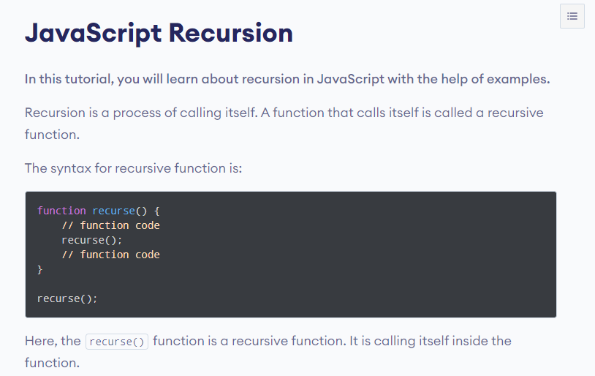

# **JavaScript Objects**

1. A JavaScript object is an entity having state and behaviour (properties and method). For example: car, pen, bike, chair, glass, keyboard, monitor etc.
2. **JavaScript is an object-based language. Everything is an object in JavaScript.**
3. **JavaScript is template based not class based.** Here, we don't create class to get the object. But we direct create objects.

## Creating Objects in JavaScript

1. By object literal.
2. By creating instance of Object directly (using new keyword)
3. By using an object constructor (using new keyword)

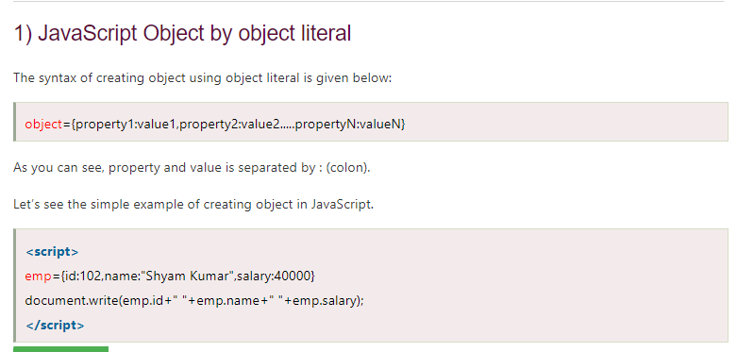

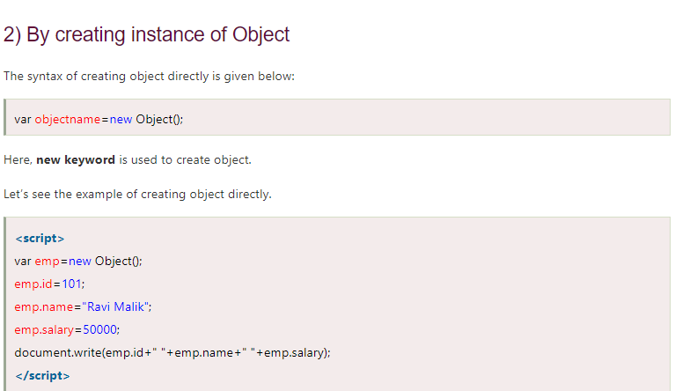

## By using an Object constructor

## You need to create function with arguments. Each argument value can be assigned in the current object by using this keyword.

## This keyword refers to the current object.Text Description automatically generatedGraphical user interface, application, Teams Description automatically generatedGraphical user interface, application Description automatically generated

## Accessing Object Properties

**Adding a Method to a JavaScript Object**

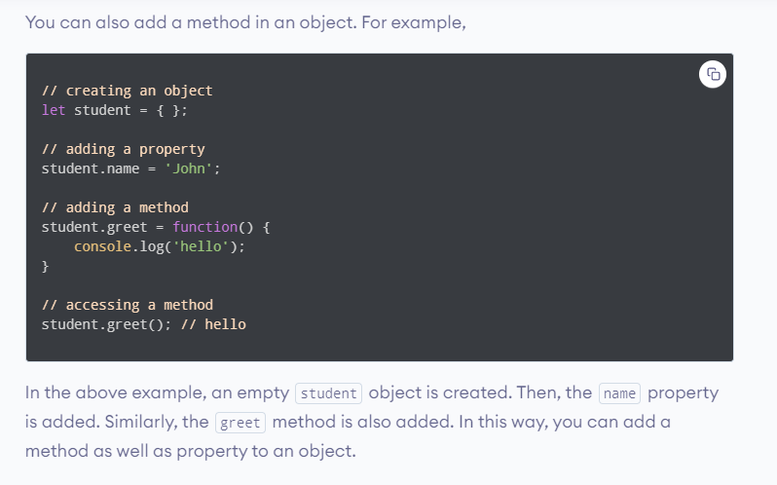

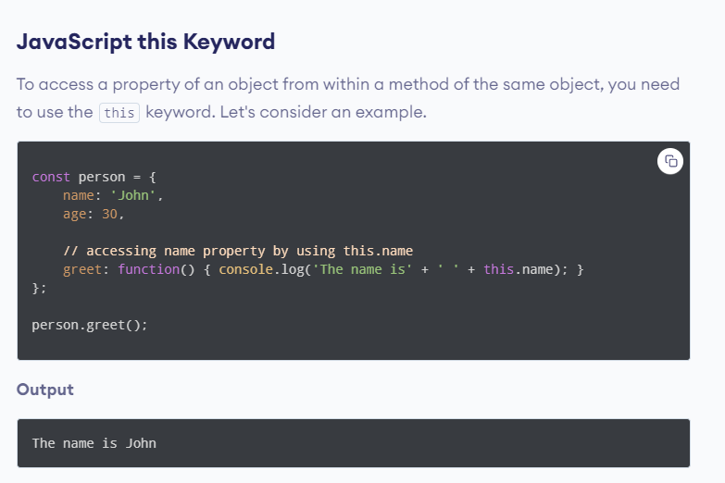

1. In the above example, a person object is created. It contains properties (name and age) and a method greet.
2. In the method greet, while accessing a property of an object, this keyword is used.
3. In order to access the **properties** of an object, this keyword is used following by . and **key**.

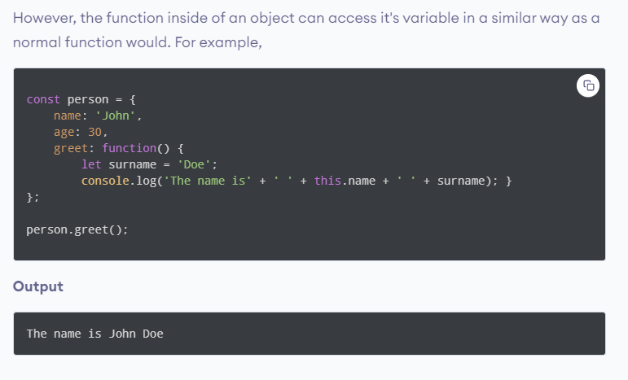

# **JavaScript Constructor Function**

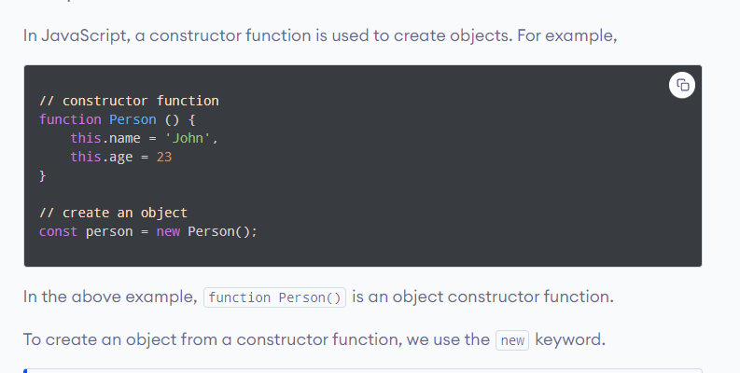

**Create Multiple Objects with Constructor Function** In JavaScript, you can create multiple objects from a constructor function.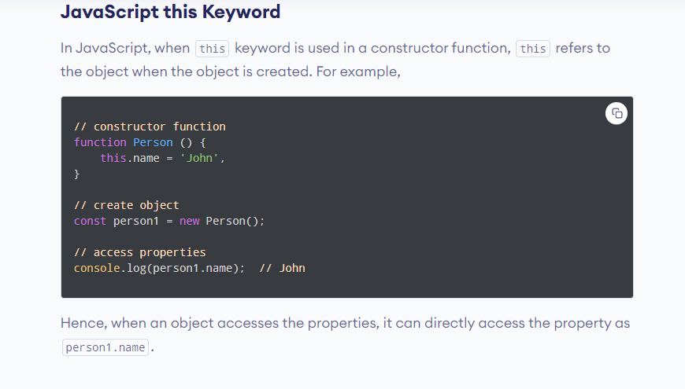

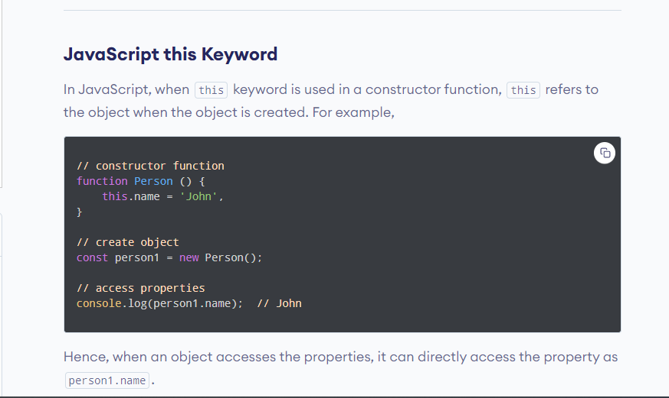

## JavaScript Getter and Setter

In JavaScript, there are two kinds of object properties:

1**)Data properties 2) Accessor properties**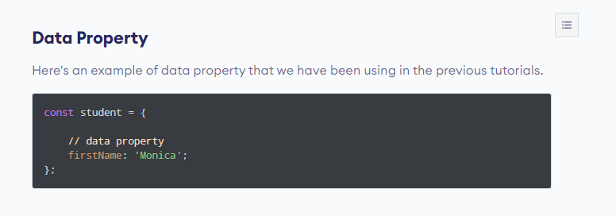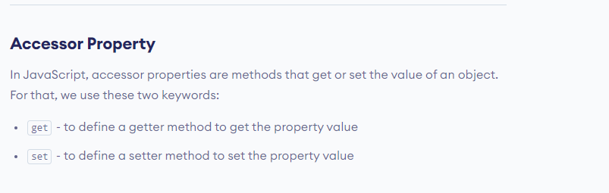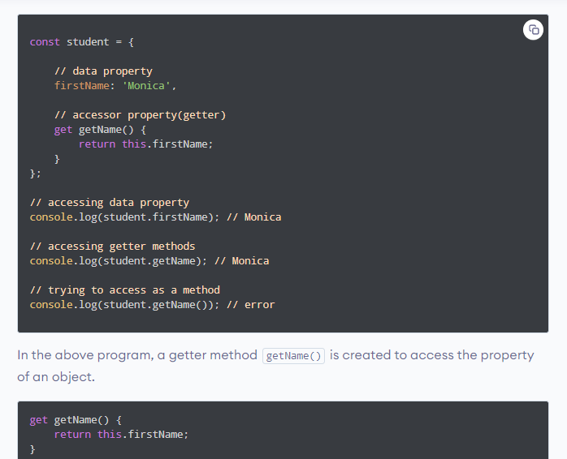

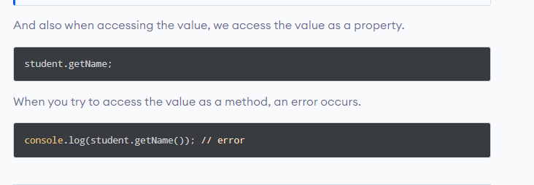

**JavaScript Setter**

In JavaScript, setter methods are used to change the values of an object. For example,

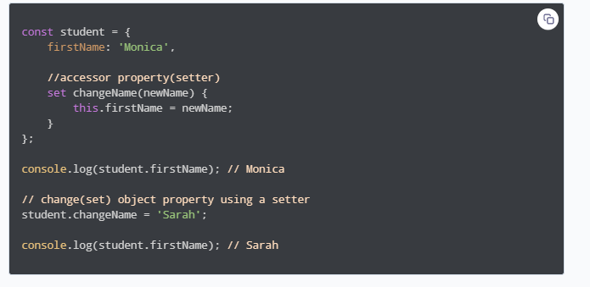

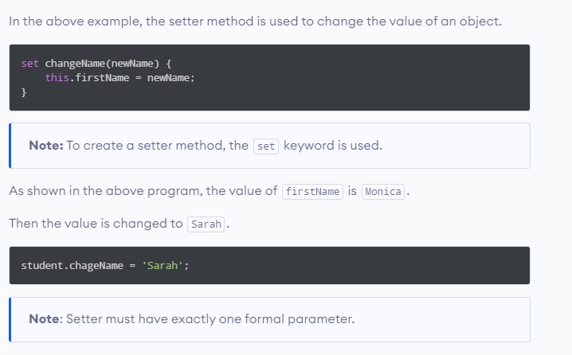

**JavaScript Object.defineProperty()**

In JavaScript, you can also use **Object.defineProperty()** method to add getters and setters. For example,

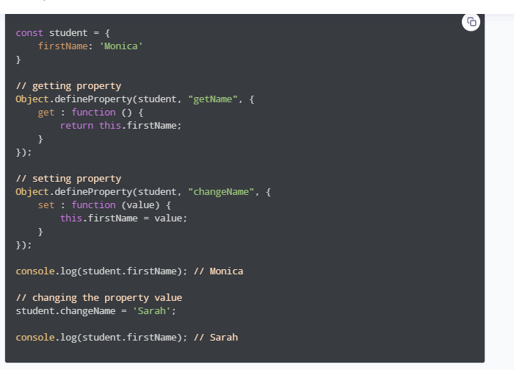

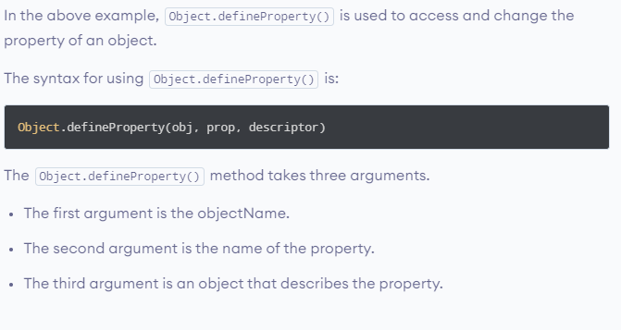

**JavaScript Prototype**

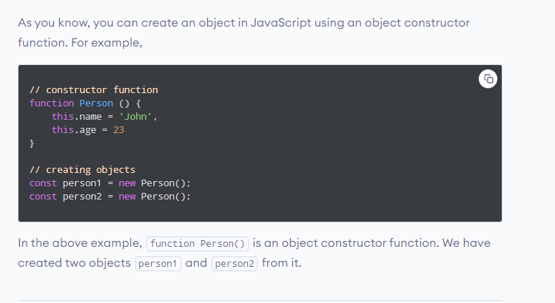

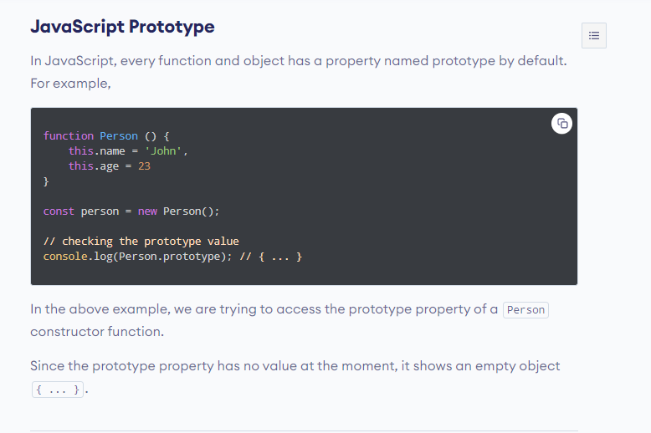

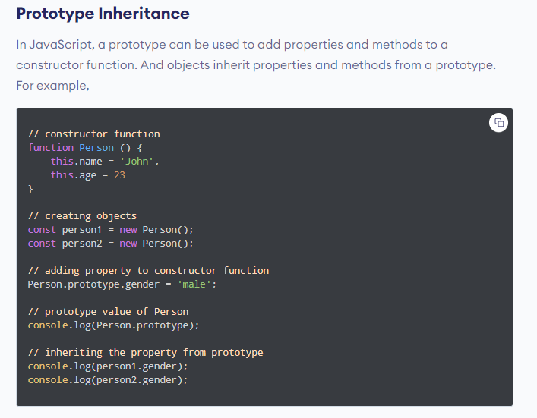

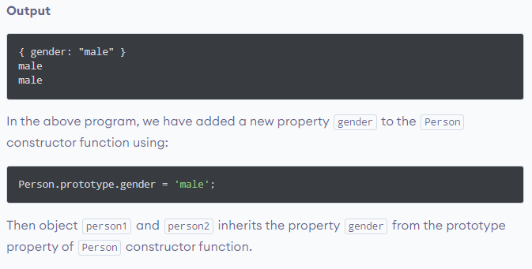

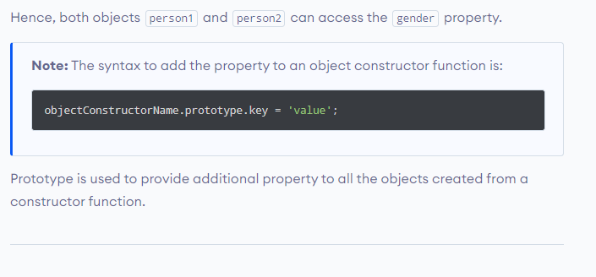

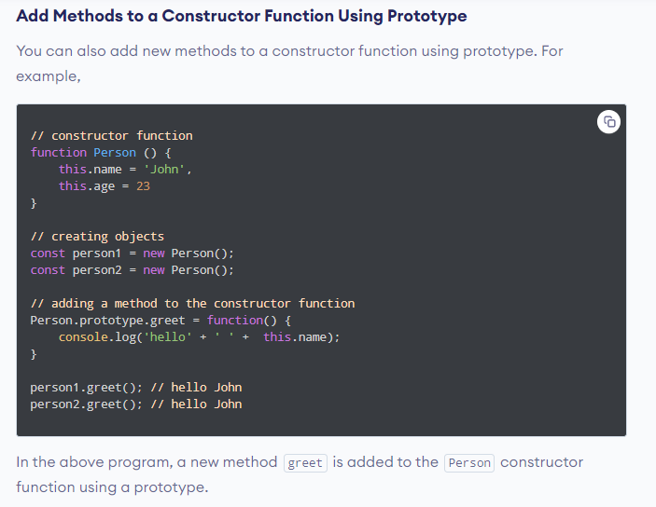

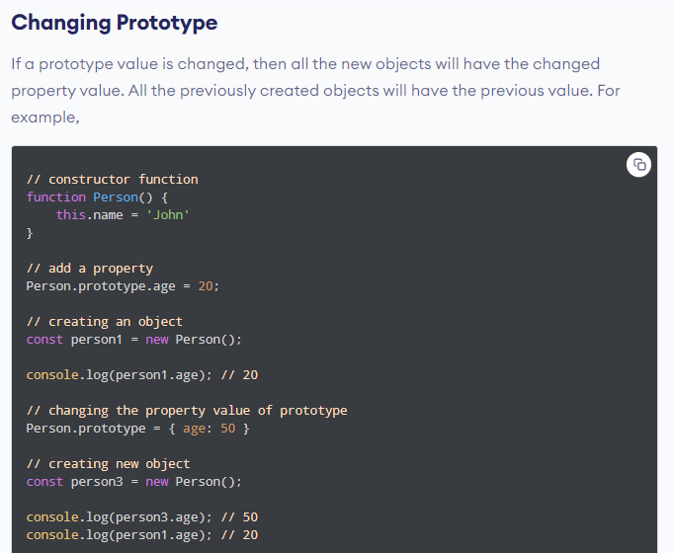

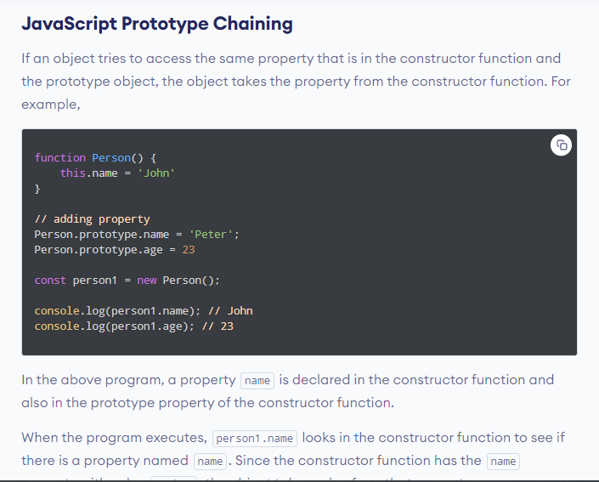

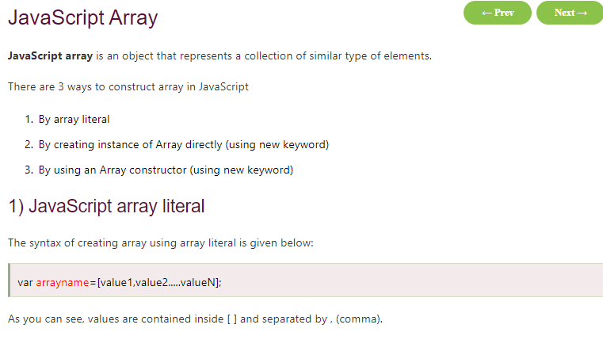

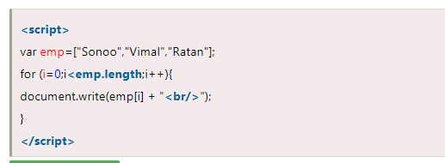

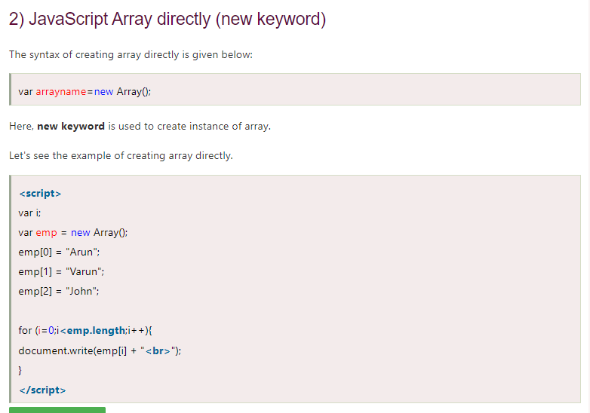

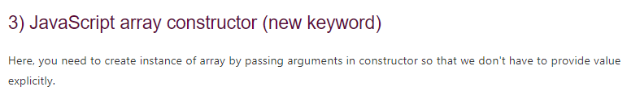

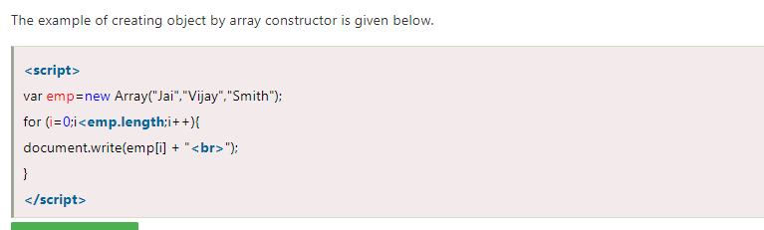

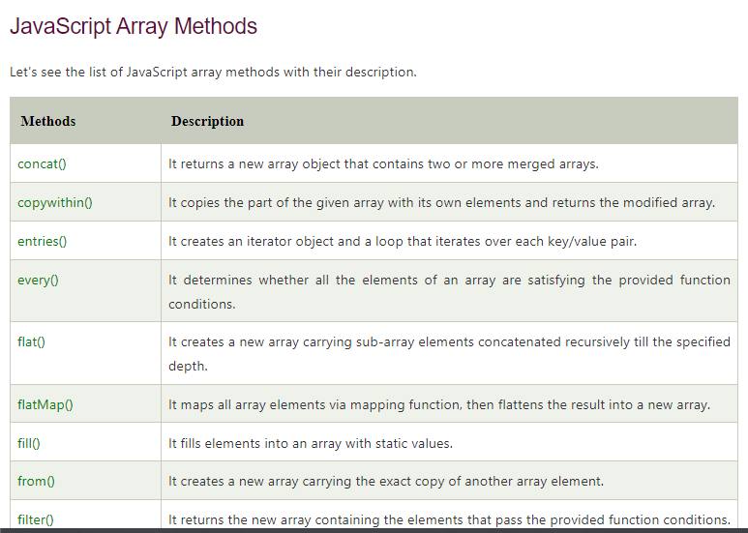

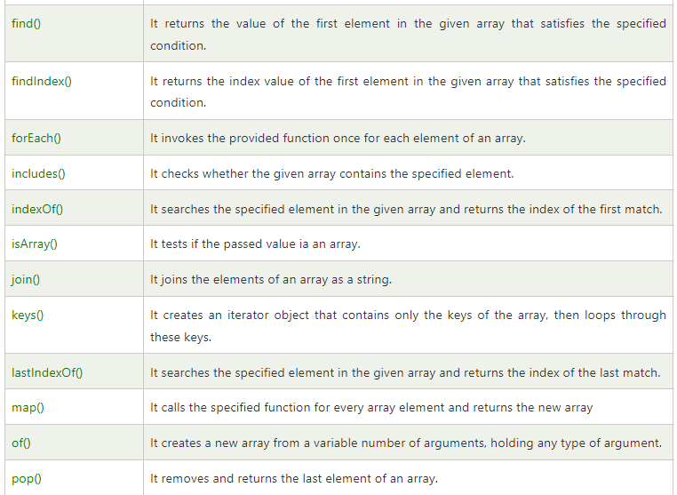

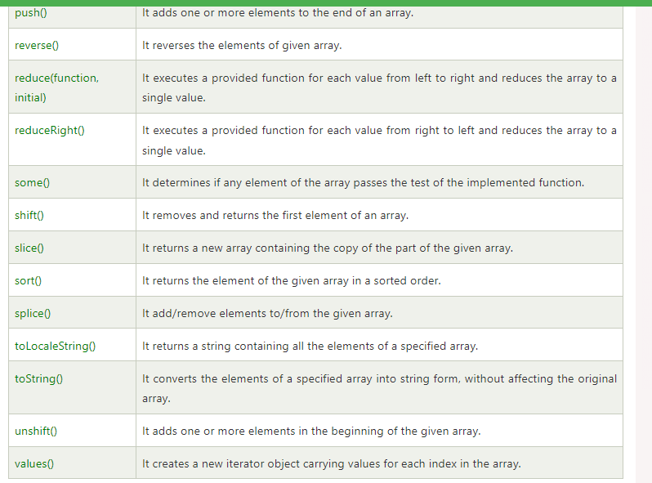

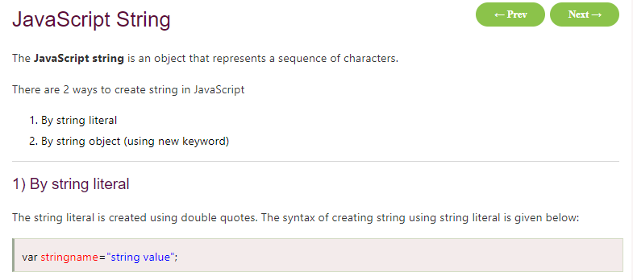

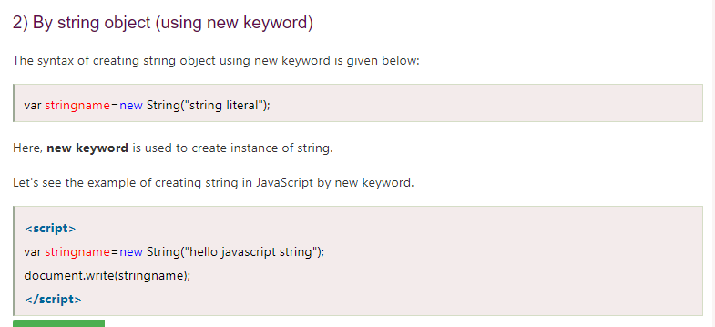

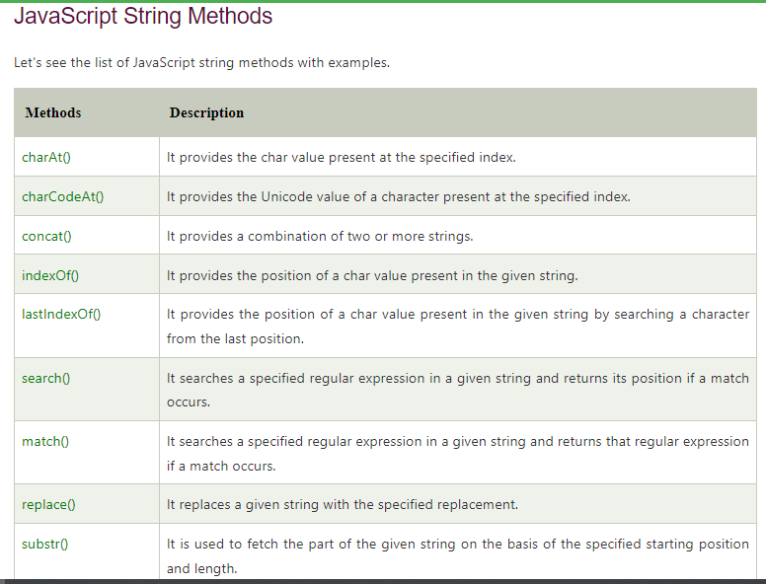

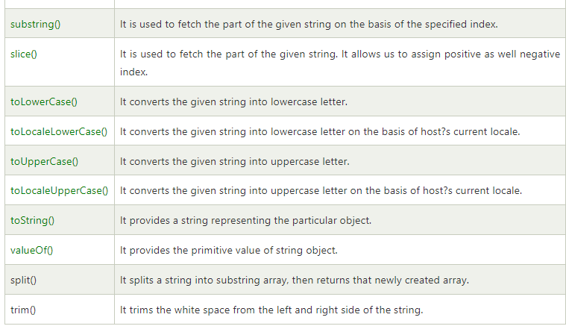

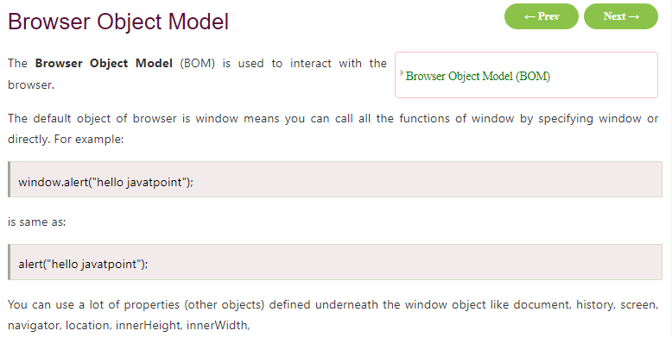

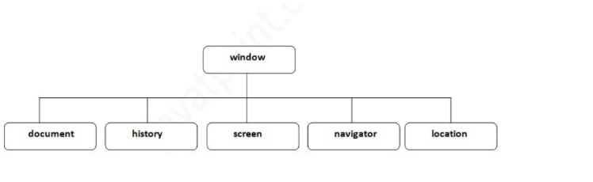

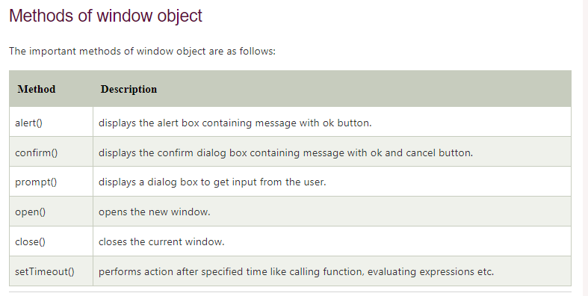

## Objects are Variables

JavaScript variables can contain single values:

let person = "John Doe";

JavaScript variables can also contain many values.

Objects are variables too. But objects can contain many values.

Object values are written as **name : value** pairs (name and value separated by a colon).

let person = {firstName:"John", lastName:"Doe", age:50, eyeColor:"blue"};

A JavaScript object is a collection of **named values**

It is a common practice to declare objects with the **const**keyword.

With JavaScript, you can define and create your own objects.

**There are different ways to create new objects:**

* Create a single object, using an object literal.
* Create a single object, with the keyword new.
* Define an object constructor, and then create objects of the constructed type.
* Create an object using Object.create().

const person = {  
  firstName: "John",  
  lastName: "Doe",  
  age: 50,  
  eyeColor: "blue"  
};

## Using the JavaScript Keyword new

const person = new Object();  
person.firstName = "John";  
person.lastName = "Doe";  
person.age = 50;  
person.eyeColor = "blue";

## JavaScript Objects are Mutable

Objects are mutable: **They are addressed by reference, not by value.**

If person is an object, the following statement will not create a copy of person:

const x = person;  // Will not create a copy of person.

The object x is **not a copy** of person. It **is** person. Both x and person are the same object.

Any changes to x will also change person, because x and person are the same object.

const person = {  
  firstName:"John",  
  lastName:"Doe",  
  age:50, eyeColor:"blue"  
}  
  
const x = person;  
x.age = 10;      // Will change both x.age and person.age

## JavaScript Properties

1. Properties are the values associated with a JavaScript object.
2. A JavaScript object is a collection of unordered properties.
3. Properties can usually be changed, added, and deleted, but some are read only.

## JavaScript for...in Loop

The JavaScript for...in statement loops through the properties of an object.

### **Syntax**

for (let *variable* in *object*) {  
*// code to be executed*  
}

const person = {  
  fname:" John",  
  lname:" Doe",  
  age: 25  
};  
  
for (let x in person) {  
  txt += person[x];  
}

## Adding New Properties

You can add new properties to an existing object by simply giving it a value.

person.nationality = "English";

## Deleting Properties

The delete keyword deletes a property from an object:

const person = {  
  firstName: "John",  
  lastName: "Doe",  
  age: 50,  
  eyeColor: "blue"  
}; delete person.age;

const person = {  
  firstName: "John",  
  lastName: "Doe",  
  age: 50,  
  eyeColor: "blue"  
}; delete person["age"];

1. The delete keyword deletes both the value of the property and the property itself.
2. After deletion, the property cannot be used before it is added back again.
3. The delete operator is designed to be used on object properties. It has no effect on variables or functions.

## Nested Objects

Values in an object can be another object:

myObj = {  
  name:"John",  
  age:30,  
  cars: {  
    car1:"Ford",  
    car2:"BMW",  
    car3:"Fiat"  
  }  
}

You can access nested objects using the dot notation or the bracket notation:

myObj.cars.car2;

myObj.cars["car2"];

myObj["cars"]["car2"];

**SPECFLOW**

Cucumber is a testing framework which supports Behaviour Driven Development (BDD). It lets us define application behaviour in plain meaningful English text using a simple grammar defined by a language called Gherkin.

The main feature of the Cucumber is that it focuses on Acceptance testing. It made it easy for anyone in the team to read and write test and with this feature it brings business users into the test process, helping teams to explore and understand requirements.

Specflow SetUp

**Git Tutorials**

<https://git-scm.com/downloads>

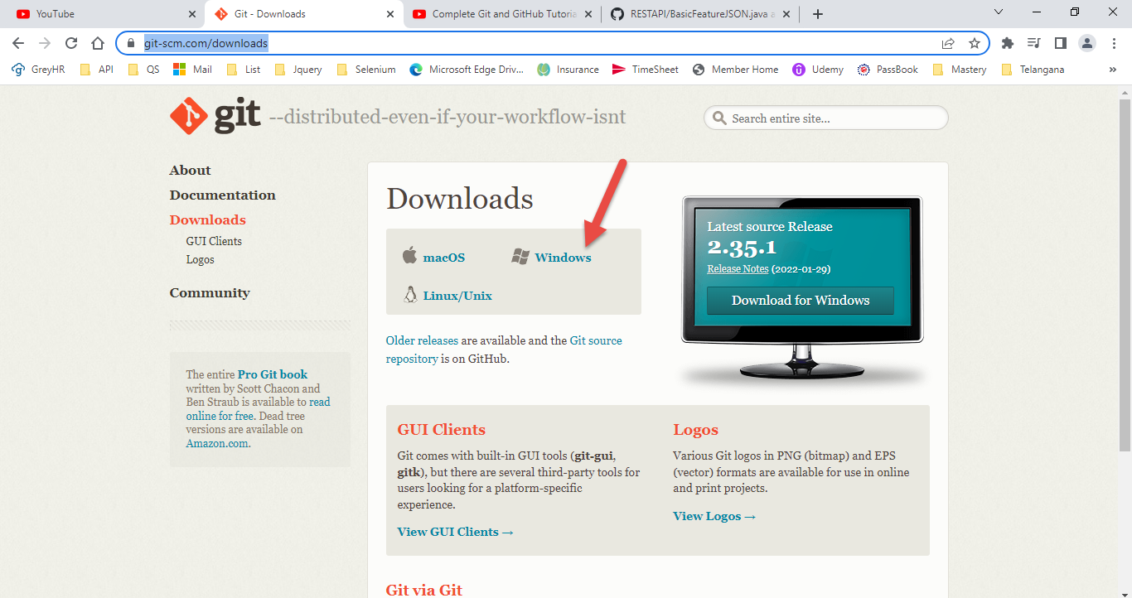

ls 🡺 To get the list.

ls -a 🡺 To get the hidden items.

**touch GitTutorial.txt** 🡺 touch linux command to create the file

**How to check the files are changed/modified**

**Git status**

**How to place file in GitHub**

**Git add .** ( . means all files)

**How to commit**

**Git commit -m “GitTutorial.txt file added” Note: -m means message**

**Git status**

**Cypress Automation**

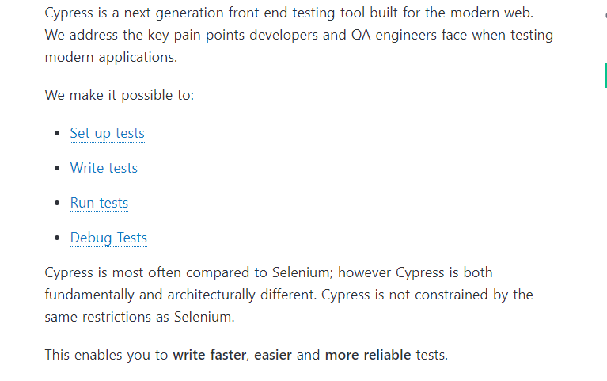

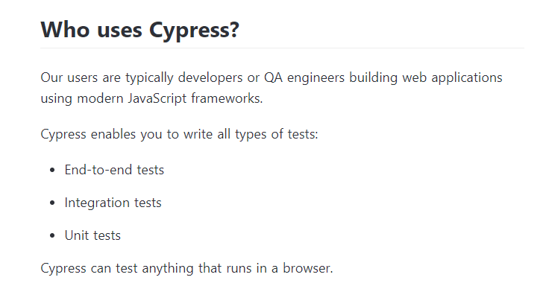

Cypress comes fully baked, batteries included. Here is a list of things it can do that no other testing framework can:

1. **Time Travel:** Cypress takes snapshots as your tests run. Hover over commands in the [Command Log](https://docs.cypress.io/guides/core-concepts/test-runner#Command-Log) to see exactly what happened at each step.
2. **Debuggability:** Stop guessing why your tests are failing. [Debug directly](https://docs.cypress.io/guides/guides/debugging) from familiar tools like Developer Tools. Our readable errors and stack traces make debugging lightning fast.
3. **Automatic Waiting:** Never add waits or sleeps to your tests. Cypress [automatically waits](https://docs.cypress.io/guides/core-concepts/introduction-to-cypress#Cypress-is-Not-Like-jQuery) for commands and assertions before moving on. No more async hell.
4. **Spies, Stubs, and Clocks:** Verify and [control the behaviour](https://docs.cypress.io/guides/guides/stubs-spies-and-clocks) of functions, server responses, or timers. The same functionality you love from unit testing is right at your fingertips.
5. **Network Traffic Control:** Easily [control, stub, and test edge cases](https://docs.cypress.io/guides/guides/network-requests) without involving your server. You can stub network traffic however you like.
6. **Consistent Results:** Our architecture doesn’t use Selenium or WebDriver. Say hello to fast, consistent and reliable tests that are flake-free.
7. **Screenshots and Videos:** View screenshots taken automatically on failure, or videos of your entire test suite when run from the CLI.
8. **Cross browser Testing:** Run tests within Firefox and Chrome-family browsers (including Edge and Electron) locally and [optimally in a Continuous Integration pipeline](https://docs.cypress.io/guides/guides/cross-browser-testing).
9. With help of Cypress End to End test , integration and unit tests are easy to write and debug.

[***Introduction and Architecture***](https://www.toolsqa.com/cypress/what-is-cypress/):

1. Cypress is a next-generation front end testing tool constructed for modern web applications.
2. Most testing tools (*like Selenium*) operate by running outside of the browser and executing remote commands across the network.
3. But the Cypress engine directly operates inside the browser.
4. It enables Cypress to listen and modify the browser behaviour at run time by manipulating DOM and altering Network requests and responses on the fly.

[***Node Installation and Setup***](https://www.toolsqa.com/blogs/install-node/):

1. Node.js is a server-side runtime environment that is built on top of ***Chrome’s V8 JavaScript engine***.
2. It is open-source, totally free of cost, and millions of developers use it across the globe. It is a runtime environment.
3. Additionally, it includes everything you need to run a program written in [**JavaScript**](https://www.toolsqa.com/javascript/javascript-tutorial/). You are required to ***Install Node JS*** framework before start building your Node.js application.

[***Cypress Installation and Project Setup***](https://www.toolsqa.com/cypress/install-cypress/): Cypress can be downloaded directly from the Cypress CDN (***https://download.cypress.io/desktop***). The direct download will always download the latest version for your platform. It will download a zip file, which can be extracted by the user. and it can also be Downloaded using npm. It also explains how to set up a basic project with package. json and cypress installed with it. Cypress Tutorial

[***Cypress Test***](https://www.toolsqa.com/cypress/cypress-test/): The basis of ***Cypress*** is [***Mocha***](https://docs.cypress.io/guides/references/bundled-tools.html#Mocha) and [***Chai***](https://docs.cypress.io/guides/references/bundled-tools.html#Chai) (***one of the famous assertion libraries in JavaScript***), and it adheres to the same style of writing test cases as will be used by any other JavaScript-based framework. We will use the default folder structure provided by Cypress to manage and write our test cases in the Cypress Workshop project and will learn how to operate Cypress with its basic test case.

[***Cypress Test Runner***](https://www.toolsqa.com/cypress/cypress-test-runner/): ***Cypress*** has a unique test runner that allows us to see commands as they execute. Additionally, it also shows the real-time run of the application under test. We will complete the development of our first automated test case using Cypress and we will be executing that test case with the help of the ***Cypress Test Runner***. We will also learn about different components Test Runner has and how we can operate that using the terminal.

[***Locator in Cypress***](https://www.toolsqa.com/cypress/cypress-locators/): Locators are the backbone for all automation frameworks for ***Web-based applications***. Additionally, a locator is an identifier that tells any automation tool that ***GUI elements*** ( say Text Box, Buttons, Check Boxes, etc.); it needs to operate. Following the same concepts, ***Cypress*** also uses the locators to identify the UI element for the application under test. Cypress Tutorial

[***Get and Find Command***](https://www.toolsqa.com/cypress/cypress-get-command/): ***Cypress*** provides two essential methods

1. **get()**
2. **find()**

to search for the web elements based on the locators. The results for both of these methods are almost identical. But each has its importance and place of implementation. Subsequently, in this article, we will be covering aspects detailing where get() and find() methods that can be used during the web test automation using Cypress.

[***Cypress Asynchronous Nature***](https://www.toolsqa.com/cypress/cypress-asynchronous-nature/): ***Asynchronous programming*** is a means of ***parallel programming*** whereby, a unit of work runs separately from the main application thread. Additionally, it notifies the calling thread of its completion, failure, or progress. These types of programs are “***non-blocking***.” When you execute something synchronously, you wait for it to finish before moving on to another task.  On the other hand, when you run something asynchronously, you can move on to another task before it ends.

[***Handle Non-Cypress async promises***](https://www.toolsqa.com/cypress/handle-non-cypress-async-promises/): We know that ***Cypress*** internally handles the ***asynchronous behaviour*** of its commands and still provides a seamless, sequential, and consistent execution of the test cases. Still, there can be situations, such as combining the Cypress commands with third-party libraries or JavaScript commands, where we have to handle the async promises or commands explicitly. We will learn that how Cypress can help in managing these Non-Cypress ***Async Promises*** explicitly

[***Cypress Assertions***](https://www.toolsqa.com/cypress/cypress-assertions/): ***Assertions*** are the validation steps that determine whether the specified step of the automated test case succeeded or not. In actual, Assertions validates the desired state of your elements, objects, or application under test. Eg. assertions enable you to validate scenarios such as whether an element is visible or has a particular attribute, CSS class, or state. It is always a recommended practice that all the automated test cases should have assertion steps, otherwise, it will not be feasible to validate whether the application reached the expected state or not. Cypress Tutorial

[***Interacting with DOM Elements***](https://www.toolsqa.com/cypress/cypress-commands-ui-interaction-commands/): Each ***UI automation tool*** provides some ***APIs or methods*** to interact with the web elements, so the designated operation can be performed on the UI element. In addition to this, these methods also assist in the needed user journey simulation. Continuing the same practice, ***Cypress*** also provides multiple commands which can simulate the user's interaction with the application.

**CYPRESS**

1. It is built on [***Node.js***](https://en.wikipedia.org/wiki/Node.js) and comes packaged as an npm module. As its basis is Node.js, it uses [***JavaScript***](https://www.toolsqa.com/javascript/what-is-javascript/) for writing tests.
2. It also [***bundles with jQuery***](https://docs.cypress.io/guides/references/bundled-tools.html#Other-Library-Utilities) *(JavaScript Library)* and inherits many of jQuery methods for UI components identification and simplify HTML DOM tree traversal and manipulation, as well as event handling, CSS animation, and Ajax.

### **What makes Cypress a unique tool?**

There is multiple uniqueness, which makes Cypress one of the quickly adaptable choices for Web automation. Few of them are:

* It delivers fast, consistent, and reliable test execution compared to other automation tools because of its architectural design.
* Flake Resistant - Cypress **automatically waits** for commands and assertions before moving on. No more async issues.
* Ability to test edge test cases by mocking the server response. (Network Requests)
* Debuggability - It takes snapshots as your tests run. We can hover over each command in the **Command Log** to accurately see what happened at each step.
* View videos of the execution of your entire tests when running from the Cypress Dashboard.

### **What are the components of Cypress?**

It has two main components that come by default in its installation –

1. **Cypress Test Runner**
2. **Cypress Dashboard**

One of them is used as a runner to run our Cypress test cases on the local machine, and the other tracks our runs and status from our Automation Suite.

***Test Runner:*** It runs tests in a unique interactive runner that allows you to see commands as they execute while also viewing the application under test. Below are the key subcomponents of the test runner that we should pay focus while executing our test cases.

***Dashboard Service:*** The ***Cypress Dashboard*** is a service that provides you access to recorded tests - typically when running Cypress tests from your [***CI provider***](https://docs.cypress.io/guides/guides/continuous-integration.html). The Dashboard provides you with insight into what happened when your tests ran.

### ***What are the unique features provided by Cypress?***

*It provides multiple features which make the life of a test developer very easy:*

1. ***Time Travel:***It can take snapshots of the application when the tests are running. Then as a test developer, we can hover over each command in the Test Runner panel to see what happened at each step.
2. ***Debuggability:***It enables debugging of the tests directly from the familiar tools like Developer Tools. The readable errors and stack traces make debugging lightning fast.
3. ***Automatic Waiting:***With Cypress, there is no need to put explicit waits or sleeps to your tests. It automatically waits for commands and assertions before proceeding.
4. ***Spies, Stubs, and Clocks:***Similar to unit test cases, you can verify and control the behaviour of functions, server responses, or timers at run time using the spies and stubs provided by Cypress.
5. ***Network Traffic Control:***Using Cypress, you can stub network traffic as you like and customize the response of your API calls as per your need.
6. ***Consistent Results:***As Cypress doesn't use Selenium or WebDriver and executes tests directly in the browser, it aids for fast, consistent, and reliable tests that are flake-free.
7. ***Screenshots and Videos:****\** It takes screenshots automatically on failure, or record videos of your entire test suite when running from the CLI.*

The basis of the Cypress Test is [Mocha](https://docs.cypress.io/guides/references/bundled-tools.html#Mocha) and [Chai](https://docs.cypress.io/guides/references/bundled-tools.html#Chai) (one of the famous assertion libraries in JavaScript), and it adheres to the same style of writing test cases as will be used by any other JavaScript-based framework.

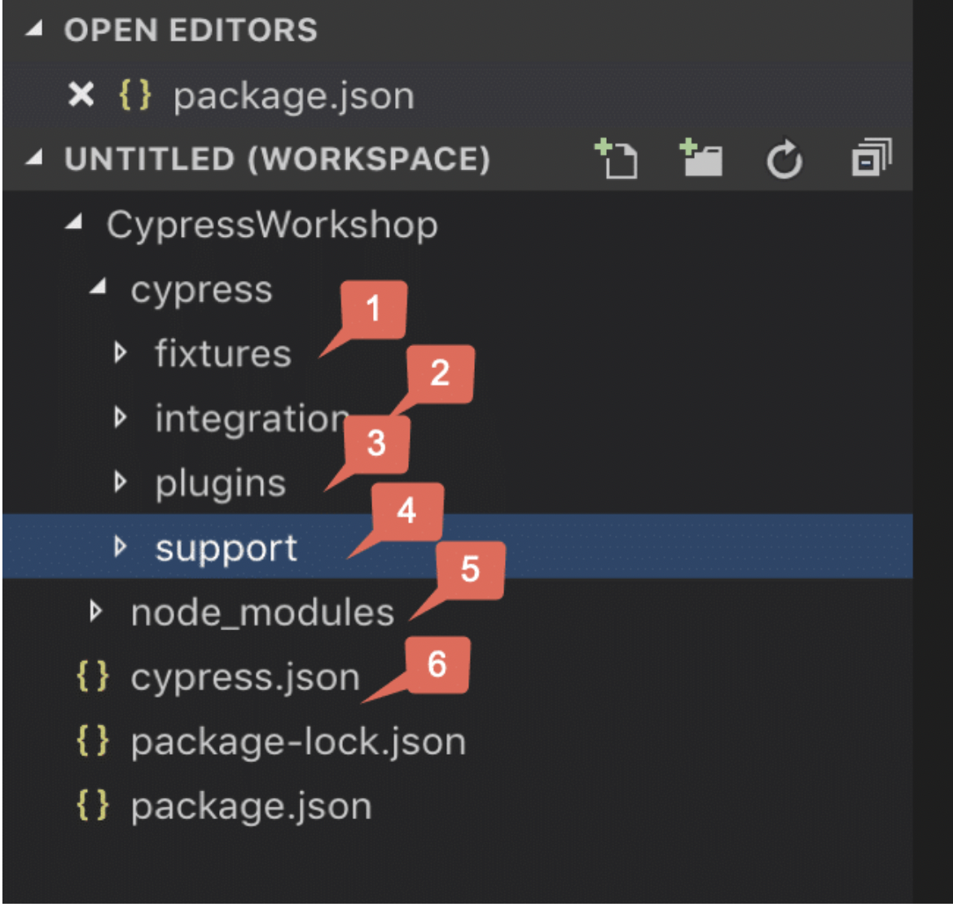

**Cypress has created a default folder hierarchy** when it opens the first time. Below are the details for each of these folders/files created by Cypress:

1. **Fixtures** are external pieces of static data that can be used by your tests. We should not hard code data in the test case. It should drive from an external source like CSV, HTML, or JSON. They will be majorly used with the **cy.fixture()** command when you need to stub the network calls.
2. **The integration** folder provides a place that writes out test cases. It also provides an "**examples**" directory, which contains the default test cases provided by Cypress and can be used to add new test cases also. We can also create our folder under the integration directory and add out test cases under that.
3. **Plugins** contain the plugins or listeners. By default, Cypress will automatically include the plugins file "**cypress/plugins/index.js**" **before** every test it runs. You can programmatically alter the resolved configuration and environment variables using plugins, Eg. **If we have to inject customized options to browsers like accepting the certificate, or do any activity on test case pass or fail or to handle any other events like handling screenshots.** They enable you to extend or modify the existing behaviour of Cypress.
4. **Support** **writes customized commands or reusable methods that are available for usage in all of your spec/test files.** This file runs before every single spec file. That's why you don’t have to import this file in every single one of your spec files.  The "**support**" file is a great place to put reusable behaviour such as Custom Commands or global overrides that you want to be applied and available to all of your spec files.
5. **Node_Modules** in the default project structure is the heart of the cypress project. **All the node packages will be installed in the node_modules directory and will be available in all the test files**. So, in a nutshell, this is the folder where NPM installs all the project dependencies.
6. **Cypress.json** **is used to store different configurations. E.g., timeout, base URL, test files, or any other configuration that we want to override for tweaking the behaviour of Cypress.** We can also manage the customized folder structure because it is part of by default Cypress Configurations.

## What are the basic Constructs of Cypress:

Cypress has adopted Mocha’s syntax for the development of test cases, and it uses all the fundamental harness that Mocha provides. Below are a few of the main constructs which we majorly use in Cypress test development:

* ***describe()***: It is is simply a way to group our tests. It takes two arguments, the first is the name of the test group, and the second is a callback function.
* ***context()***: It is is just an alias for describe().
* ***it()***: We use it for an individual test case. It takes two arguments, a string explaining what the test should do, and a callback function which contains our actual test.
* ***before()***:  It runs once before all tests in the block.
* ***after()***: It runs once after all tests in the block.
* ***beforeEach()***: It runs before each test in the block.
* ***afterEach()***: It runs after each test in the block.
* ***.only()***: To run a specified suite or test, append "***.only***" to the function.
* ***.skip()***: To skip a specified suite or test, append "***.skip()***" to the function.

**Steps to Install and run Cypress**

[npm init](https://docs.npmjs.com/cli/init)

npm install cypress --save-dev

**To Open Cypress**

cd node_modules/.bin

cypress open

**TestNG**

* 1. It is an open-source automated testing framework;
  2. TestNG eliminates most of the limitations of the older framework and gives the developer the ability to write more flexible and powerful tests with help of easy annotations, grouping, sequencing & parametrizing.

### **What are the Benefits of TestNG?**

There are a number of benefits but from Selenium perspective, major advantages of TestNG are :

1. It gives the ability to produce **HTML Reports** of execution
2. **Annotations** made testers life easy
3. Test cases can be **Grouped & Prioritized** more easily
4. **Parallel** testing is possible
5. Generates **Logs**
6. Data **Parameterization** is possible

### **What are the different Annotations are present in TestNG?**

1. ***@BeforeSuite***: The annotated method will be run before all tests in this suite have run.
2. ***@AfterSuite***: The annotated method will be run after all tests in this suite have run.
3. ***@BeforeTest***: The annotated method will be run before any test method belonging to the classes inside the tag is run.
4. **@AfterTest**: The annotated method will be run after all the test methods belonging to the classes inside the tag have run.
5. **@BeforeGroups**: The list of groups that this configuration method will run before. This method is guaranteed to run shortly before the first test method that belongs to any of these groups is invoked.
6. **@AfterGroups**: The list of groups that this configuration method will run after. This method is guaranteed to run shortly after the last test method that belongs to any of these groups is invoked.
7. **@BeforeClass**: The annotated method will be run before the first test method in the current class is invoked.
8. **@AfterClass**: The annotated method will be run after all the test methods in the current class have been run.
9. **@BeforeMethod**: The annotated method will be run before each test method.
10. **@AfterMethod**: The annotated method will be run after each test method.
11. **@Test**: The annotated method is a part of a test case.

**Note**: This process of running multiple tests at once is called a test suite, and performing it in TestNG is called ***TestNG Test Suites***.

The collection of [***TestNG Tests***](https://www.toolsqa.com/testng/testng-test/) together is called a ***Test Suite***. A test suite can run multiple tests at once by executing the test suite. Additionally, these test cases can be dependent on each other or may have to be executed in a specific order independently.

**Note**: It is important to remember that the TestNG does not let us define the test suites inside the test code or the main testing source code. Hence, we need to create a TestNG XML file for the same and execute this file.

## How To Create and Run TestNG Test Suite?

Running a test suite in TestNG requires us to create a TestNG XML file and executing it to achieve the goals. Through this TestNG XML file only, we will be able to create and handle multiple test classes in the TestNG framework. In addition to this, the XML file will be the target file where you will configure your test run, set test dependency, include or exclude any test, method, class or package and set priority, etc.

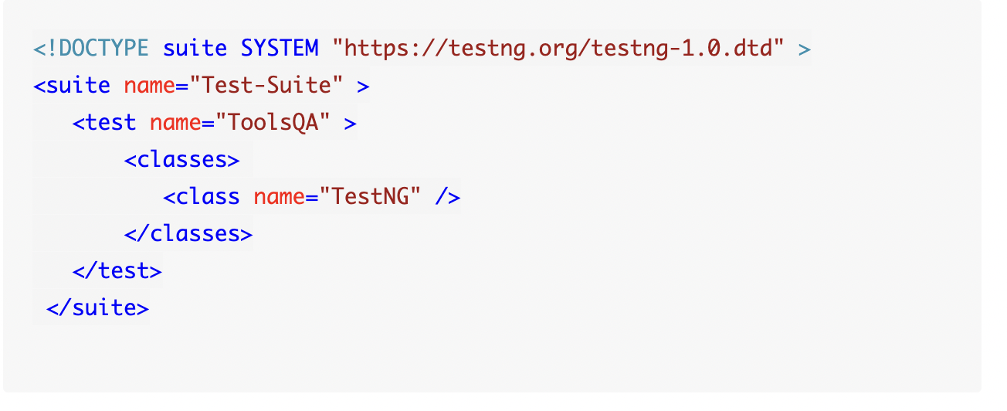

## TestNG Annotations?

TestNG annotations are the code that is written inside your source test code logic to control the flow of the execution of tests. It is essential to annotate your methods in TestNG to run the tests. [***TestNG***](https://testng.org/doc/) will ignore the method which does not contain an annotation since it won't know when to execute this method.

### **Hierarchy In TestNG Annotations**

1. @BeforeSuite
2. @BeforeTest
3. @BeforeClass
4. @BeforeMethod
5. @Test
6. @AfterMethod
7. @AfterClass
8. @AfterTest
9. @AfterSuite

### **Test Priority in TestNG**

Remember that priority check happens after the annotation check by TestNG. So the TestNG annotation hierarchy is followed first and then priority-based execution. The larger the priority number, the lower is its priority. So a method with priority 1 will run after the test with priority 0.

#### **TestNG Test Case With and Without Priority**

This section will explain how the TestNG will execute the test cases with and without the priority option. For this, I will add two more methods to our previous code.

import org.testng.annotations.Test;

public class TestNG {

@Test (priority = 1)

public void b_method() {

System.out.println("This is B method");

}

@Test (priority = 1)

public void a method() {

System.out.println("This is A method");

}

@Test

public void d_method() {

System.out.println("This is D Method");

}

@Test

public void c_method() {

System.out.println("This is C Method");

}

}

Execute the following code and see the output:

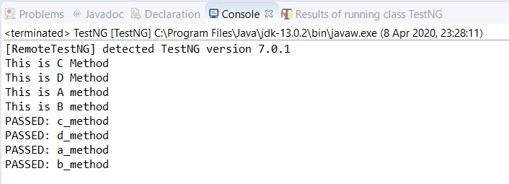

**Note** : The **test cases without the priority attribute are given the "priority" and executed before the methods with priority**. Also, they run alphabetically.

## What Are TestNG Groups?

Groups in TestNG denotes the process of grouping different tests together into a straightforward group and running these tests together by just running the group in a single command.

Remember that the groups defined in <test> tag apply to only that particular test tag, but the groups defined in <suite> tag apply to all the <test> tags in the XML file.

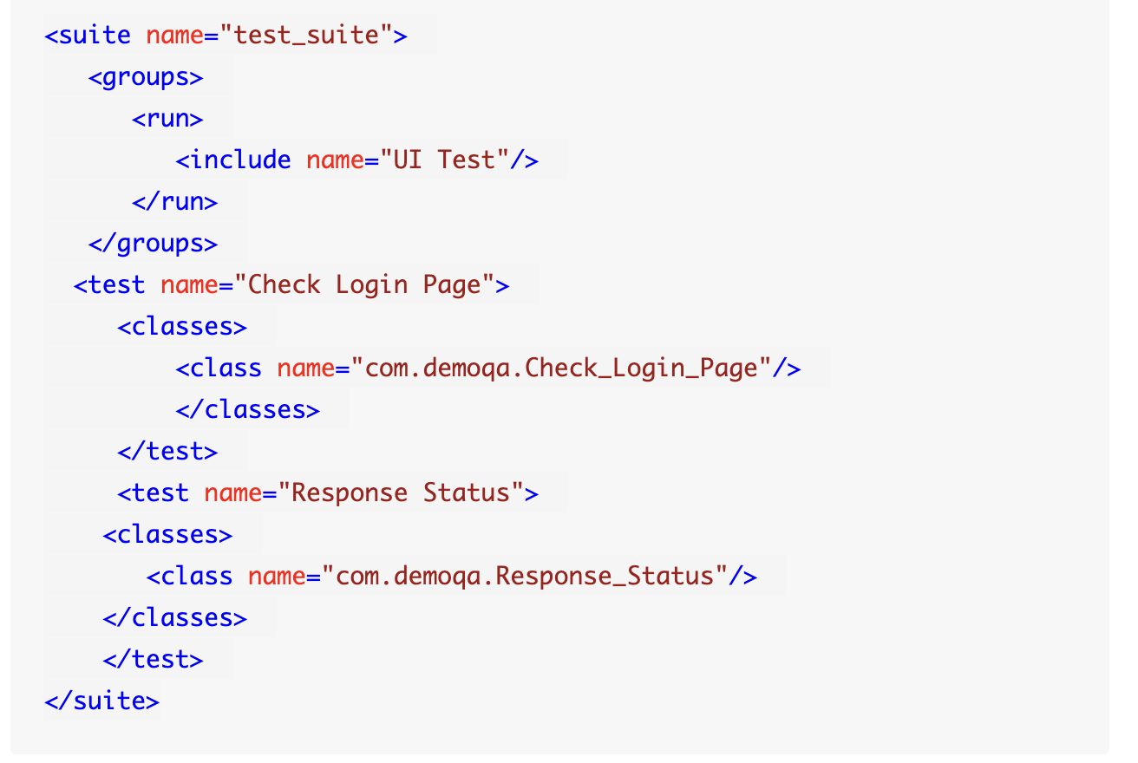

Since the "***groups***" is inside the suite tag, it will run all the tests in the XML file.

**Second One**

<suite name="test_suite">

<test name="Check Login Page">

<groups>

<run>

<include name="UI Test"/>

</run>

</groups>

<classes>

<class name="com.demoqa.Check_Login_Page"/>

</classes>

</test>

<test name="Response Status">

<classes>

<class name="com.demoqa.Response_Status"/>

</classes>

</test>

</suite>

**Note:** Now the groups will work only inside the test tag with the name Check Login Page.

### **How To Create Groups?**

import org.openqa.selenium.By;

import org.openqa.selenium.WebDriver;

import org.openqa.selenium.chrome.ChromeDriver;

import org.testng.annotations.Test;

import org.testng.Assert;

public class TestNG {

WebDriver driver;

// Saving the expected title of the Webpage

String title = "ToolsQA - Demo Website For Automation";

@Test

public void starting_point(){

System.out.println("This is the starting point of the test");

//Initialize Chrome Driver

//driver.manage().timeouts().implicitlyWait(1,TimeUnit.SECONDS);

driver = new ChromeDriver();

driver.get("https://demoqa.com/");

}

@Test(groups = { "demo" })

public void checkTitle() {

String testTitle = "Free QA Automation Tools For Everyone";

String originalTitle = driver.getTitle();

Assert.assertEquals(originalTitle, testTitle);

}

@Test(groups = { "demo" })

public void click_element() {

driver.findElement(By.xpath("//*[@id=\"sidebar\"]/aside[1]/ul/li[1]/a")).click();

System.out.println("Home Page heading is displayed");

}

}

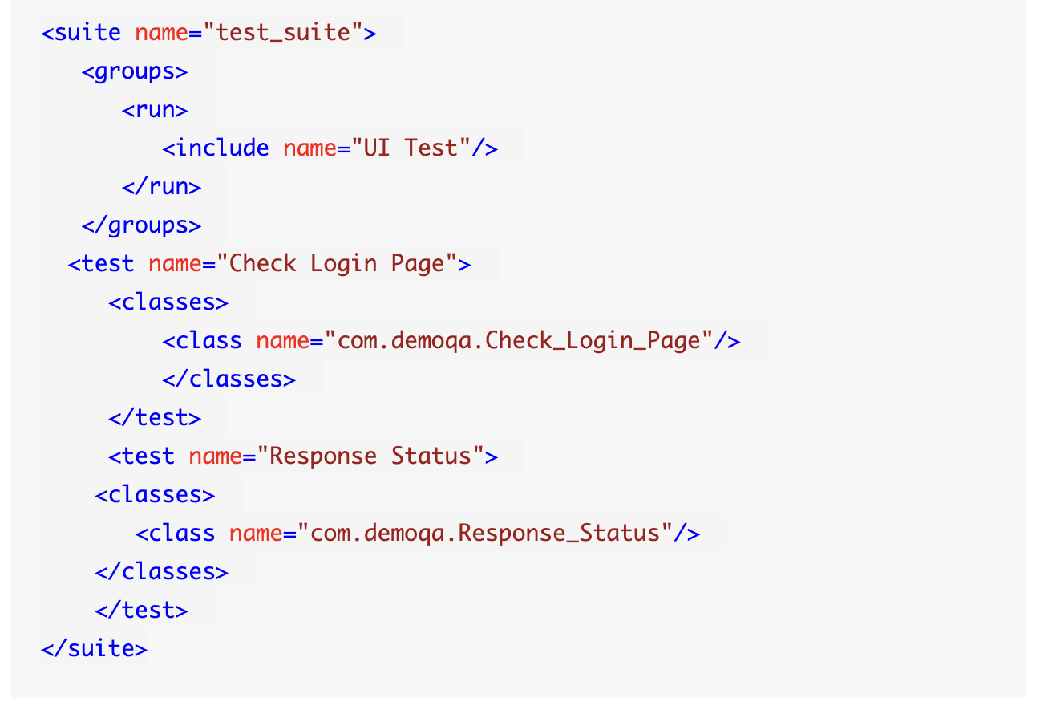

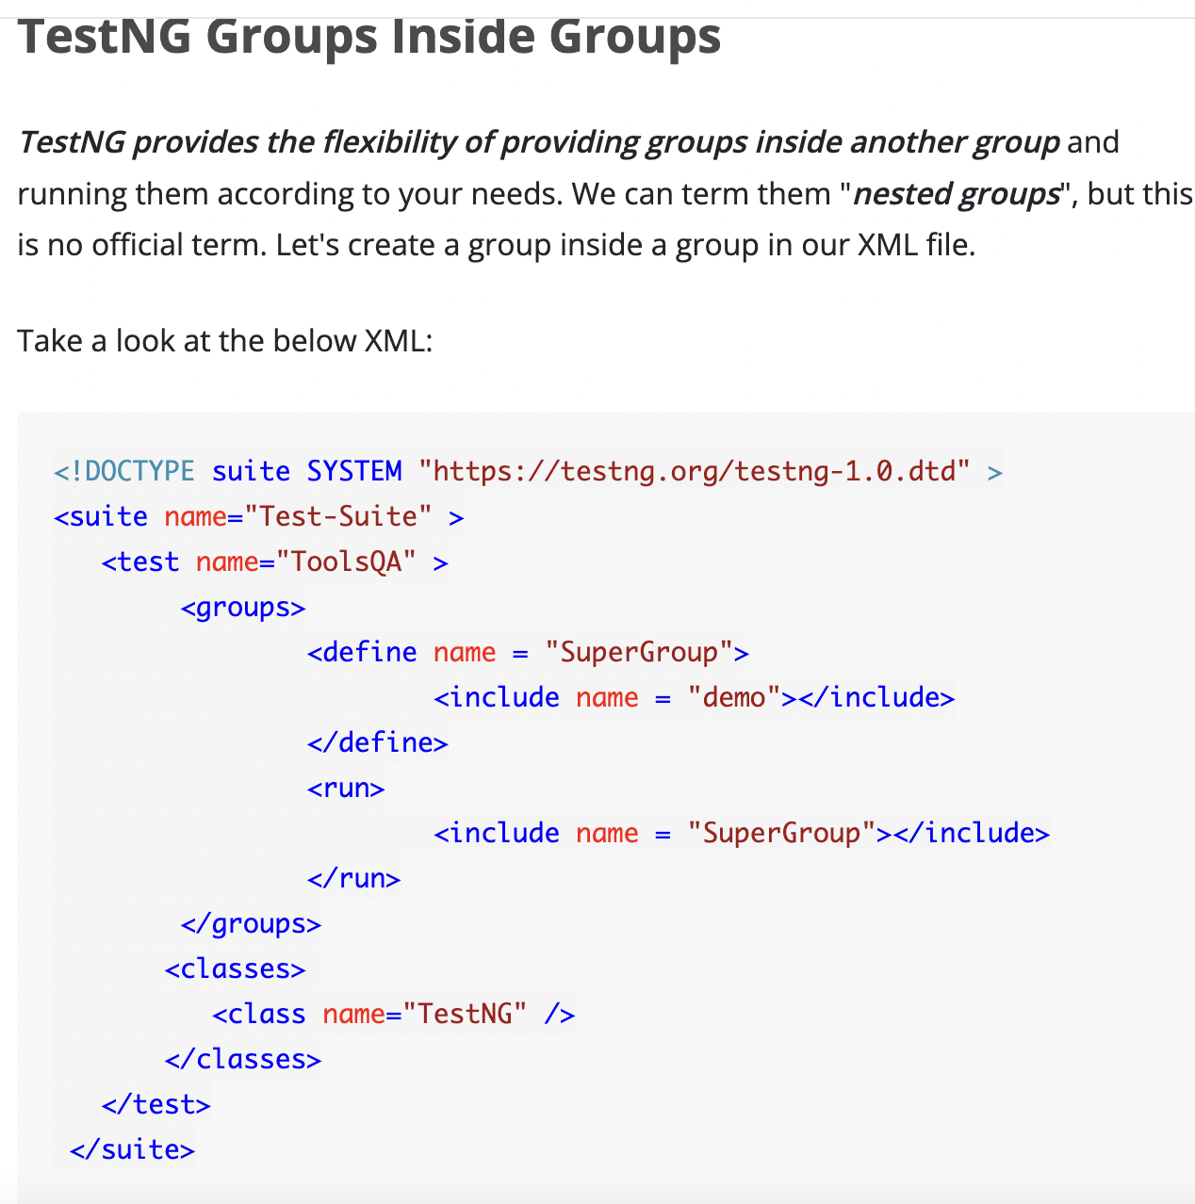

# **TestNG - Dependent Tests**

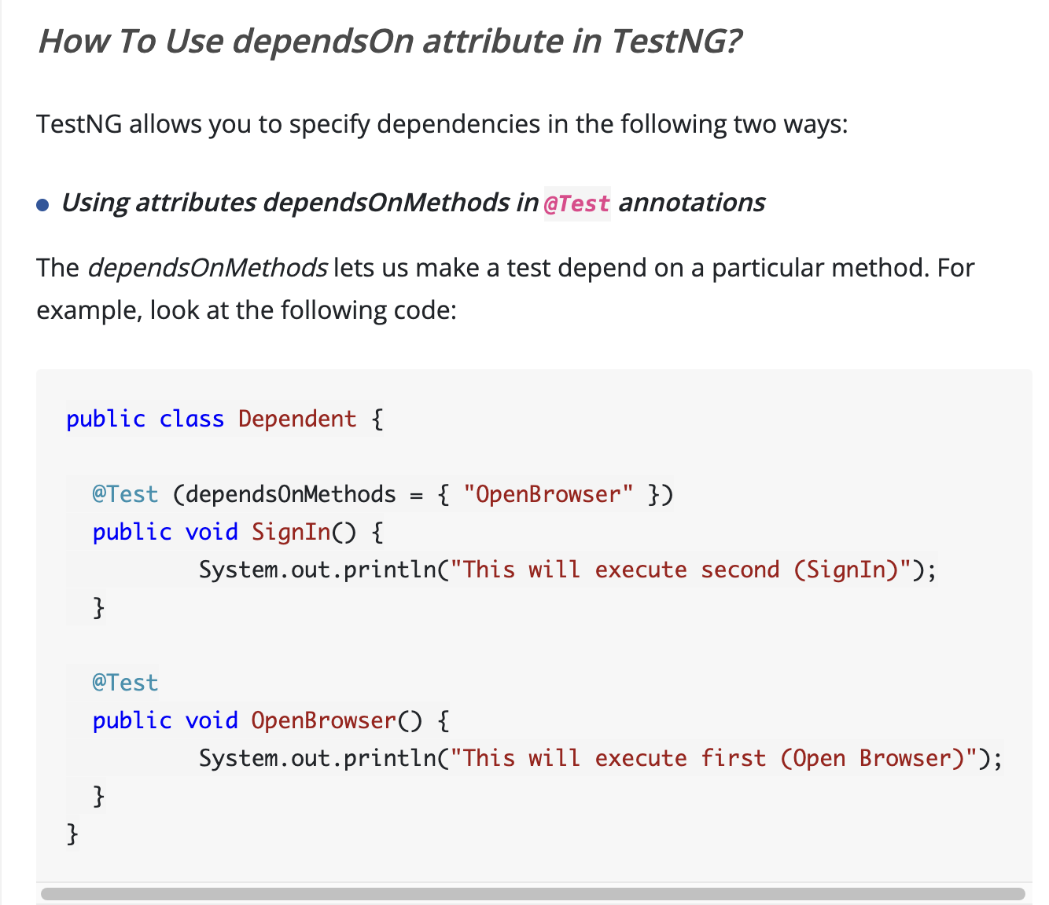

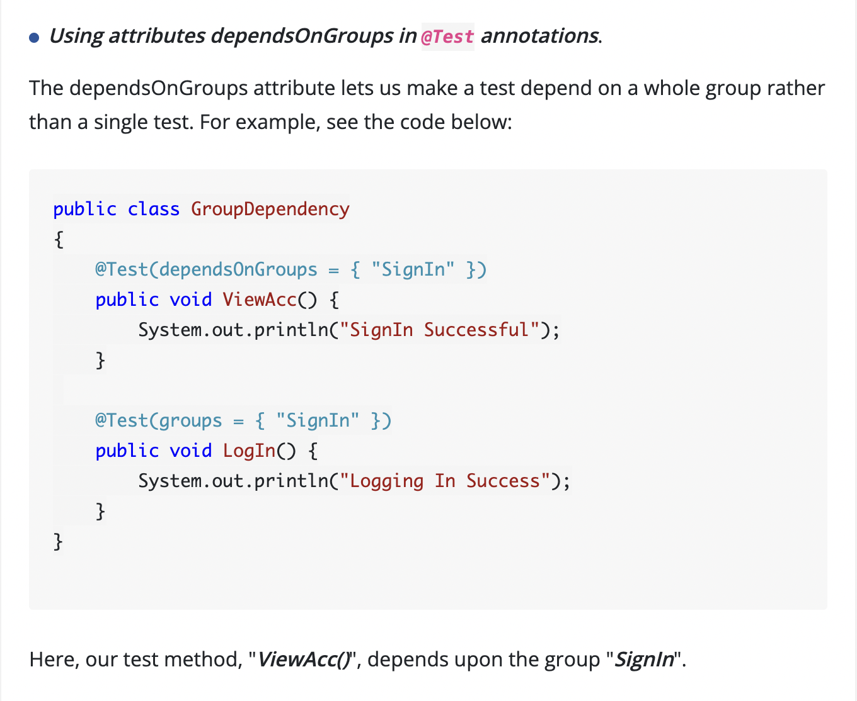

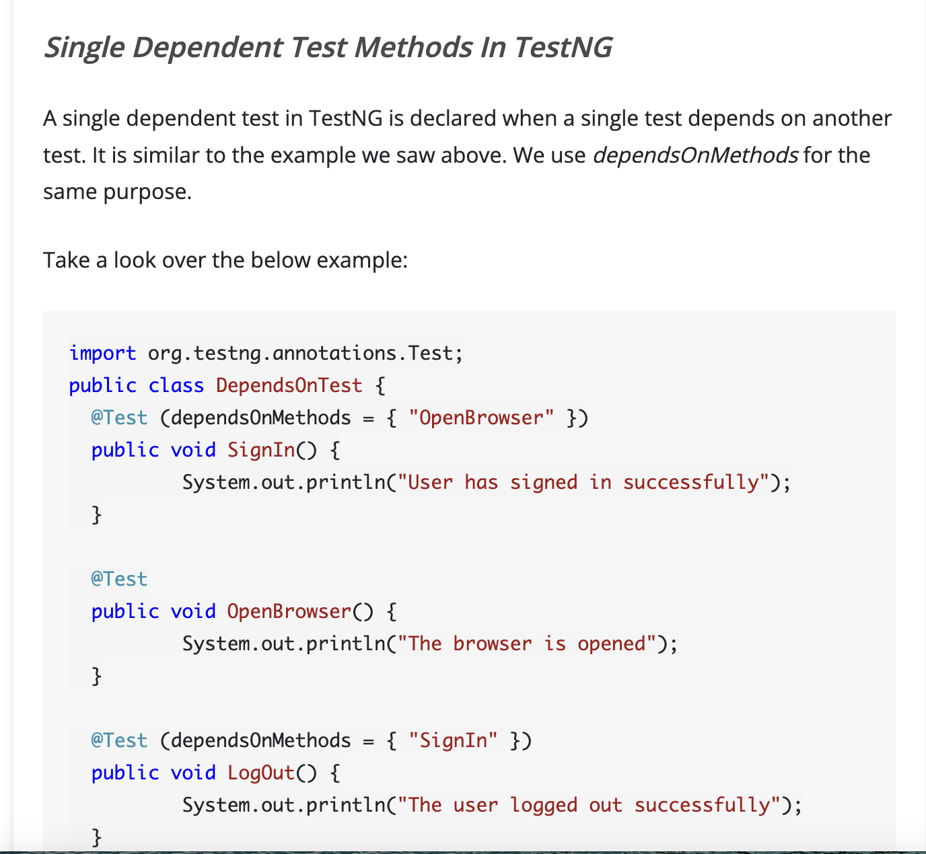

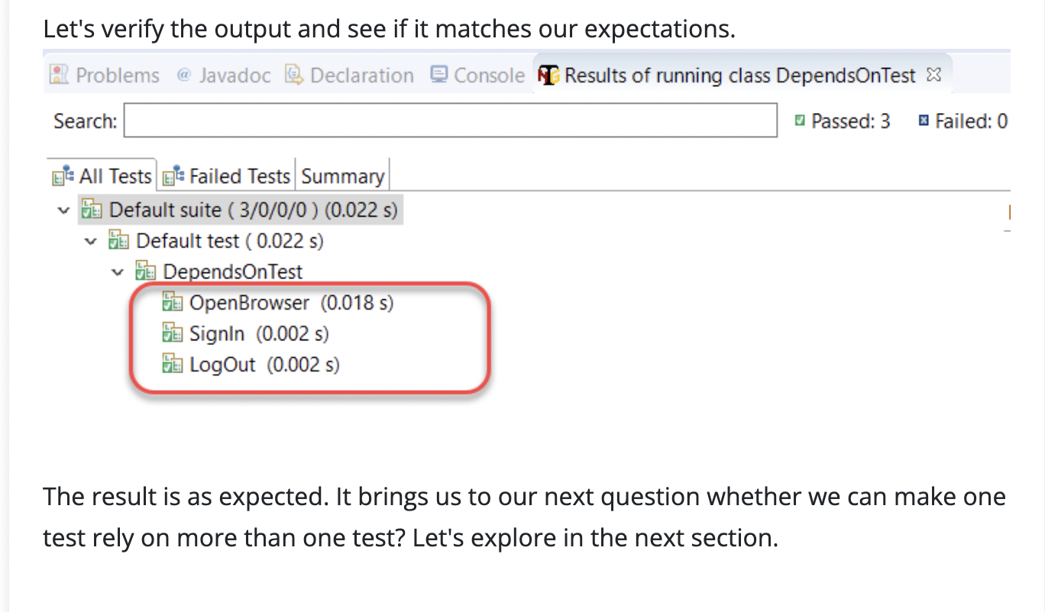

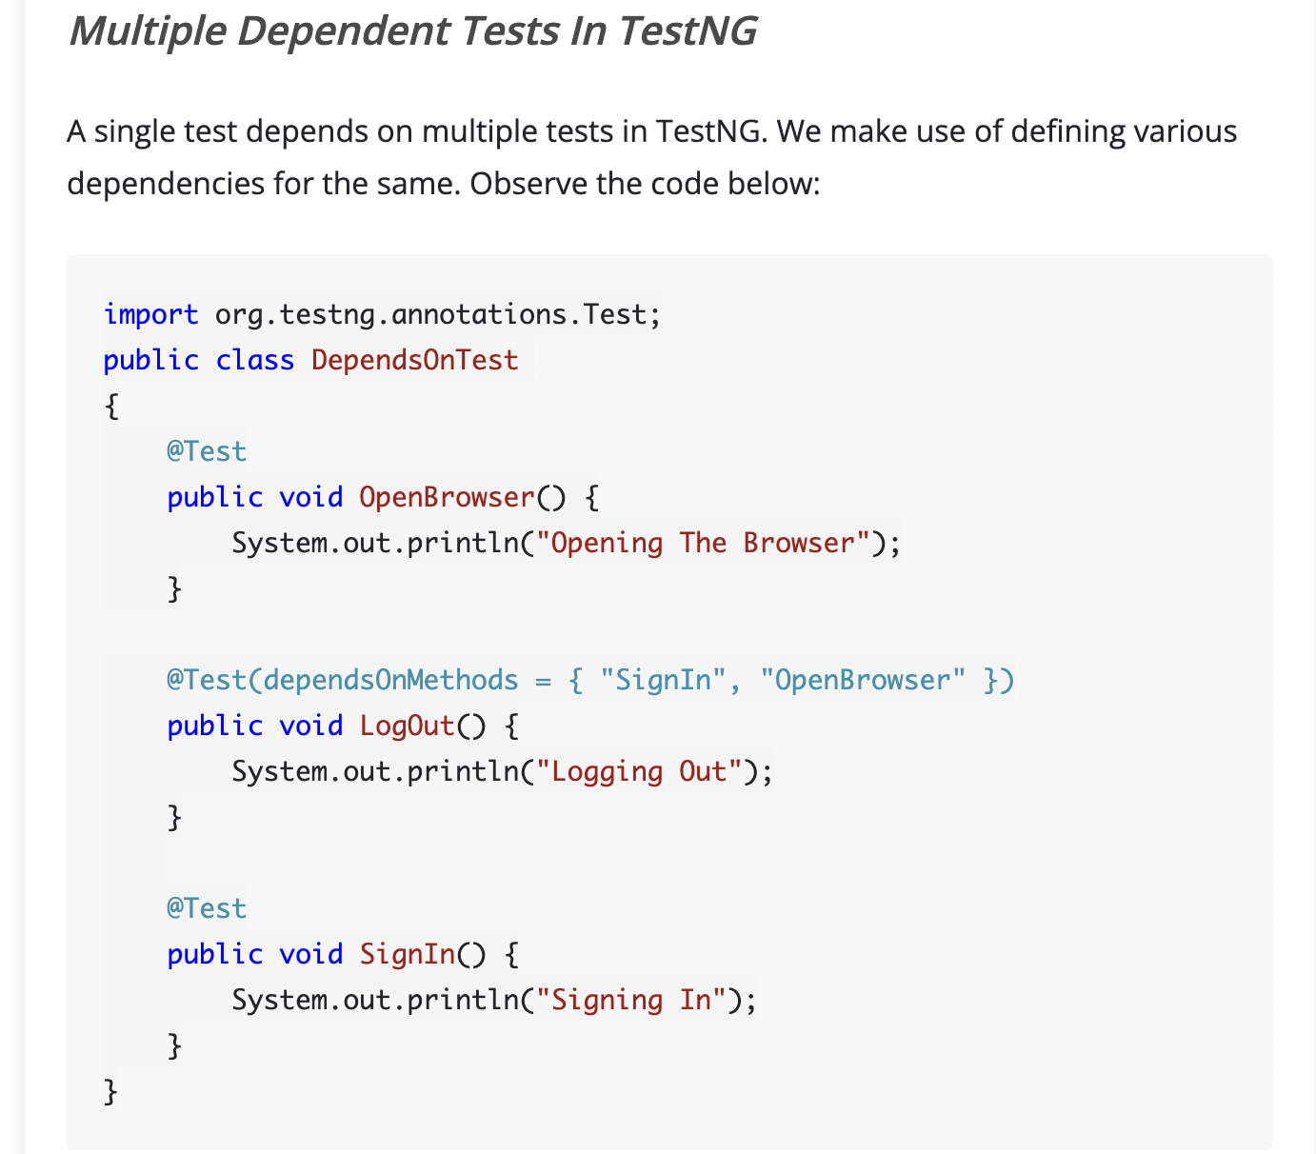

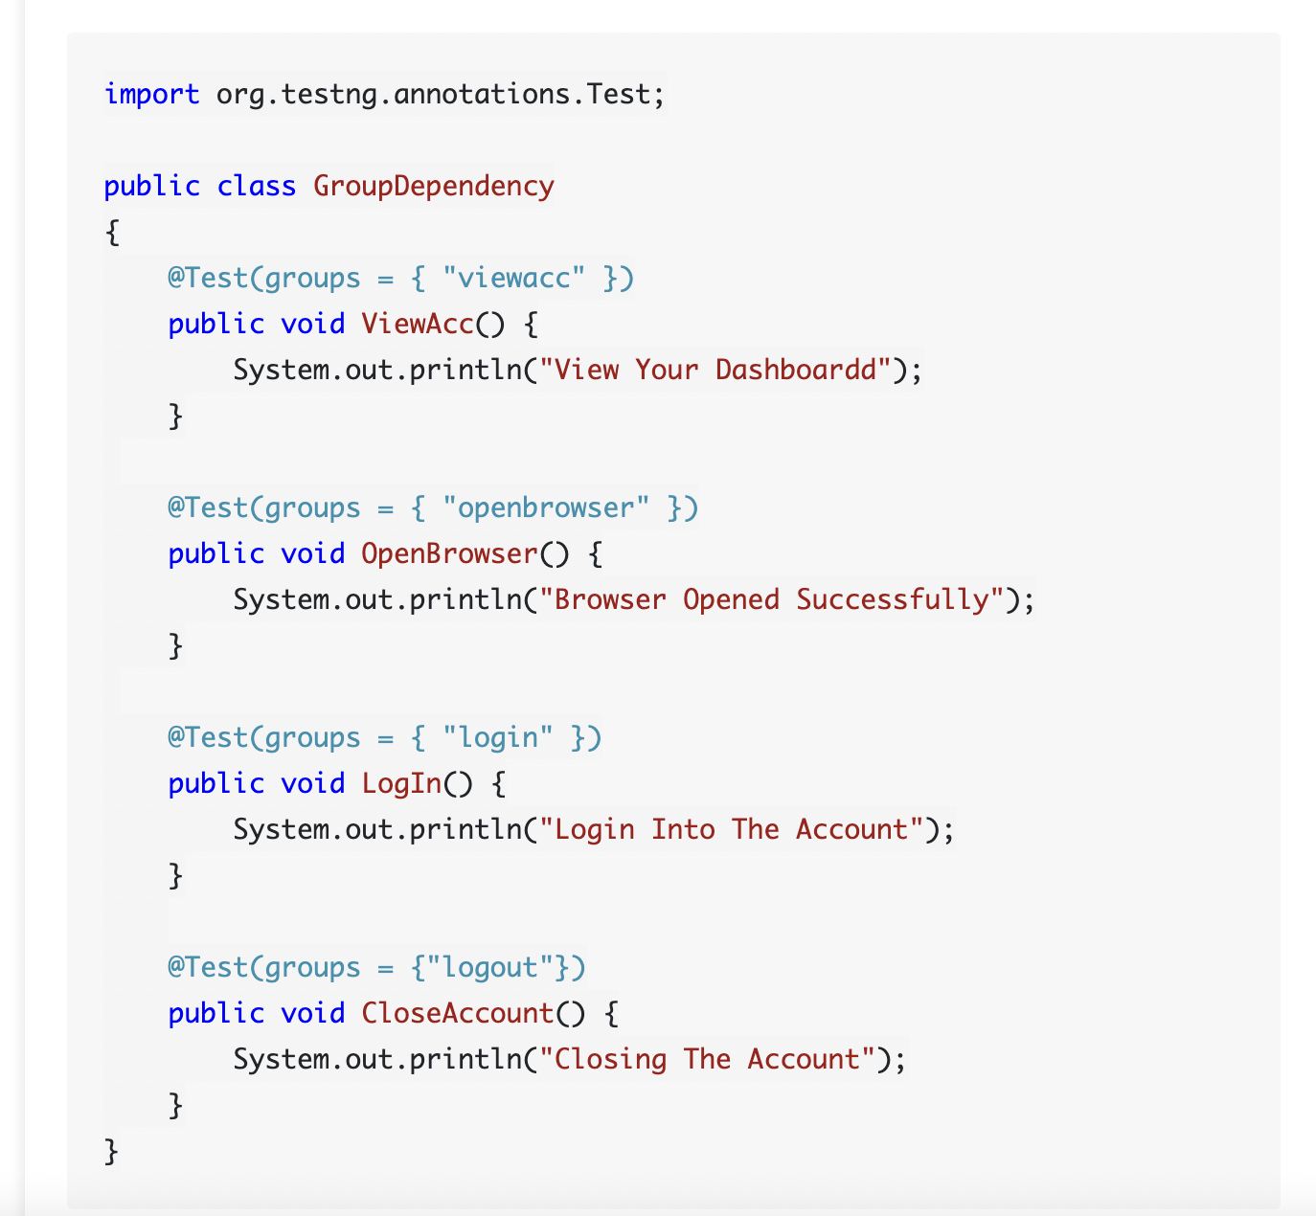

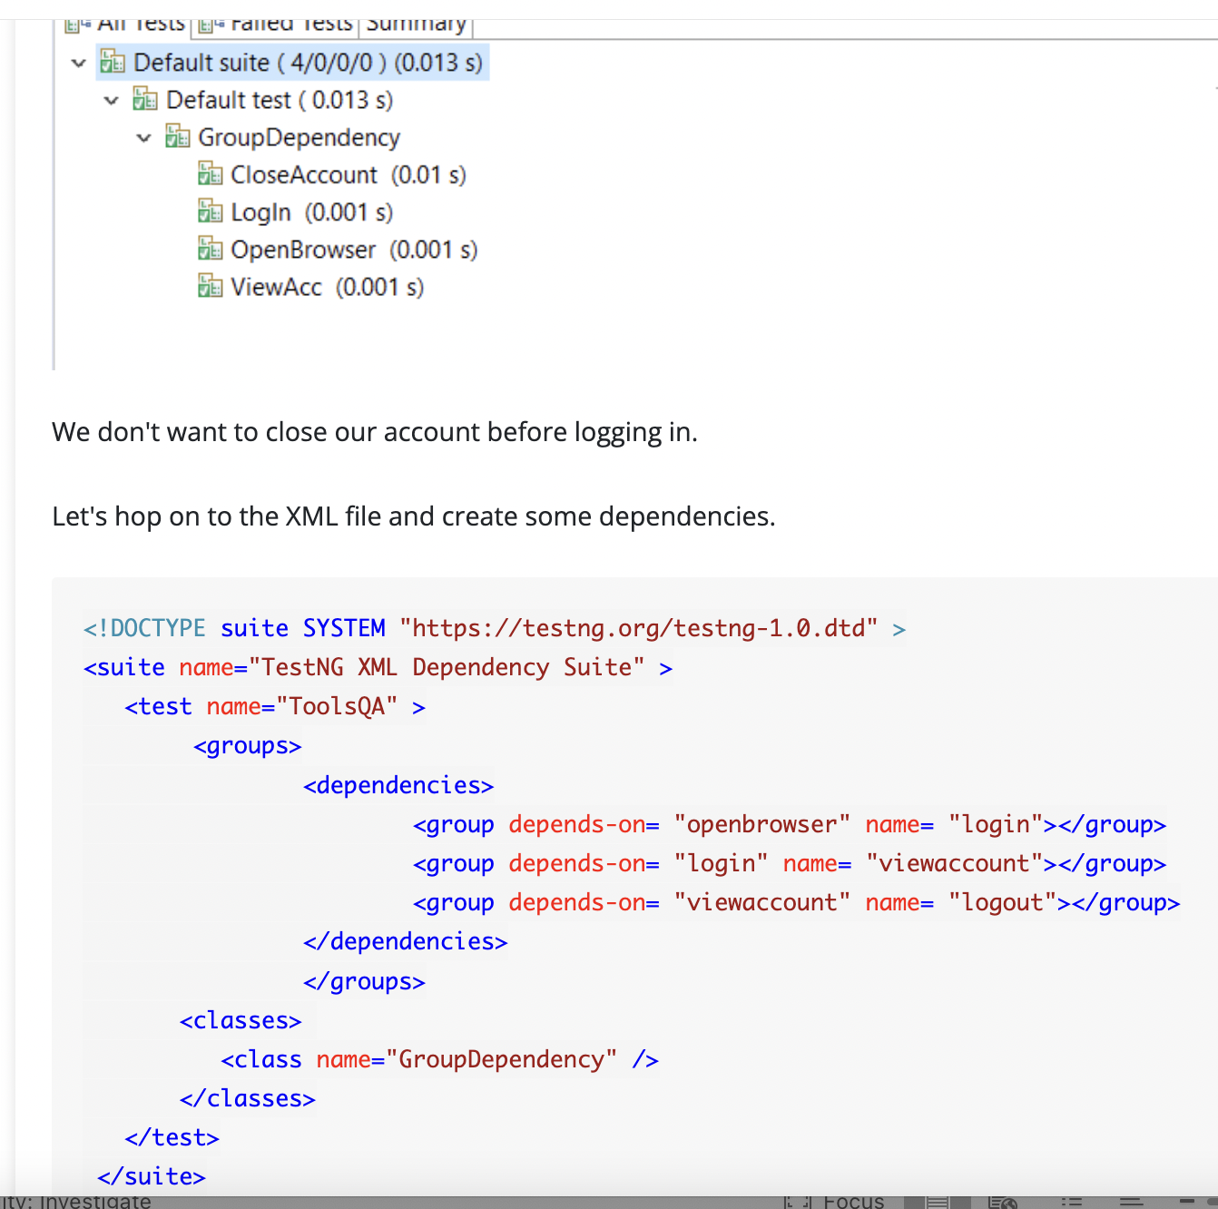

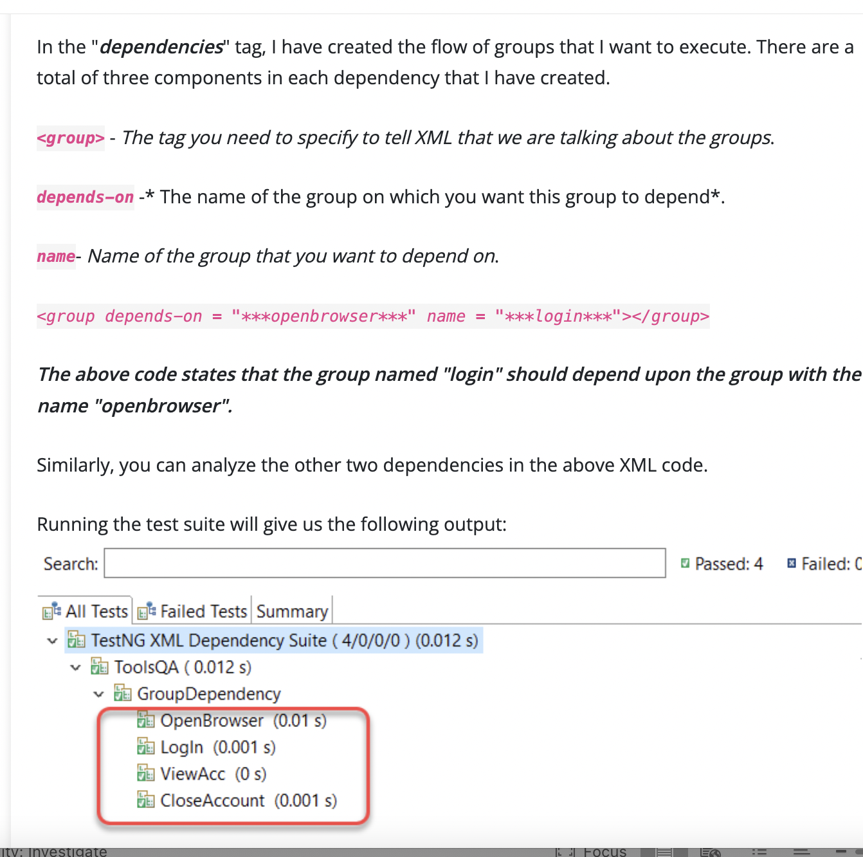

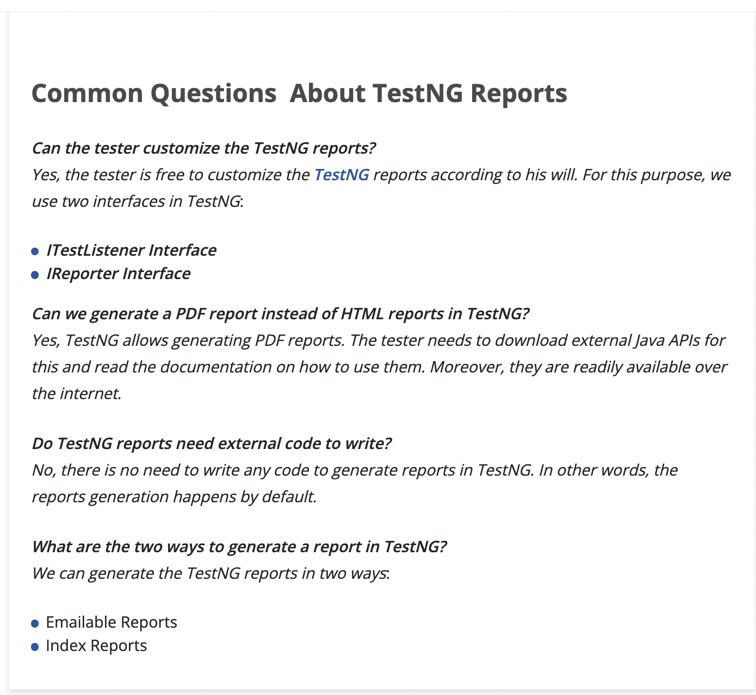

## What are the TestNG parameters?

[***Parameters***](https://en.wikipedia.org/wiki/Parameter_(computer_programming)) in TestNG is similar to [***annotations in TestNG***](https://www.toolsqa.com/testng/testng-annotations/) in their declaration. Similar to parameters in any other [***programming language***](https://www.toolsqa.com/python/what-is-programming/), they are declared to pass some values onto the function. A simple reason to use parameters is that they let us run a function many times with different values or to run different functions with the same values. ***Parameters pass the values in the runtime***.

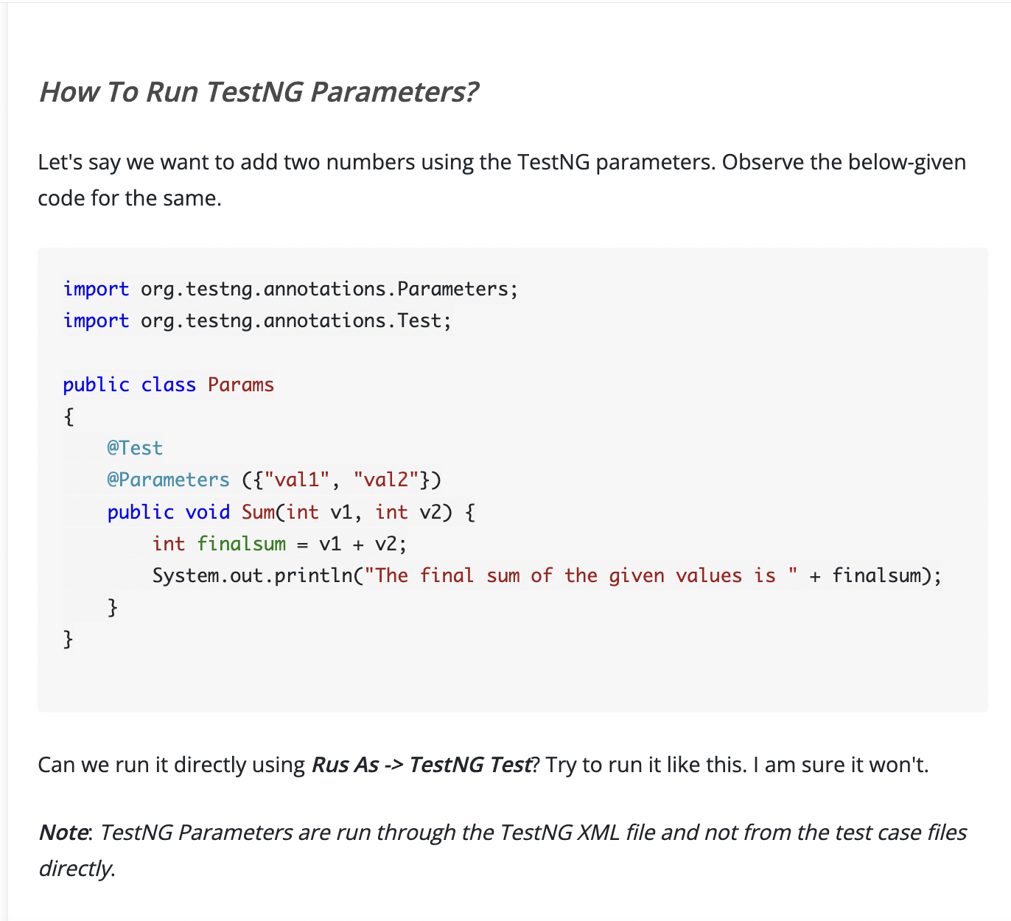

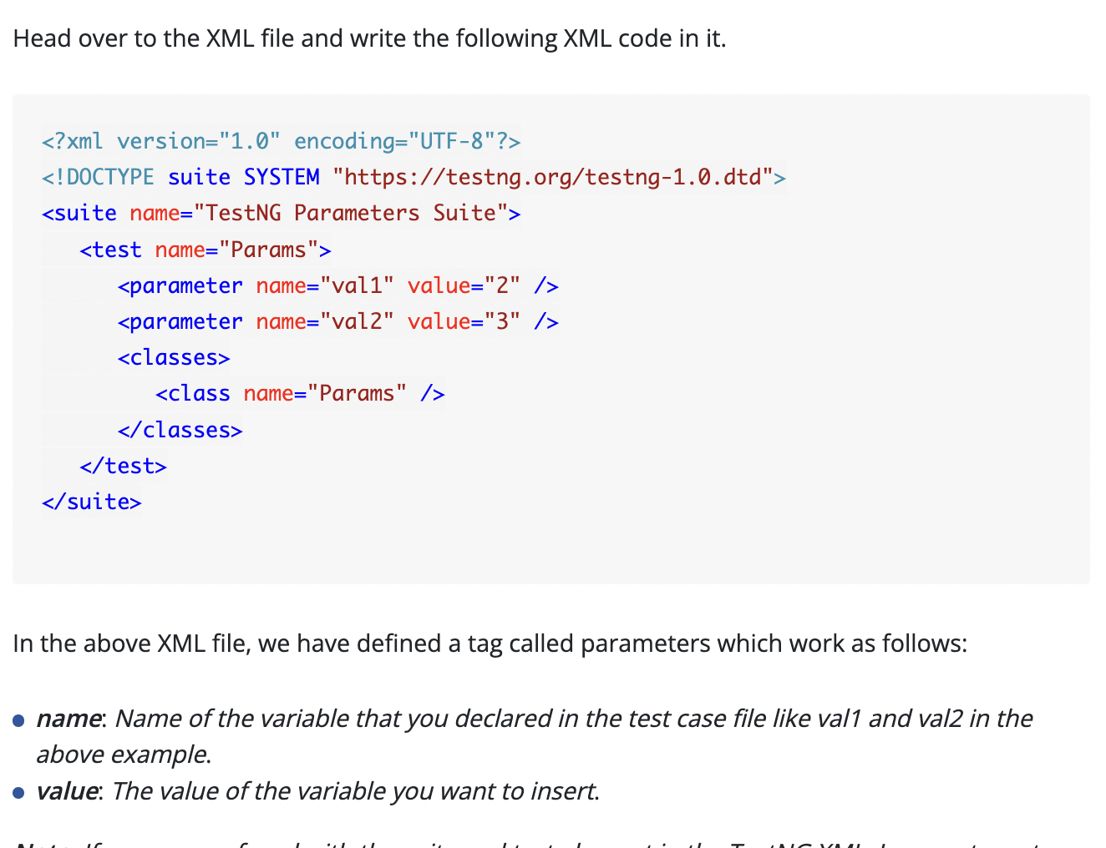

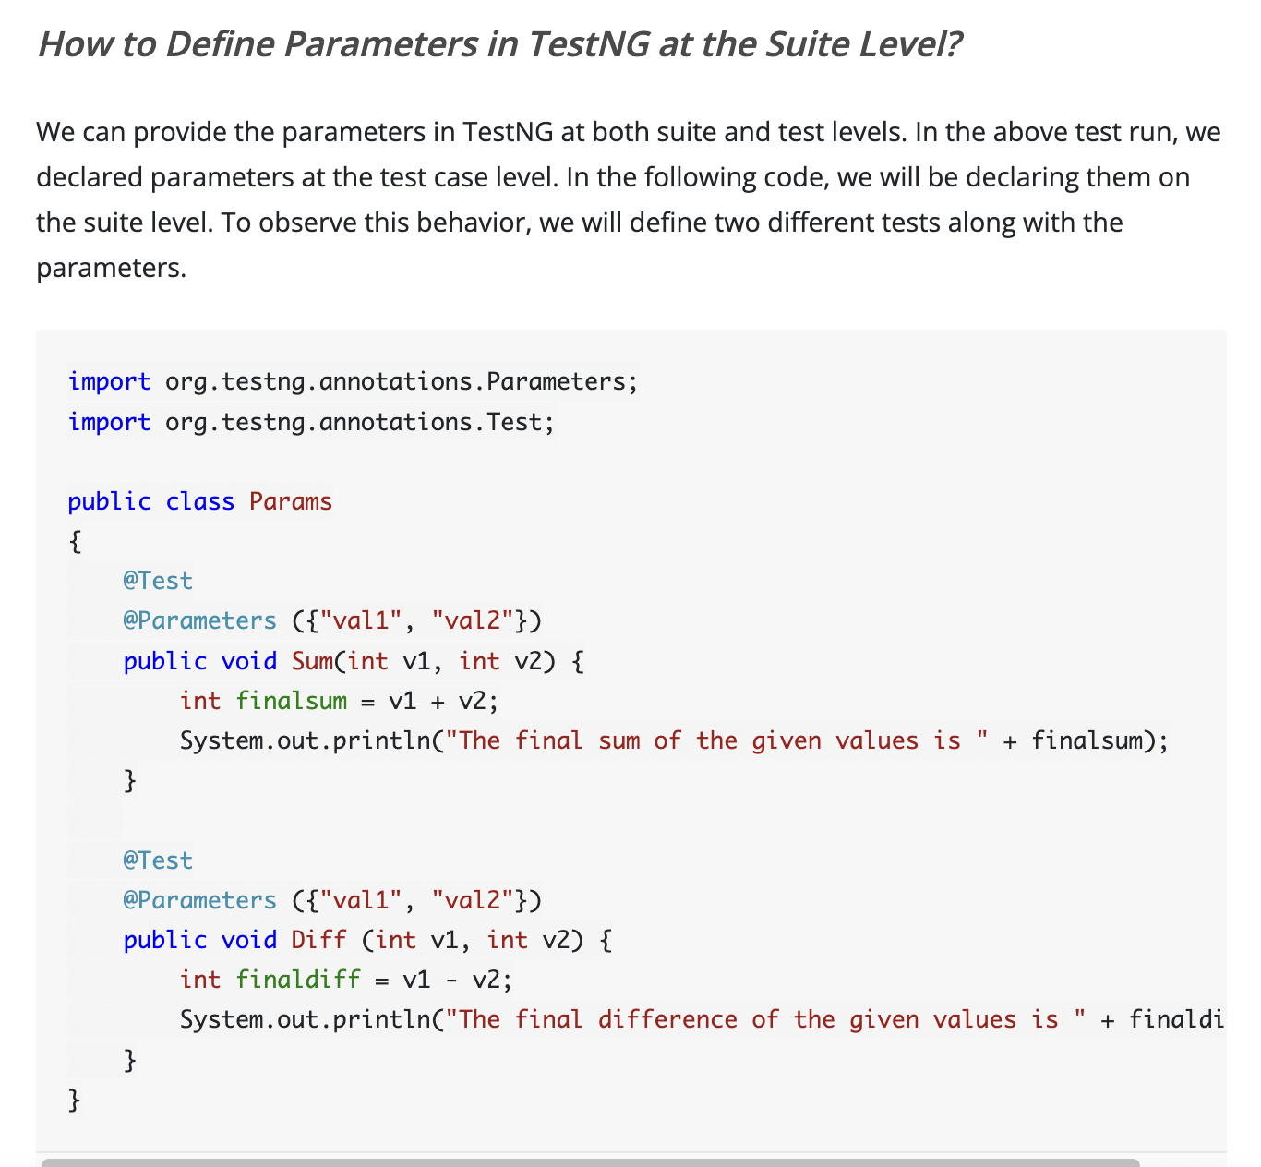

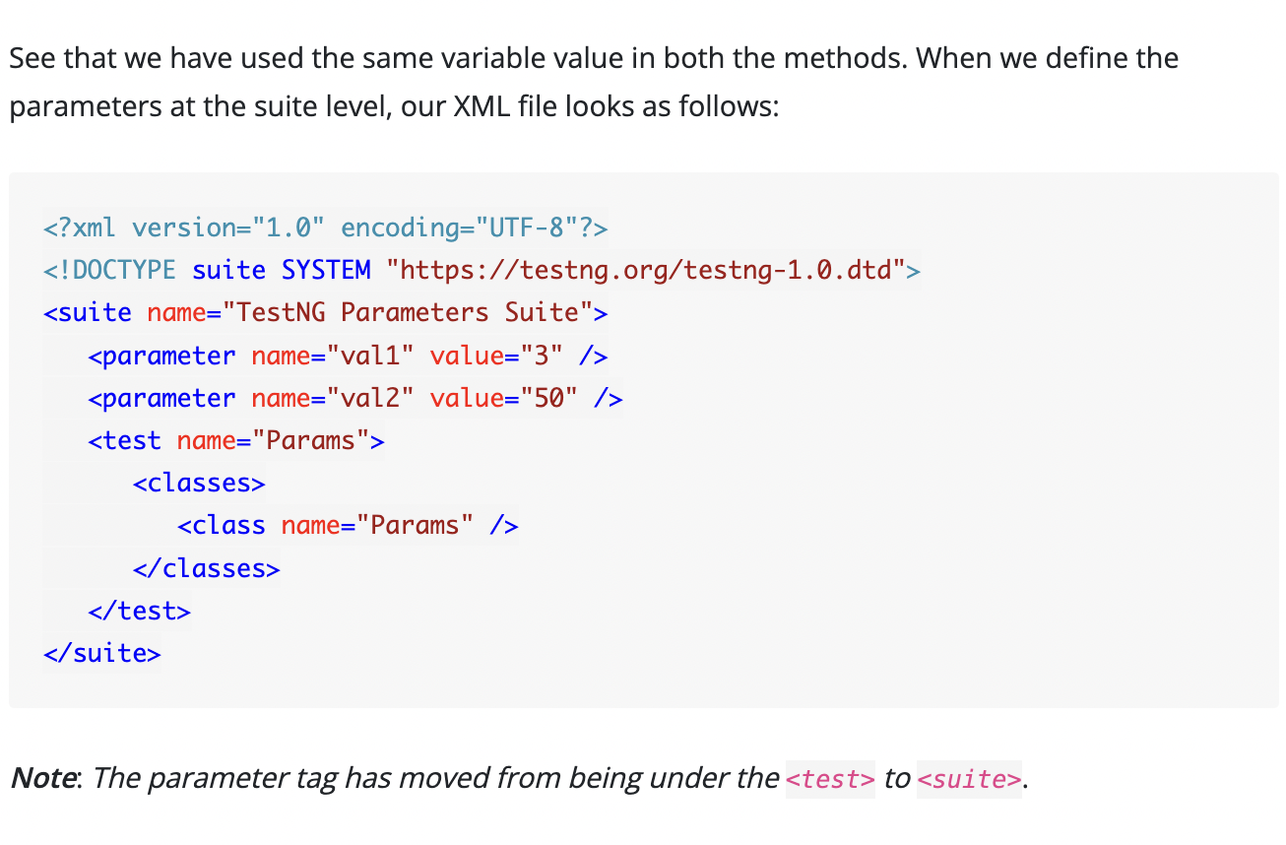

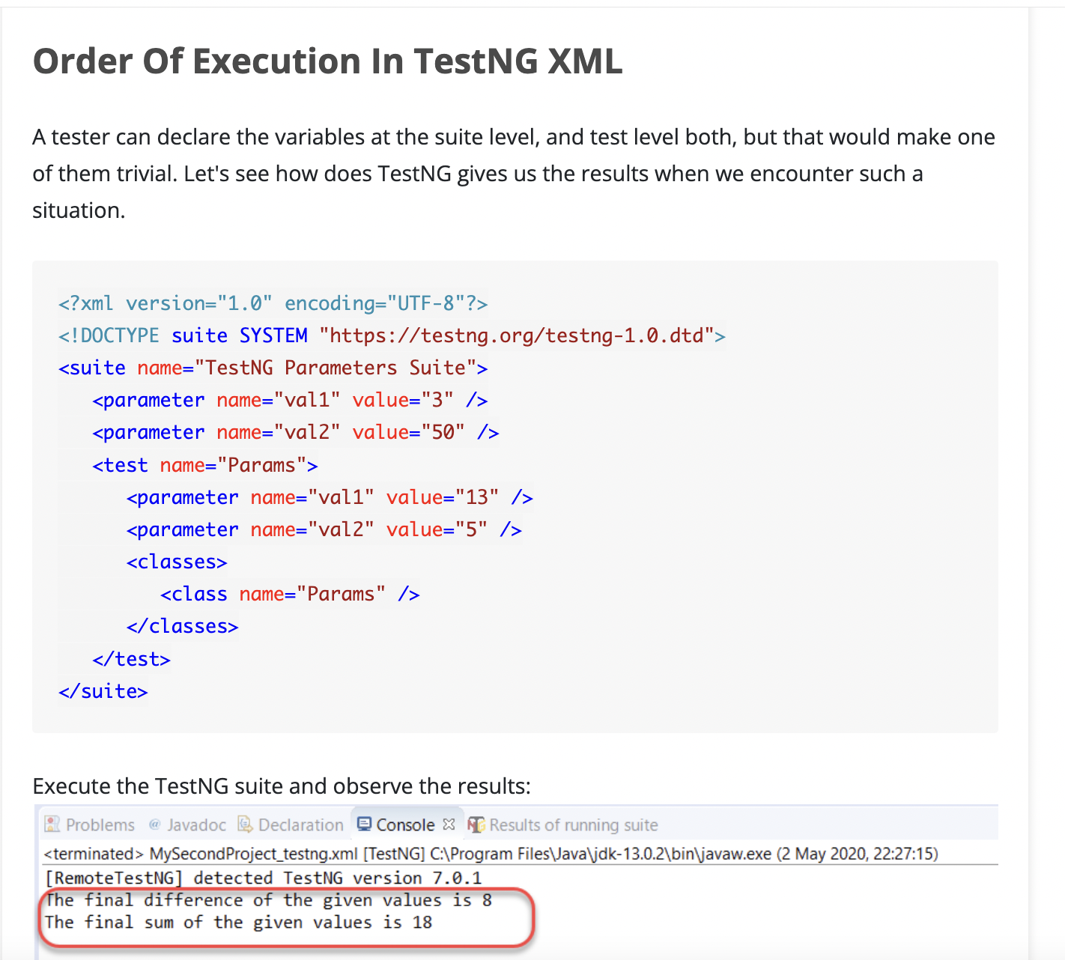

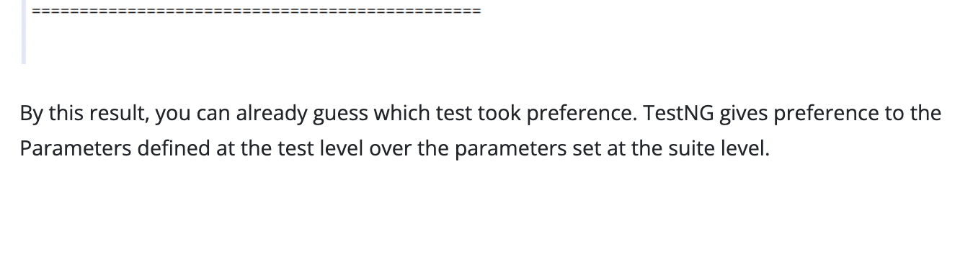

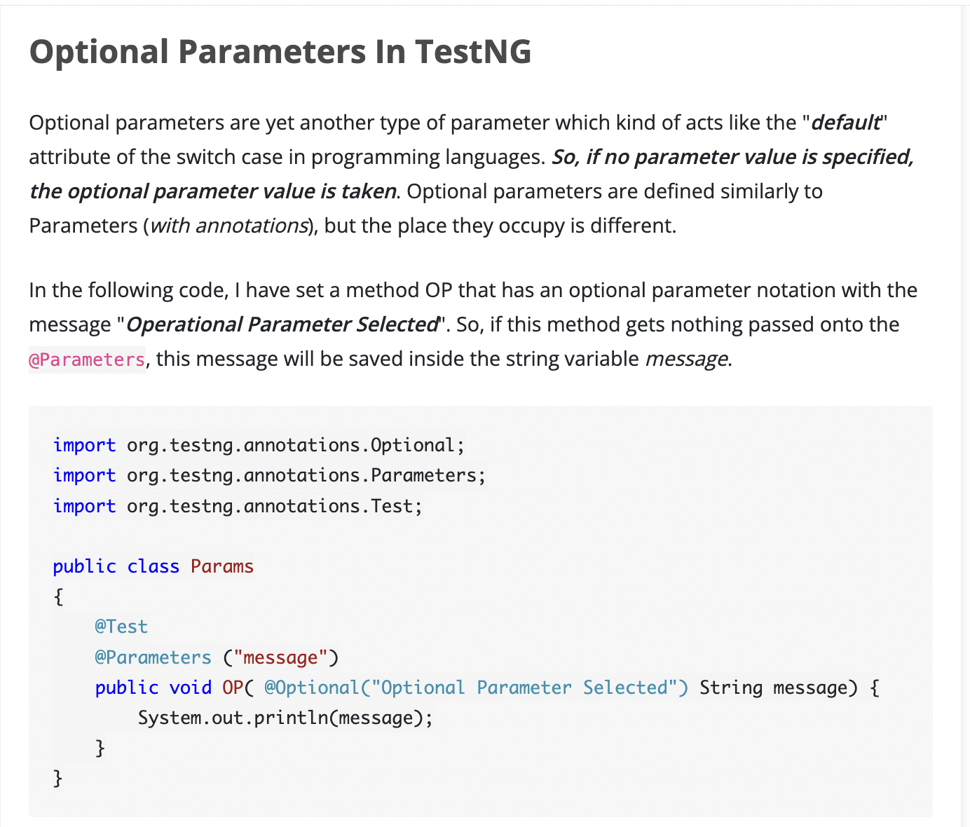

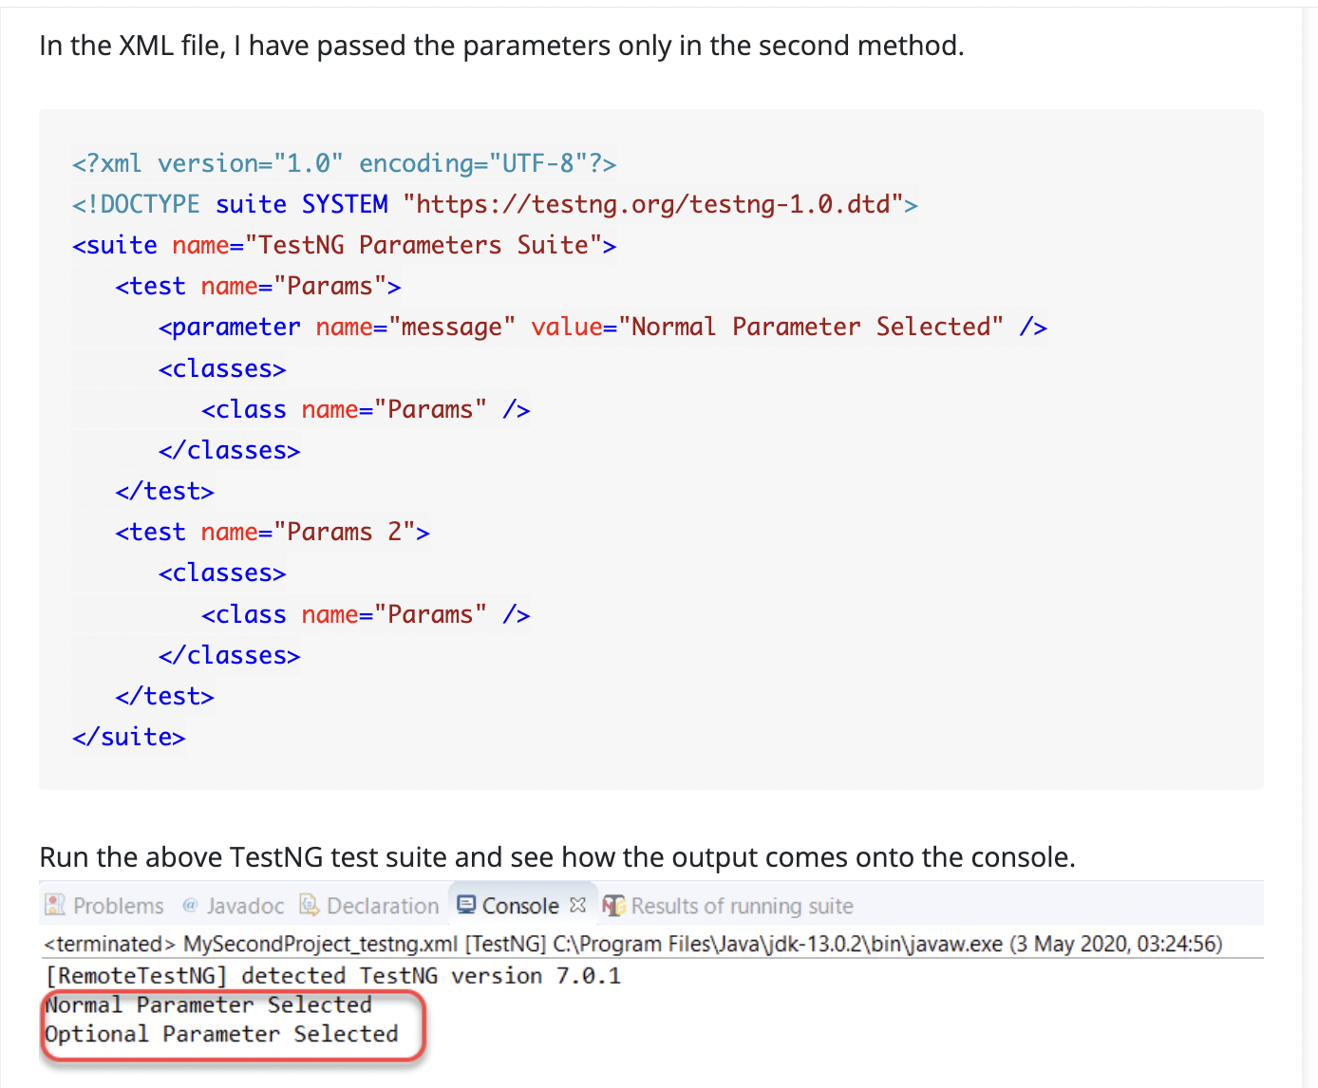

**TestNG DataProviders**

There is a problem with TestNG parameters. They worked very well to pass the value and run the tests, but that happens only once per execution. What if I want to run the same test with multiple values? Can I do that with parameters? No, I can't since this is a very common operation while testing; there needs to be a standard way to accomplish this goal. It is where ***TestNG DataProviders*** come into the picture, and this tutorial will cover just that.

## What are DataProviders in TestNG?

The DataProviders in TestNG are another way to pass the parameters in the test function, the other one being TestNG parameters. DataProviders pass different values to the [***TestNG Test Case***](https://www.toolsqa.com/testng/testng-test/) in a single execution and in the form of [***TestNG Annotations***](https://www.toolsqa.com/testng/testng-annotations/). It is a part of the inbuilt TestNG data-driven testing for which TestNG is quite popular. DataProviders help in passing the parameters in different ways.

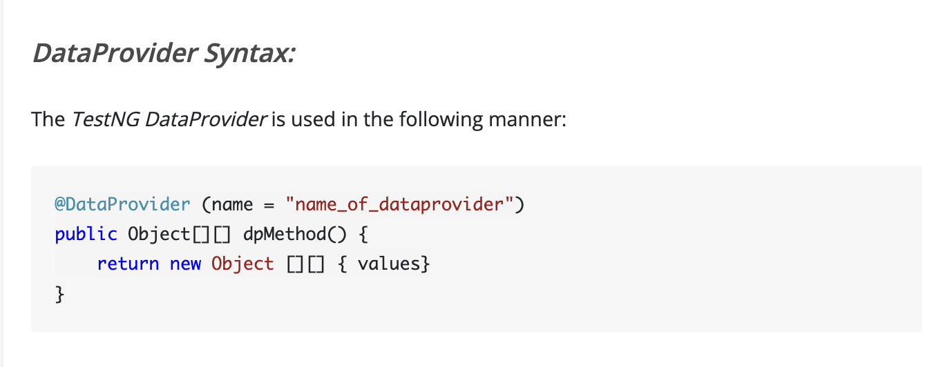

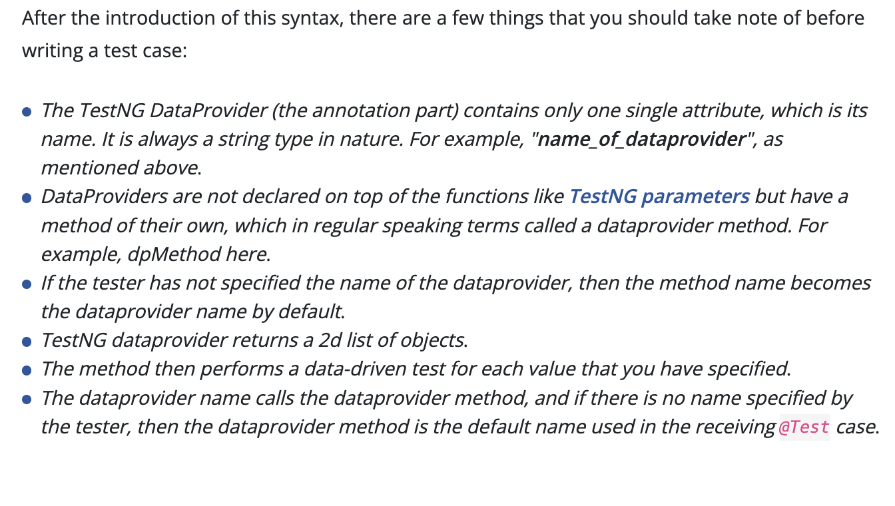

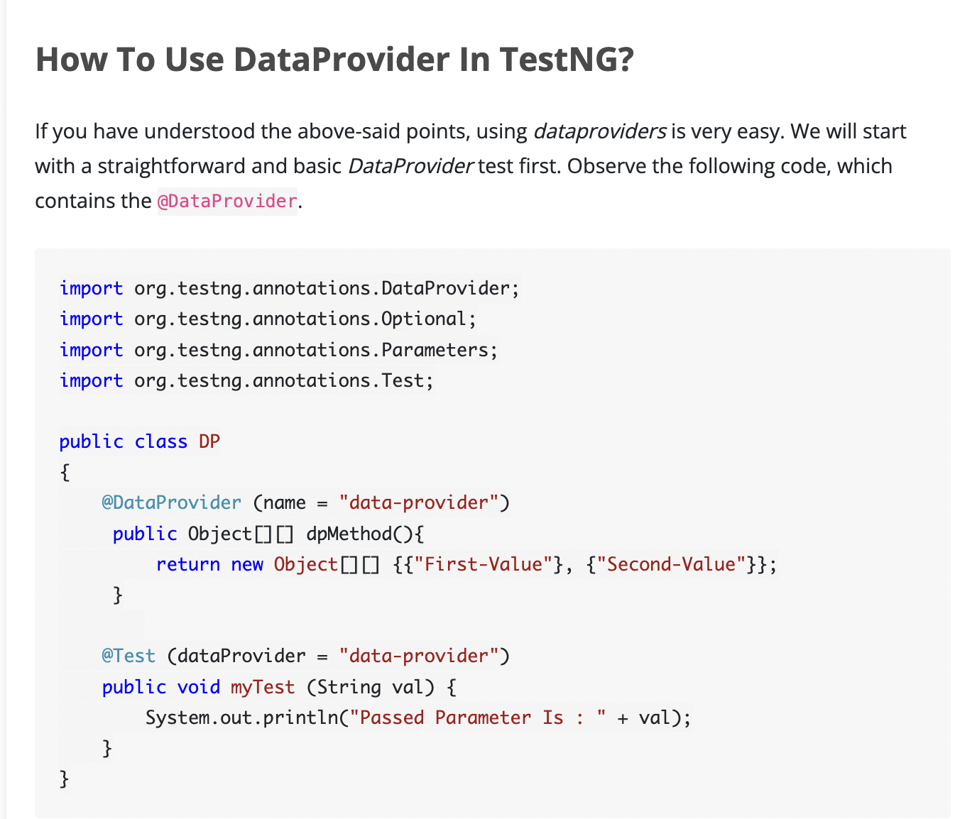

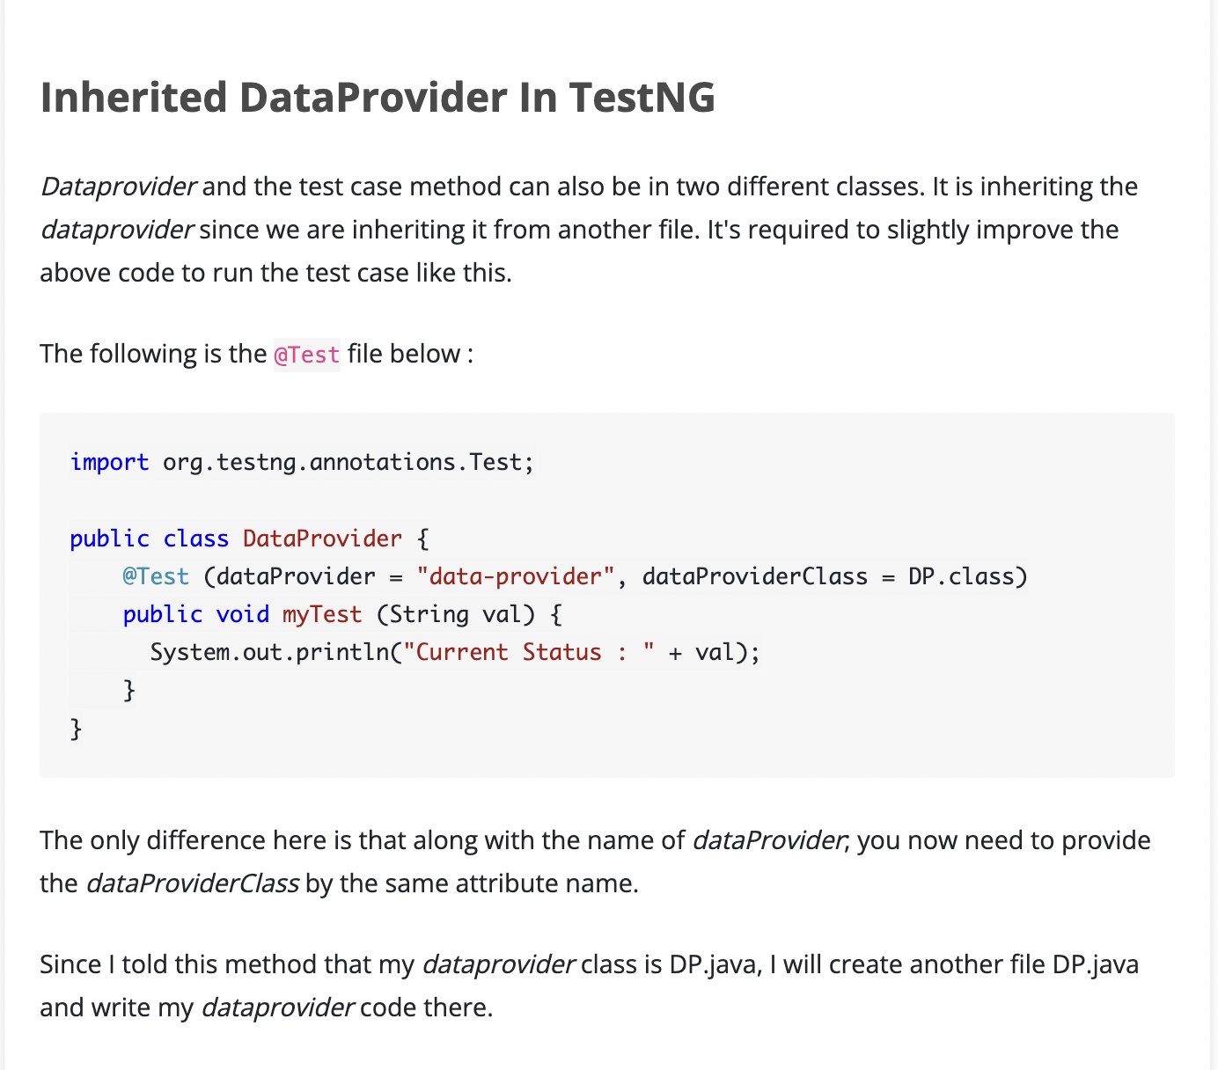

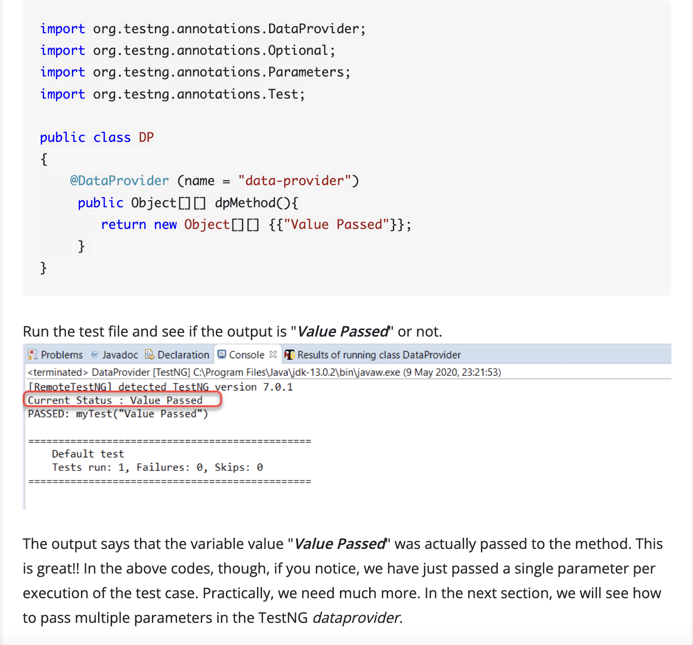

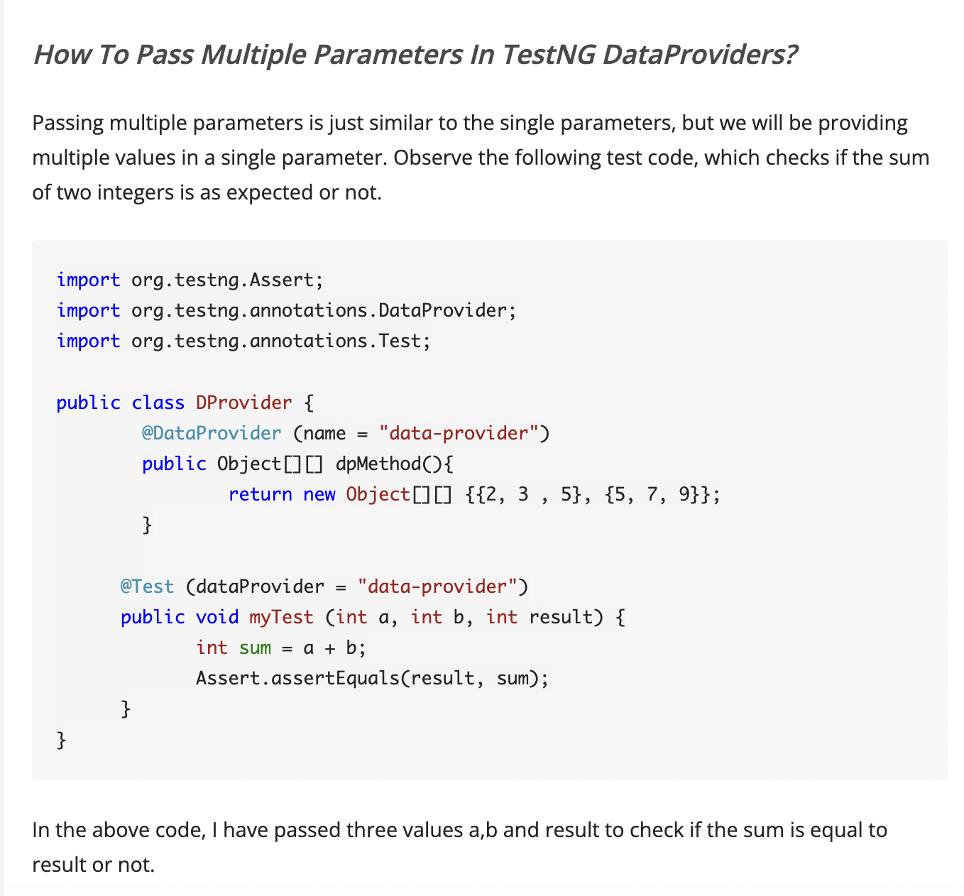

## DataProviders With Method As A Parameter

import org.testng.Assert;

import java.lang.reflect.Method;

import org.testng.annotations.DataProvider;

import org.testng.annotations.Test;

public class DProvider {

@DataProvider (name = "data-provider")

public Object[][] dpMethod (Method m){

switch (m.getName()) {

case "Sum":

return new Object[][] {{2, 3 , 5}, {5, 7, 9}};

case "Diff":

return new Object[][] {{2, 3, -1}, {5, 7, -2}};

}

return null;

}

@Test (dataProvider = "data-provider")

public void Sum (int a, int b, int result) {

int sum = a + b;

Assert.assertEquals(result, sum);

}

@Test (dataProvider = "data-provider")

public void Diff (int a, int b, int result) {

int diff = a - b;

Assert.assertEquals(result, diff);

}

}

This code provides a switch case to check the name of the method and return the parameters according to the method name.

# **TestNG Test Case Priority And Sequence**

## What Is Prioritization In TestNG?

Prioritization in TestNG is a way to provide a sequence to the methods so that they do not run out of order.

*Priority in TestNG test cases is a parameter with attribute value as "****priority****".*

### ***How to give Priority in TestNG test?***

The following is the syntax for allocating a priority to a test case method.

@Test (priority = 1)

public void func(){

//test code

}

**It is important to note a couple of points regarding priority in TestNG:**

* Definition of Priority in TestNG test methods can only be the @Test methods.
* Lower the priority number; higher is the priority of the test case method.
* **Priority in TestNG contains only integer value. The value can be negative, zero, or positive**.
* If a tester defines a priority in decimal in TestNG, it needs to convert first to Integer (through typecasting).
* One method is allowed to have only one priority in TestNG.
* Priority cannot pass through the XML files.

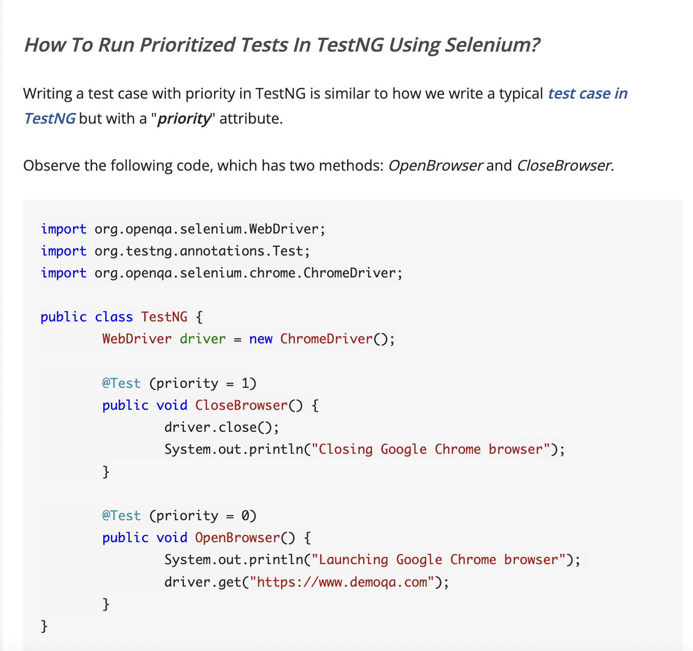

Can you guess it by shooting in the air?

***The test methods with no priority assigned have a default priority equal to 0. It means if we define no priorities, all the test methods will be assigned priority 0, and a similar priority case will apply***.

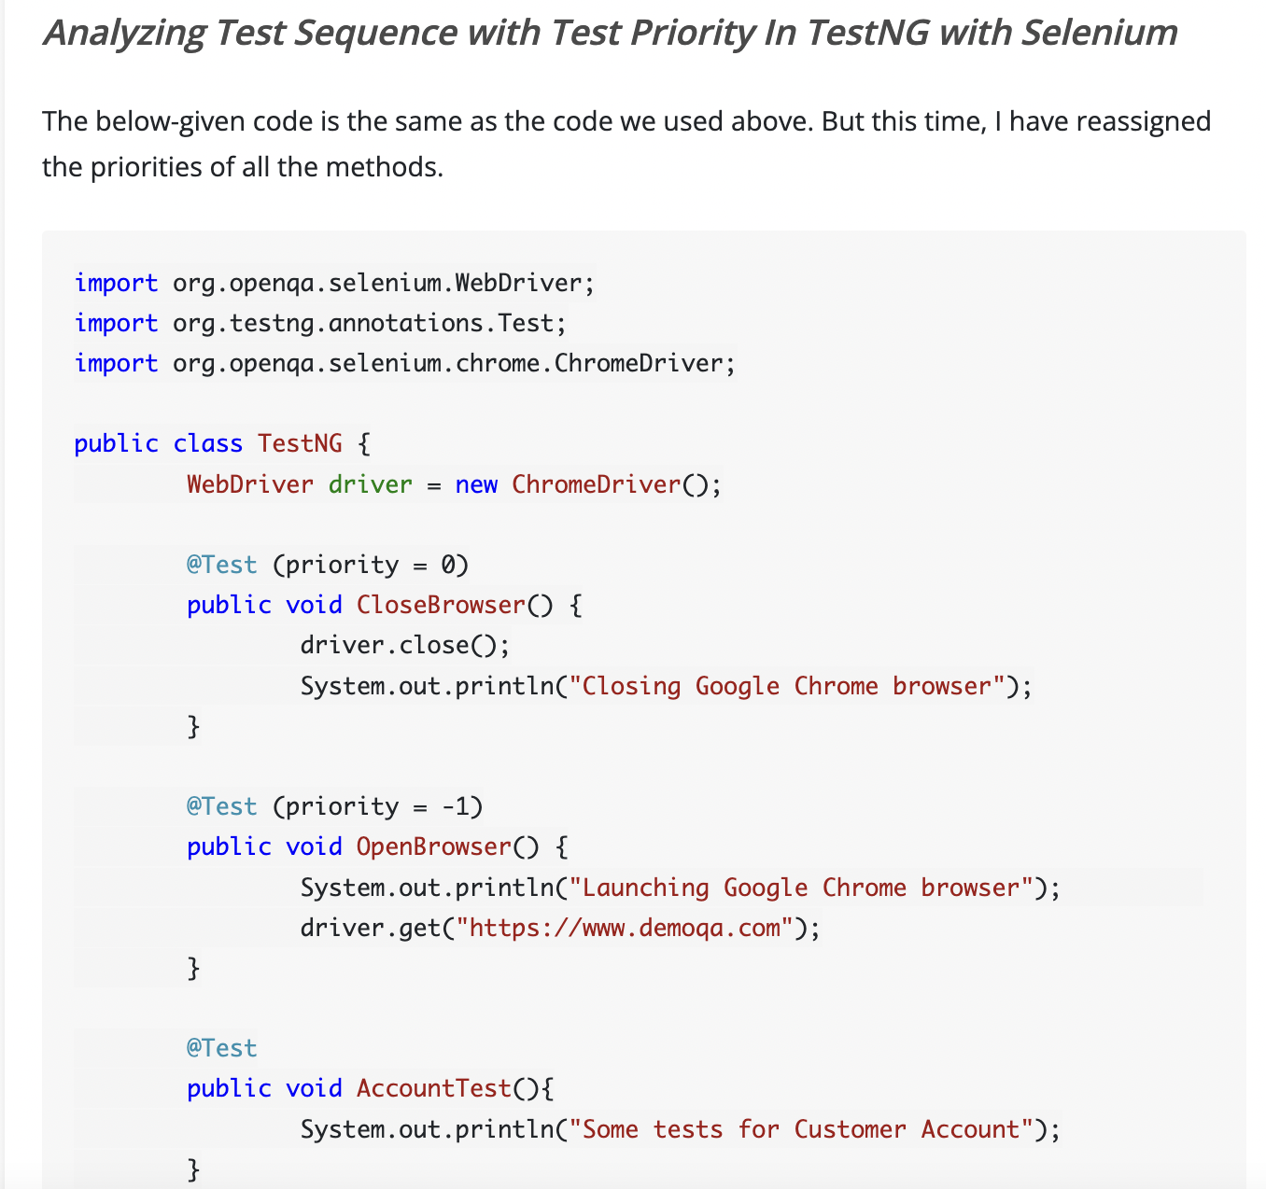

**How to Skip tests in TestNG using Parameters?**

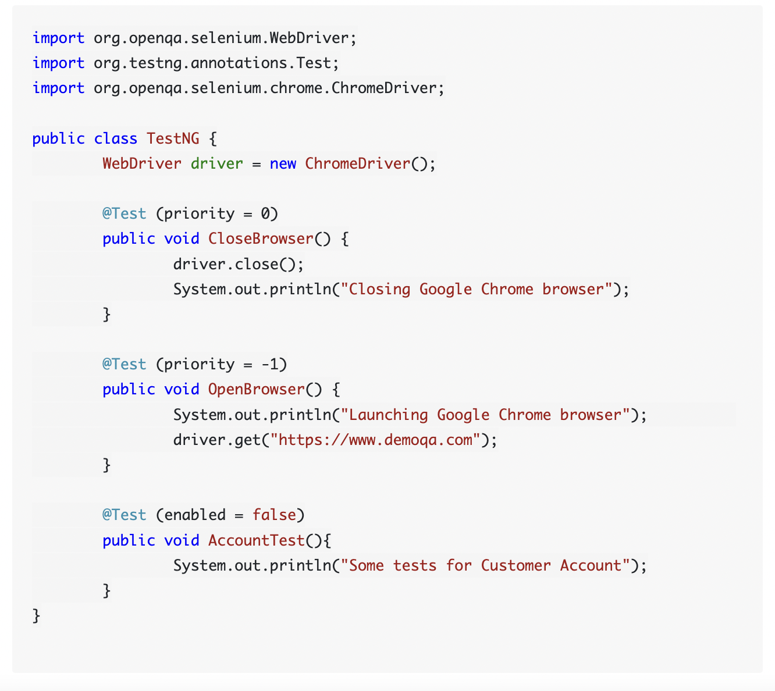

## Different types of Asserts in TestNG

There are two types of TestNg Assert:

* Hard Assert
* Soft Assert

**Hard Asserts** are those asserts that stop the test execution when an assert statement fails, and the subsequent assert statements are therefore not validated.

### **Soft Assert in TestNG**

Soft asserts are just the opposite of hard asserts. In soft asserts, the subsequent assertions keep on running even though one assert validation fails, i.e., the test execution does not stop.

**Commonly used TestNG Assert Methods**

* ***Assert.assertEqual(String actual, String expected)***: *Pass the actual string value and the expected string value as parameters. Validates if the actual and expected values are the same or not*.
* ***Assert.assertEqual(String actual, String expected, String message)***: *Similar to the previous method just that when the assertion fails, the message displays along with the exception thrown*.
* ***Assert.assertEquals(boolean actual, boolean expected)***: *Takes two boolean values as input and validates if they are equal or not*.
* ***Assert.assertTrue(condition)***: *This method asserts if the condition is true or not. If not, then the exception error is thrown*.
* ***Assert.assertTrue(condition, message)***:  *Similar to the previous method with an addition of message, which is shown on the console when the assertion fails along with the exception*.
* ***Assert.assertFalse(condition)***: *This method asserts if the condition is false or not. If not, then it throws an exception error*.
* ***Assert.assertFalse(condition, message)***: Similar to the previous method but with an addition of a message string which is shown on the console when the assertion fails, i.e., the condition is true*.
* ***public static void assertEquals(Object actual, Object expected, String message)***: *Asserts whether the two objects passed are equal or not. If not, the message and the exception error appears. The message parameter is optional*.
* ***public static void assertEquals(String actual, String expected, String message)***: *Asserts whether two strings are equal or not. If not, the message along with the exception error displays. The message parameter is optional*.

### **How To Perform Cross-Browser Testing In TestNG Using Selenium?**

import org.openqa.selenium.By;

import org.openqa.selenium.WebDriver;

import org.openqa.selenium.firefox.FirefoxDriver;

import org.openqa.selenium.chrome.*;

import org.testng.annotations.AfterClass;

import org.testng.annotations.BeforeClass;

import org.testng.annotations.Parameters;

import org.testng.annotations.Test;

public class MultiBrowser {

public WebDriver driver;

@Parameters("browser")

@BeforeClass

// Passing Browser parameter from TestNG xml

public void beforeTest(String browser) {

// If the browser is Firefox, then do this

if(browser.equalsIgnoreCase("firefox")) {

//Initializing the firefox driver (Gecko)

driver = new FirefoxDriver();

}else if (browser.equalsIgnoreCase("chrome")) {

//Initialize the chrome driver

driver = new ChromeDriver();

}

// Enter the website address in the browser

driver.get("https://www.demoqa.com");

}

// Once Before method is completed, Test method will start

@Test public void login() throws InterruptedException {

driver.findElement(By.xpath("//*[@id=\"app\"]/div/div/div[2]/div/div[1]/div/div[1]")).click();

}

@AfterClass public void afterTest() {

driver.quit();

}

}

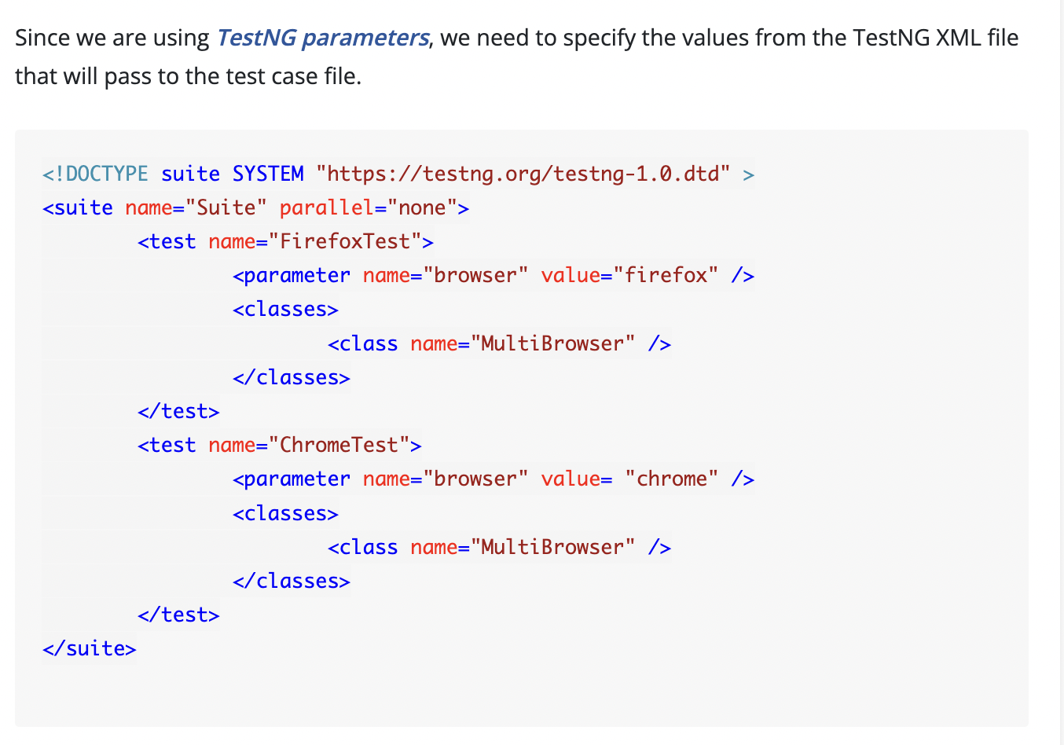

### **Running test methods parallelly in TestNG using Selenium**

import org.openqa.selenium.By;

import org.openqa.selenium.WebDriver;

import org.openqa.selenium.firefox.FirefoxDriver;

import org.openqa.selenium.chrome.*;

import org.testng.annotations.Test;

public class ParallelTest {

public WebDriver driver;

@Test

public void FirefoxTest() {

//Initializing the firefox driver (Gecko)

driver = new FirefoxDriver();

driver.get("https://www.demoqa.com");

driver.findElement(By.xpath("//*[@id=\"app\"]/div/div/div[2]/div/div[1]/div/div[1]")).click();

driver.quit();

}

@Test

public void ChromeTest()

{

//Initialize the chrome driver

driver = new ChromeDriver();

driver.get("https://www.demoqa.com");

driver.findElement(By.xpath("//*[@id=\"app\"]/div/div/div[2]/div/div[1]/div/div[1]")).click();

driver.quit();

}

}

<!DOCTYPE suite SYSTEM "https://testng.org/testng-1.0.dtd" >

<suite name = "Parallel Testing Suite">

<test name = "Parallel Tests" parallel = "methods">

<classes>

<class name = "ParallelTest" />

</classes>

</test>

</suite>

### **Introduction to Threads in TestNG**

<!DOCTYPE suite SYSTEM "https://testng.org/testng-1.0.dtd" >

<suite name = "Parallel Testing Suite">

<test name = "Parallel Tests**" parallel = "methods" thread-count = "2">**

<classes>

<class name = "ParallelTest" />

</classes>

</test>

</suite>

### **Running test classes Parallelly in TestNG using Selenium**

<!DOCTYPE suite SYSTEM "https://testng.org/testng-1.0.dtd" >

<suite name = "Parallel Testing Suite">

<test name = "Parallel Tests" **parallel = "classes" thread-count = "2">**

<classes>

<class name = "ChromeTest" />

<class name = "FirefoxTest" />

</classes>

</test>

</suite>

### **Running Test Suites parallelly in TestNG using Selenium**

<!DOCTYPE suite SYSTEM "https://testng.org/testng-1.0.dtd" >

<suite name = "Parallel Testing Suite" parallel = "tests" thread-count = "2">

<test name = "Parallel Tests1">

<classes>

<class name = "ChromeTest" />

</classes>

</test>

<test name = "Parallel Tests2">

<classes>

<class name = "ChromeTest" />

</classes>

</test>

</suite>

* ***Methods***: *This will run the parallel tests on all @Test methods in TestNG*.
* ***Tests***: *All the test cases present inside the <test> tag will run with this value*.
* ***Classes***: *All the test cases present inside the classes that exist in the XML will run in parallel*.
* ***Instances***: *This value will run all the test cases parallelly inside the same instance*.

**Configuring the Test Methods to run parallelly in TestNG**

**In TestNG, we also get the liberty to run a single test method parallelly by configuring it inside the test code itself.**

import org.testng.annotations.Test;

public class TestNG

{

@Test(threadPoolSize = 4, invocationCount = 4, timeOut = 1000)

public void testMethod()

{

System.out.println("Thread ID Is : " + Thread.currentThread().getId());

}

}

# **TestNG Listeners**

## Types Of Listeners In TestNG

TestNG provides a bunch of listeners as a part of its testing environment. These listeners are as follows:

1. ITestListener
2. IReporter
3. ISuiteListener
4. IInvokedMethod
5. IHookable
6. IConfigurationListener
7. IConfigurableListener
8. IAnnotationTransformer
9. IExecution
10. IMethodInterceptor

***TestNG listeners are the piece of code that listens to the events occurring in the TestNG***. If the event matches the event for which we want the listener to listen, it executes the code, which ultimately results in modifying the default behavior of TestNG. For example, we want to print the exception error onto the reports only if the test fails. Here, we can apply a TestNG listener that will listen to the event of "***failing of test case***" and when it does, it will log the error.

## ITestListener In TestNG

ITestListener is the most used listener in TestNG with [***Selenium webdriver***](https://www.toolsqa.com/selenium-webdriver/selenium-tutorial/). The ITestListener ***implements*** since it is an interface, and the class in which we implement the listener overrides the ITestListener methods. ITestListener listens to specific events (depending on its methods) and executes the code written inside the method.  With ITestListener in TestNG, we can also log the events onto the reports using the Selenium web driver. The ITestListener contains the following methods:

* ***onStart***: This method invokes when the test class is instantiated and before executing any test method.

***Syntax***: ***void onStart(ITestContext context);***

* ***onFinish***: This method invokes when all the test methods have run, and calling of all of their configuration methods happens.

***Syntax***: ***void onFinish(ITestContext context);***

* ***onTestStart***:  This method invokes every time a test method is called and executed.

***Syntax***: ***void onTestStart(ITestResult result);***

* ***onTestSuccess***: This method is invoked every time a test case passes (succeeds).

***Syntax***: ***void onTestSuccess(ITestResult result);***

* ***onTestFailure***: This method invokes every time a test case fails.

***Syntax***: ***void onTestFailure(ITestResult result);***

* ***onTestSkipped***: This method invokes every time a test skips.

***Syntax***: ***void onTestSkipped (ITestResult result);***

* ***onTestFailedButWithinSuccessPercentage***: This method invokes when the test method fails as a whole but has passed a certain success percentage, which is defined by the user.

***Syntax***: ***void onTestFailedButSuccessPercentage (ITestResult result);***

**ITestContext and ITestResult.**

* 1. **'ITestResult' *is an interface that describes the result of the test***. Therefore '*result*' has been passed as its instance in the syntax.
  2. **ITestContext** ' ***is a class that defines an instance*** '*context*', ***which contains all the information about the test run***. We can use this information to pass to our listeners, and they can proceed with their queries.

### **How to implement ITestListener in TestsNG?**

***Listeners can implement in two ways in TestNG***:

* ***At the class level***: *Annotating listeners on each class in the test code*.
* ***At the suite level***: *Define the class names to implement listeners in the TestNG XML file*.

#### **Implementing ITestListener At Class Level**

To implement *ITestListener*, we need to create a class with all the methods that we want to override.

import org.testng.ITestContext;

import org.testng.ITestListener;

import org.testng.ITestResult;

public class ListenersTestNG implements ITestListener {

public void onStart(ITestContext context) {

System.out.println("onStart method started");

}

public void onFinish(ITestContext context) {

System.out.println("onFinish method started");

}

public void onTestStart(ITestResult result) {

System.out.println("New Test Started" +result.getName());

}

public void onTestSuccess(ITestResult result) {

System.out.println("onTestSuccess Method" +result.getName());

}

public void onTestFailure(ITestResult result) {

System.out.println("onTestFailure Method" +result.getName());

}

public void onTestSkipped(ITestResult result) {

System.out.println("onTestSkipped Method" +result.getName());

}

public void onTestFailedButWithinSuccessPercentage(ITestResult result) {

System.out.println("onTestFailedButWithinSuccessPercentage" +result.getName());

}

}

Now that our Listeners class sets, we need to implement the listeners in another class whose events it will listen.

import org.openqa.selenium.WebDriver;

import org.testng.SkipException;

import org.testng.annotations.Listeners;

import org.testng.annotations.Test;

import org.openqa.selenium.firefox.FirefoxDriver;

import org.testng.Assert;

@Listeners(ListenersTestNG.class)

public class TestNG {

WebDriver driver = new FirefoxDriver();

@Test //Success Test

public void CloseBrowser() {

driver.close();

Reporter.log("Driver Closed After Testing");

}

@Test //Failed Test

public void OpenBrowser() {

driver.get("https://www.demoqa.com");

String expectedTitle = "Free QA Automation Tools For Everyone";

String originalTitle = driver.getTitle();

Assert.assertEquals(originalTitle, expectedTitle, "Titles of the website do not match");

}

private int i = 1;

@Test (successPercentage = 60, invocationCount = 3) //Failing Within Success

public void AccountTest() {

if(i < 2)

Assert.assertEquals(i , i);

i++;

}

@Test // Skip Test

public void SkipTest() {

throw new SkipException("Skipping The Test Method ");

}

}

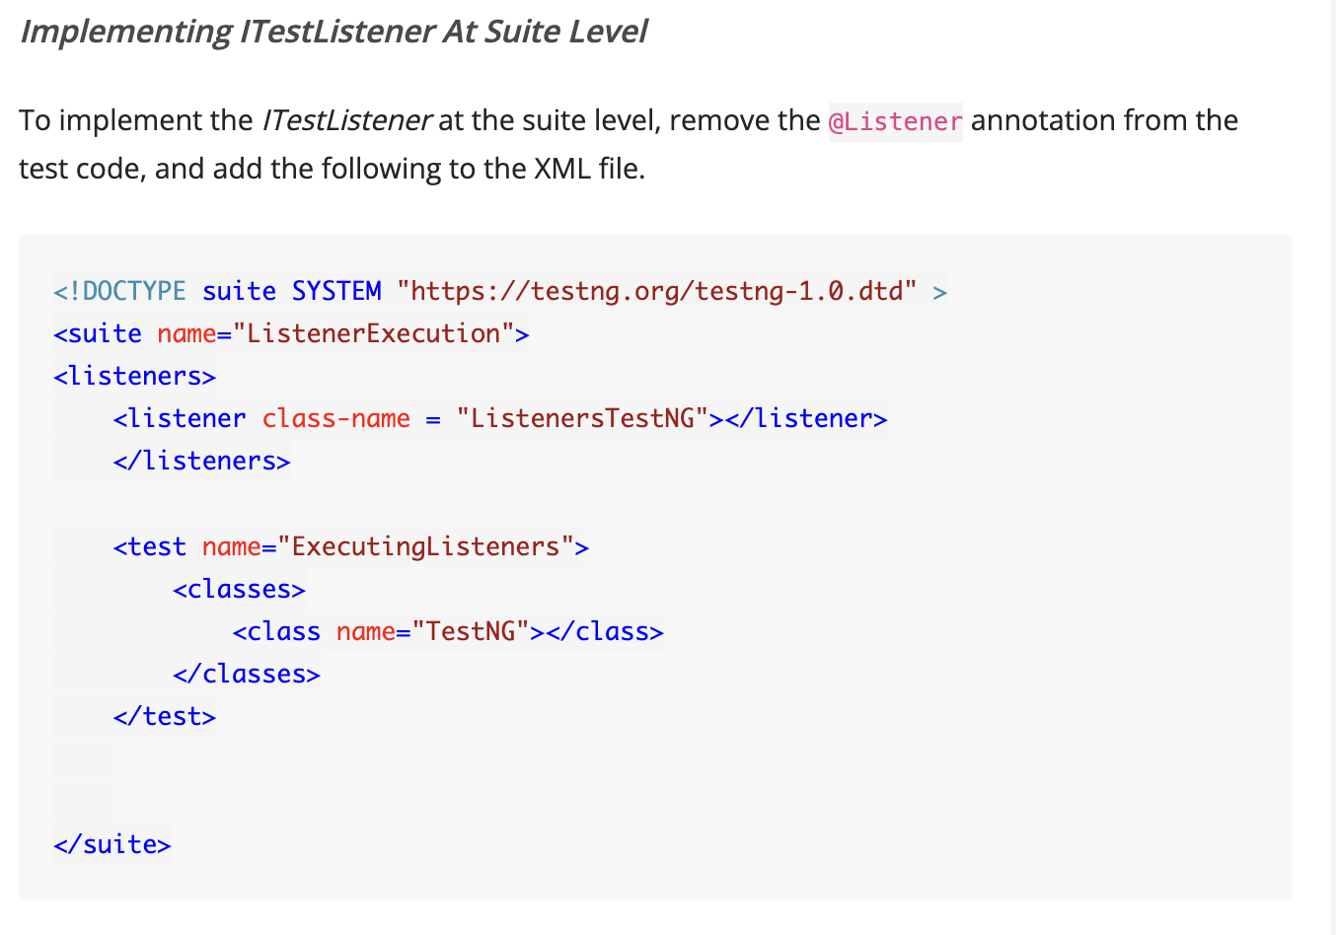

## IReporter Listeners In TestNG

The IReporter interface in the TestNG Listener provides us with a medium to generate custom reports (i.e., customize the reports generated by TestNG). The interface contains a method called generateReport() which we invoke when all the suites have run. This method takes three arguments:

* ***xmlSuite***: This is the list of suites that exist in the XML file for execution.
* ***suites***: This is an object which contains all the information about the test execution and suite related information. This information may include the package names, class names, test method names, and the test execution results.
* ***outputDirectory***: It contains the path to the output folder where the generated reports will be available.

import java.util.List;

import java.util.Map;

import org.testng.IReporter;

import org.testng.ISuite;

import org.testng.ISuiteResult;

import org.testng.ITestContext;

import org.testng.xml.XmlSuite;

public class ListenersTestNG implements IReporter{

@Override

public void generateReport(List<XmlSuite> xmlSuites, List<ISuite> suites,

String outputDirectory) {

//Iterate over every suite assigned for execution

for (ISuite suite : suites) {

String suiteName = suite.getName();

Map<String, ISuiteResult> suiteResults = suite.getResults();

for (ISuiteResult sr : suiteResults.values()) {

ITestContext tc = sr.getTestContext();

System.out.println("Passed tests for suite '" + suiteName +

"' is:" + tc.getPassedTests().getAllResults().size());

System.out.println("Failed tests for suite '" + suiteName +

"' is:" + tc.getFailedTests().getAllResults().size());

System.out.println("Skipped tests for suite '" + suiteName +

"' is:" + tc.getSkippedTests().getAllResults().size());

}

}

}

}

## ISuiteListener In TestNG

ISuiteListener is another type of listener provided in TestNG. The ISuiteListener works on the suite level. Additionally, it listens to the event of the start of a suite execution and end of the suite execution. ISuiteListener then runs the methods only before the start of the suite and at the end. It contains two methods:

* ***onStart***: This method invokes before the test suite execution starts.

***Syntax***: ***void onStart(ISuite suite);***

* ***onFinish***: This method invokes after the test suite execution ends.

***Syntax***: ***void onFinish(ISuite suite);***

***One should note that if the parent suite contains child suites as well, then the child suites are executed before the parent suite***. It helps to retrieve the combined results from child suites reflecting onto the parent suites.

### **How to implement ISuiteListener in TestNG?**

import org.testng.ISuite;

import org.testng.ISuiteListener;

public class ListenersTestNG implements ISuiteListener {

public void onStart(ISuite suite) {

System.out.println("onStart function started " + suite.getName());

}

public void onFinish(ISuite suite) {

System.out.println("onFinish function started " + suite.getName());

}

}

Let's name the first child class as xmlFile1.xml

<?xml version="1.0" encoding="UTF-8"?>

<!DOCTYPE suite SYSTEM "https://testng.org/testng-1.0.dtd">

<suite name="First Test Suite">

<test name="isuitetest">

<classes>

<class name="TestNG"/>

</classes>

</test>

</suite>

Let's name the second child class as xmlFile2.xml

<?xml version="1.0" encoding="UTF-8"?>

<!DOCTYPE suite SYSTEM "https://testng.org/testng-1.0.dtd">

<suite name="Second Test Suite">

<test name="isuitetest2">

<classes>

<class name="TestNG2"/>

</classes>

</test>

</suite>

Now, let's create the parent class, which we will execute. This file is testng.xml

<?xml version="1.0" encoding="UTF-8"?>

<!DOCTYPE suite SYSTEM "https://testng.org/testng-1.0.dtd">

<suite name="parentsuite">

<listeners>

<listener class-name="ListenersTestNG"></listener>

</listeners>

<suite-files>

<suite-file path="xmlFile1.xml"> </suite-file>

<suite-file path="xmlFile2.xml"> </suite-file>

</suite-files>

</suite>

**How to Retry Failed Tests in TestNG.**

First understand the org.testng.IRetryAnalyzer interface. The interface definition is

public interface IRetryAnalyzer {

/**

* Returns true if the test method has to be retried, false otherwise.

*

* @param result The result of the test method that just ran.

* @return true if the test method has to be retried, false otherwise.

*/

public boolean retry(ITestResult result);

}

This interface has only one method public boolean retry(ITestResult result);  
This method will be called once a test method fails. You can get the details of the test from T*estResult* input argument to this method, as shown in the method definition above. This method implementation should return true if you want to re-execute your failed test and false if you don't want to re-execute your test.

package Tests;

import org.testng.IRetryAnalyzer;

import org.testng.ITestResult;

public class RetryAnalyzer implements IRetryAnalyzer {

int counter = 0;

int retryLimit = 4;

/*

* (non-Javadoc)

* @see org.testng.IRetryAnalyzer#retry(org.testng.ITestResult)

*

* This method decides how many times a test needs to be rerun.

* TestNg will call this method every time a test fails. So we

* can put some code in here to decide when to rerun the test.

*

* Note: This method will return true if a tests needs to be retried

* and false it not.

*

*/

@Override

public boolean retry(ITestResult result) {

if(counter < retryLimit)

{

counter++;

return true;

}

return false;

}

}

**Specifying retryAnalyzer attribute in the @Test annotation**

We can do this by simply using following syntax to ***@Test(retryAnalyzer="IRetryAnalyzer Implementing class")***. Below is the code to do that

import org.testng.Assert;

import org.testng.annotations.Test;

public class Test001 {

@Test(retryAnalyzer = Tests.RetryAnalyzer.class)

public void Test1()

{

Assert.assertEquals(false, true);

}

@Test

public void Test2()

{

Assert.assertEquals(false, true);

}

}

**Specifying retryAnalyzer during runtime** In this case you would need to implement ITestAnnotationTransformer interface. ITestAnnotationTransformer interface falls under a broad category of interfaces called TestNG Listeners.

public class AnnotationTransformer implements IAnnotationTransformer {

@Override

public void transform(ITestAnnotation annotation,

Class testClass,

Constructor testConstructor,

Method testMethod) {

// TODO Auto-generated method stub

}

}

package Tests;

import java.lang.reflect.Constructor;

import java.lang.reflect.Method;

import org.testng.IAnnotationTransformer;

import org.testng.annotations.ITestAnnotation;

public class AnnotationTransformer implements IAnnotationTransformer {

@Override

public void transform(ITestAnnotation annotation,

Class testClass,

Constructor testConstructor,

Method testMethod) {

annotation.setRetryAnalyzer(RetryAnalyzer.class);

}

}

Once we have the implementation of IAnnotationTransformer, we just need to add it as a listener in the testng run xml. Like this

<!DOCTYPE suite SYSTEM "https://testng.org/testng-1.0.dtd" >

<suite name="RetryFailedTests" verbose="1" >

<listeners>

<listener class-name="Tests.AnnotationTransformer"/>

</listeners>

<test name="RetryMulitple">

<classes>

<class name="Tests.Test001"/>

</classes>

</test>

</suite>

package Tests;

import org.testng.Assert;

import org.testng.annotations.Test;

public class Test001 {

@Test

public void Test1()

{

Assert.assertEquals(false, true);

}

@Test

public void Test2()

{

Assert.assertEquals(false, true);

}

}